**Physiology of female reproductive system**

The function of the female reproductive system;

1. Formation of ova
2. Produce sex hormones like estrogens, progesterone
3. Reception of spermatozoa
4. Provide suitable environment for fertilization and fetal development
5. Parturition (childbirth)
6. Lactation; the production of breast milk which provides complete nourishment for the baby in its early life

Female reproductive system composed of;

**Ovary;**

primary sex organ that produces egg cells in a process called oogenesis

oogenesis; means maturation of primary oocyte to the secondary oocyte and also produce female sex hormones such as estrogens and progesterone

**uterine tube (fallopian tube)** consists of;

* Fimbriae; finger like appendage that collect the ovum from the ovary during ovulation
* Infundibulum channels the ovum from the fimbriae in to the uterine tube
* Ampulla is the curvature of the tube where most of ferritization occurs
* Isthmus where it sits next to the opening of the fallopian tube into the uterus

Inner wall of the fallopian tube is made of ciliated cells where the cilia propel the ovum toward the uterus

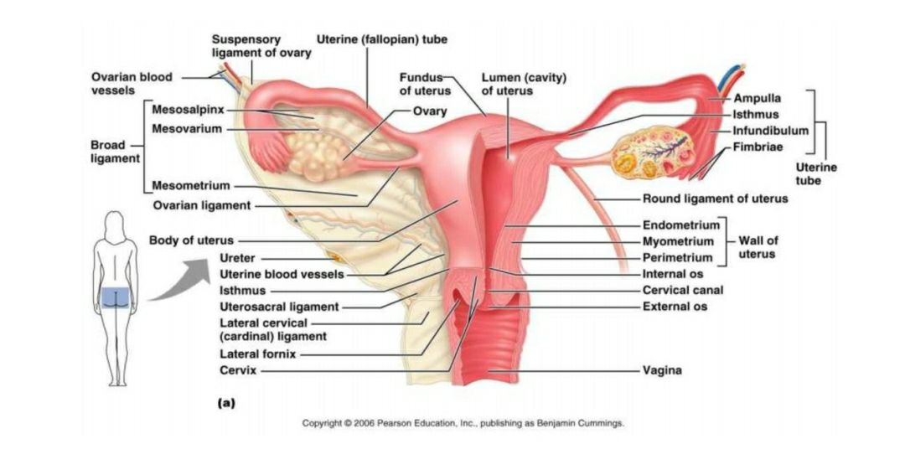

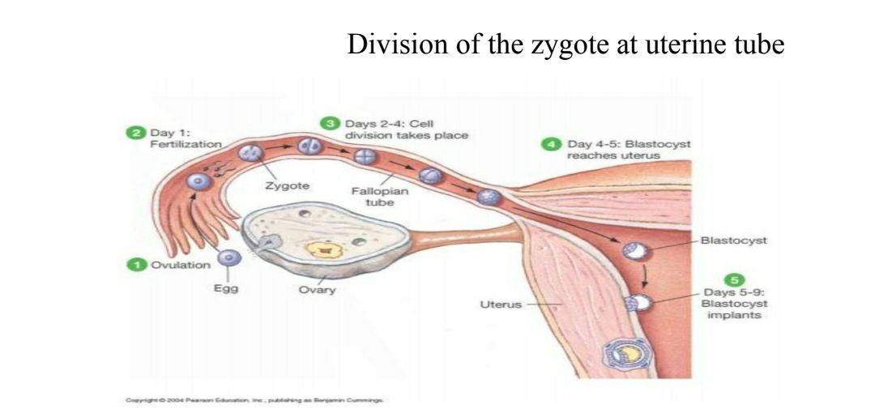

**Uterus**

A pear shape cavity formed by the union of the two uterine tubes which is composed of 3 layers;

1. Endometrium

* After ferritization embryo adheres to the endometrium layer for further development in an event called implantation
* To prepare for implantation and development endometrium is stimulated by estrogen to thicken and become vascularized in a process called the menstrual cycle

1. Myometrium under the stimulation of oxytocin contracts during labor to expel the fetus into the vagina
2. Perimetrium is the outer serous layer of the uterus

The base of uterus is closed by a narrow passageway called cervix to prevent the entry of foreign substance

The uterus serves many function

1. Site of implantation
2. 2- the uterus gives supporting, protection and nutrition to the fetus
3. Important in the delivery

**Vagina**; serve as

1. Birth canal during parturition
2. serve as the copulatory receptacle where it receives the penis during the sexual intercourse
3. in addition to the acids secretion from the cervix is also conveys uterine secretions (i.e., menstrual flow)

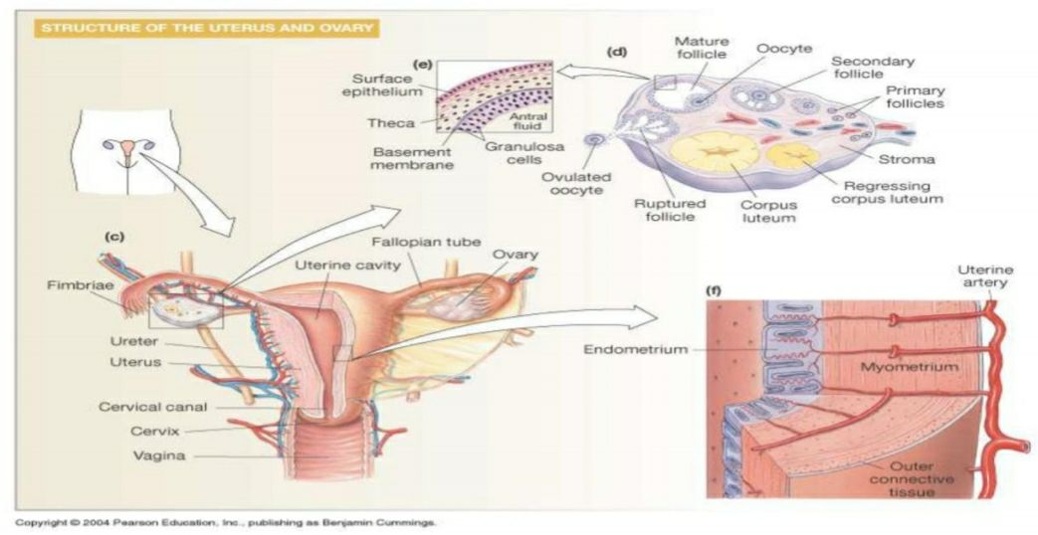

**Oogenesis;**

In the ovarian cortex a process called oogenesis (formation of egg) occurs to develop a mature ovum

Before birth several million cells called primordial oocytes exist in the ovary most of them spontaneously degenerate. At birth, only 1 million oocytes are left and by puberty (age 10-11) only 400,000 remain in the ovaries

From puberty to menopause some of these primordial oocytes (contain 46 chromosomes) undergo DNA replication and become primary oocytes (with 46 chromosomes)

Primary oocytes will then undergo crossing over to shuffle their genes and meiosis I will occur to divide the cells into secondary oocytes (containing 46 unique chromosomes) but will be degenerated oogenesis now to arrest where the ovary discharge a mature secondary oocyte into the uterine tube (in a process called ovulation)

Meiosis II is reactivated when this secondary oocyte is fertilized by a sperm (if no fertilization occurs secondary oocyte is discarded along with the menstrual flow) instantly dividing the 46 chromosomes into 23 (inside the second polar body) and another 23 will be united with the 23 chromosomes that released from the sperm to form fertilized ovum.

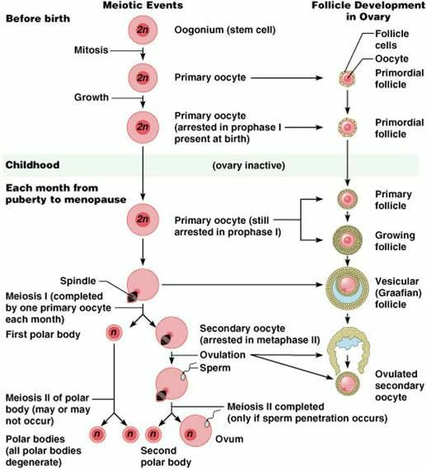

**Hormonal control of female secondary sex characteristic;**

the hypothalamus releases GnRH (gonadotropin releasing hormone) which stimulates the anterior pituitary gland.

The anterior pituitary gland secretes FSH (follicle stimulating hormone) and LH (luteinizing hormone)

FSH stimulates the maturation of a follicle

Granulose cells of the follicle produce and secrete estrogen. Estrogen is responsible for the development and maintenance of most female secondary sex characteristics

LH trigger the release of an egg from the ovary (ovulation) and helps to control the menstrual cycle and stimulate certain cell to produce progesterone and androgen

Concentration of androgen affect other secondary sex characteristics including skeletal growth and growth of hair

Progesterone secreted by the ovaries affect cyclical changes in the uterus and mammary gland

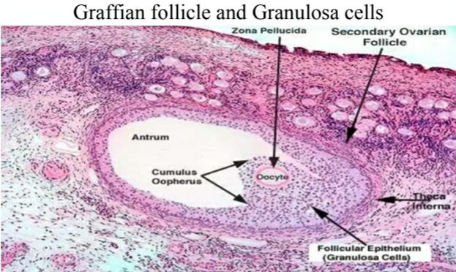

**Types of cells and hormones in the ovarian follicle**;

1. follicle cell
2. zona pellucida
3. thecal cells produce androgen that transfer onto estrogen in females
4. granulosa cells produce inhibin, estrogen and enzyme called aromatase
5. cells of corpus luteum produce progesterone and estrogen

**ovarian cycle;**

three phases of ovarian cycle;

1. follicular phase
2. ovulation
3. luteal phase

the period of each cycle is approximately 28 days

1. **follicular phase**

it is characterized by;

* follicular maturation by the effect of FSH
* increase level of estrogens (produced by granulosa cells)
* at the late period of this phase the level of FSH decreases while the level of LH increases

1. **ovulation;**

* means release of the secondary oocyte from graafian follicle
* only one ovulate each month
* ovulation is induced by peak level of LH
* It occurs on day 14 of a 28 days ovarian cycle

1. **Luteal phase;**

* Occur during days 15-28 of ovarian cycle and formation of corpus luteum
* Corpus luteum secretes mainly progesterone hormone
* Progesterone is important for implantation of fertilized ovum and to maintain pregnancy
* The life spine of corpus luteum is about 10-13 days if fertilization does not occur

**Uterine cycle (menstrual cycle)**

The uterine cycle under effect of estrogen (E2) and progesterone (P4)

Phases of uterine cycle

1. Menstrual phase
2. Proliferative phase
3. Secretary phase

**Menstrual phase**

It occurs during 1-5 days of the cycle

It is characterized by sloughing of functional layer of endometrium and bleeding occur

**Proliferative phase**

It occurs during 6-14 days of the cycle

It is characterized by development of functional layer of endometrium mainly by the action of estrogen

**Secretory phase**

It occurs from day 15-28 of the cycle and the uterus under the effect of progesterone

The functional layer of endometrium undergoes;

1. Increase vascularization
2. Development of uterine glands

If the oocyte is not fertilized the corpus luteum degenerated and the level of progesterone drops so the functional layer undergoes sloughing

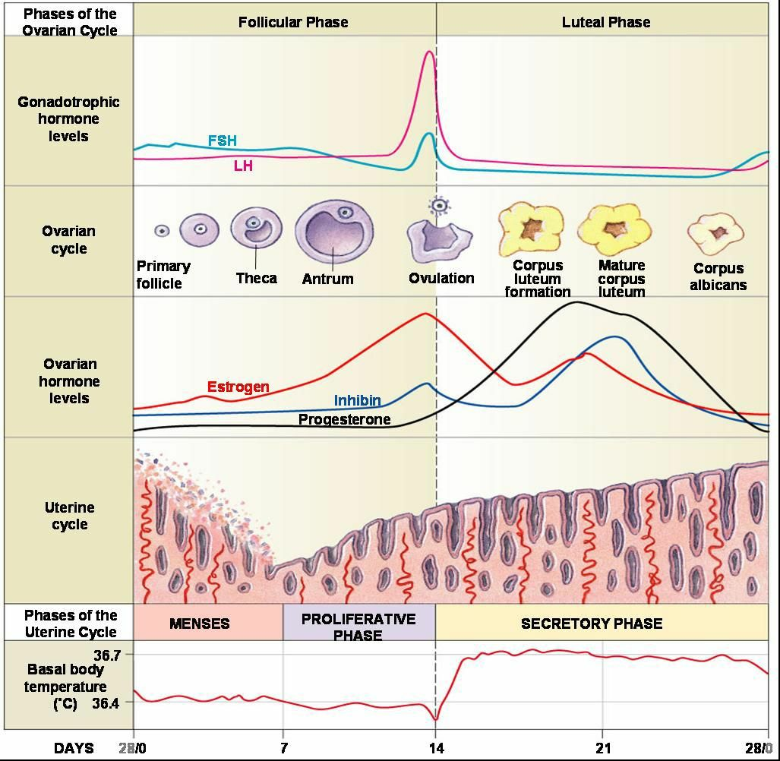

Fertilization;

Within an hour after sexual intercourse sperm would have traveled from the vagina through the cervix into the uterus and uterine tube. During the journey the acrosome on the head of spermatozoa would be worn off releasing acrosin enzyme by the time sperm are attached to the outer coating of the ovum

About 50 spermatozoa are attached to the outermost coatings called corona radiate. Using hydrolysis reaction aided by acrosin some of these sperm reach the inner coating called zone pellucida

One of the sperm will eventually penetrate through the zone pellucida and allow its cell membrane to fuse with the cell membrane of ovum. This causes a rapid electrical despoliation at the cell membrane of the ovum preventing other sperms entering the ovum

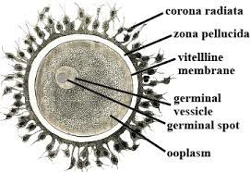

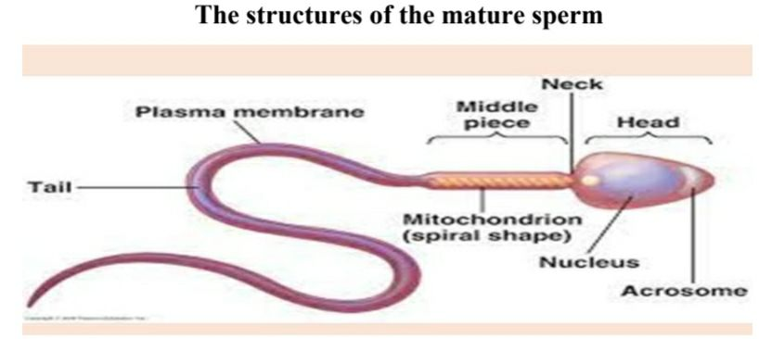

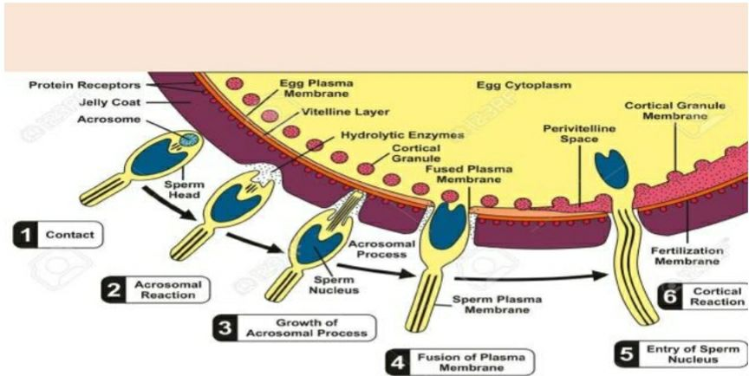

Now **meiosis II** is reactivated in the cytoplasm of ovum dividing the 46 chromosomes in the nucleus onto 23 for fertilization and 23 chromosomes to be eliminated along with the second polar body

The head of the penetrated sperm is now detached from its mid piece and tail. It will then rapture release 23 chromosomes in the form of long strands of DNA molecules

The chromosomes from the sperm and ovum now unite to form a complete set of genetic makeup for the of offspring (2 haploid cells) sperm and ovum are now joined to become a single diploid called **zygote**

Fertilization is now complete

**Hormonal control of mammary glands**

At puberty;

Ovarian hormones secreted during menstrual cycles stimulate alveolar glands and ducts of mammary glands to develop

During pregnancy

Estrogen causes the ductile system to grow and branch

Progesterone stimulates development of alveolar glands

Placental lactogen promotes development of the breasts

Prolactin (from ant. Pituitary) is secreted throughout pregnancy but placental progesterone inhibits milk production (until after birth)

**Mechanical stimulation of breast milk release**

Oxytocin from ant. Pituitary gland stimulates **ejection** of milk from ducts. **As long as milk is removed more prolactin is released;** if milk is not removed milk ceases