Endocrine Glands:
Secretion and Action of Hormones
Endocrine Glands and Hormones

Endocrine glands (also called ductless glands) lack the ducts that are present in exocrine glands.
Secrete their products, which are biologically active molecules called hormones, into the blood.
The blood carries the hormones to target cells that contain specific receptor proteins for the hormones. Affect metabolism of target organs (help regulate total body metabolism, growth, and reproduction). Target cells can respond in a specific fashion
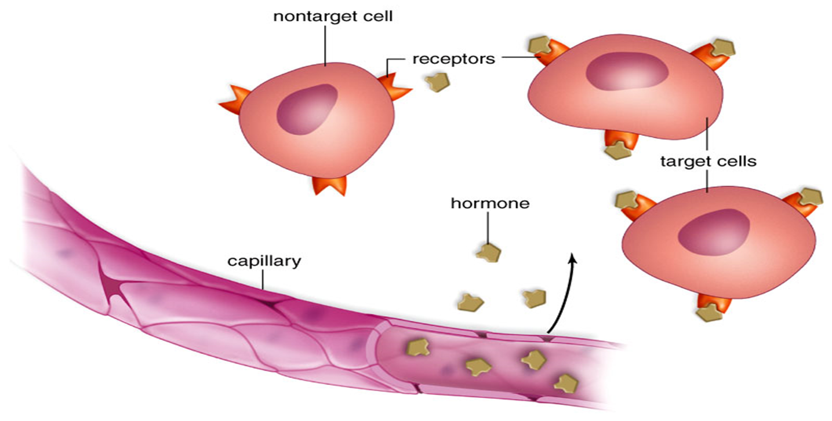
Chemical Classification of Hormones
Amines: are hormones derived from two amino acids (tryptophan and tyrosine). They include hormones secreted from:
- Thyroid gland: T3 and T4.
2- Pineal gland: melatonin.
3- Adrenal medulla: epinephrine (adrenaline) & norepinephrine (noradrenaline).
Polypeptides: less than 100 amino acids e.g ADH Proteins: more than 100 amino acids e.g Growth hormones
Glycoproteins: consist of polypeptides with one or more carbohydrate group’s e.g: follicle stimulating hormone (FSH), Luteinizing hormone (LH) and thyroid stimulating hormone (TSH).
Steroids are lipids derived from cholesterol e.g progesterone, testosterone, estradiol, cortisol, and aldosterone. Only gonadal and adrenocortical hormones are steroids.
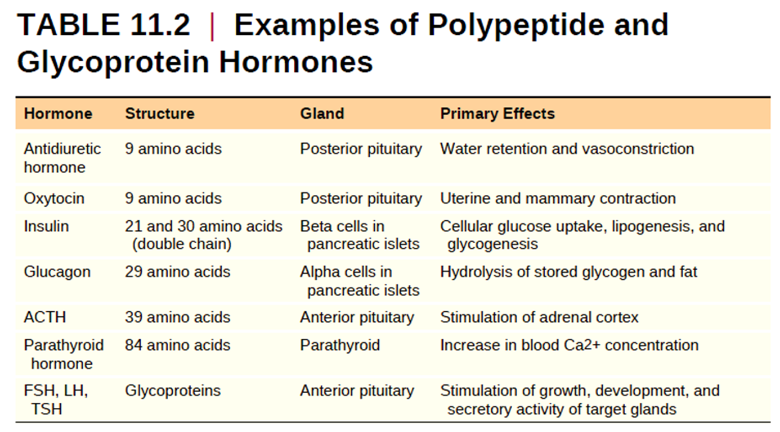
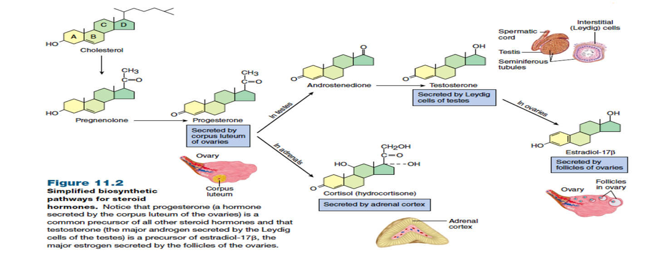
Prohormone less active “parent,” or precursor, molecules. e.g. proinsulin is cut and spliced together within the gland cell to make the hormone insulin.
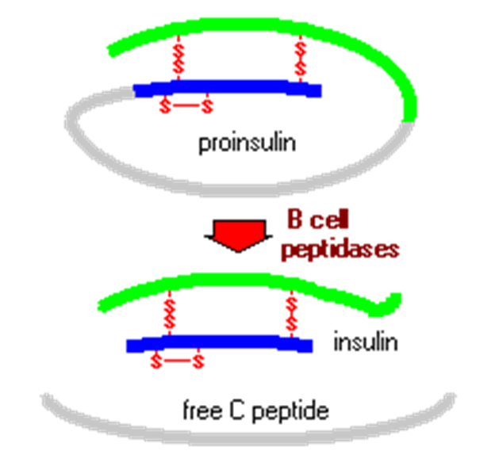

Prehormones - some hormones are inactive until activated by target cells.
The term Prehormones designates the molecules secreted by endocrine glands but are inactive until they are changed into active form in their target cell.
In order to become active, the target cells must modify the chemical structure of the secreted hormone. E.g. thyroxine (T4) is inactive until converted to T3 in target cells
Prehormones = T4 (inactive) T3 (active)
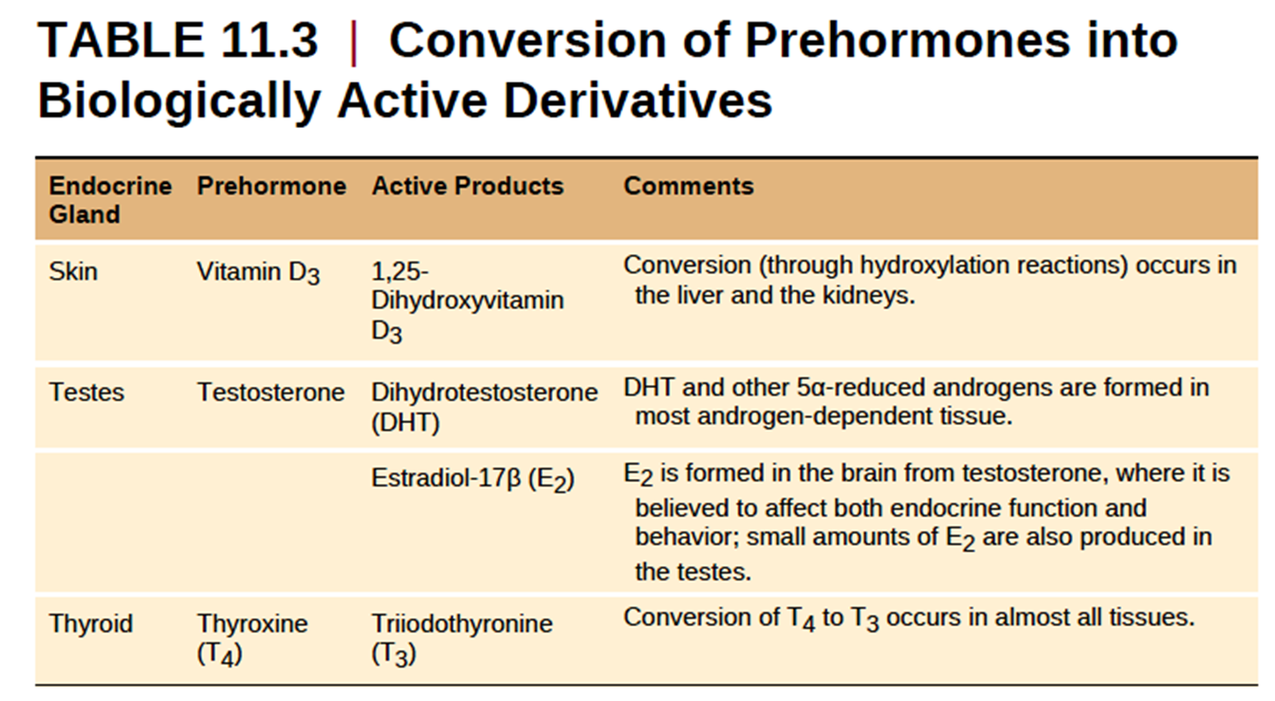
Prehormones vitamin D3 secreted By the skin Must be converted into 1,25-dihydroxyvitamin D3 to be active in its target.
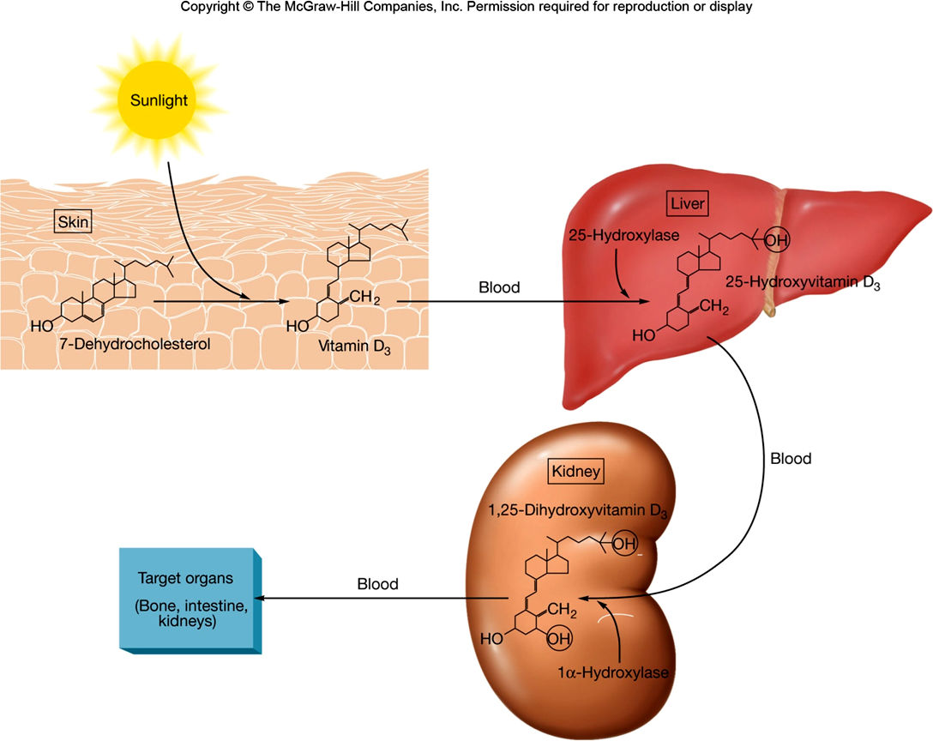
Mechanisms of Hormone Action
All major hormones circulate to virtually all tissues, but a hormone influences the activity of only those tissue cells that have receptors for it. These cells are its target cells Receptor protein–hormone interaction is highly specific. Hormones bind to receptors with a high affinity (high bond strength). In general, hormones act at receptors in one of two ways.
- Water-soluble hormones (all amino acid–based hormones except thyroid hormone) Act on receptors in the plasma membrane. These receptors are usually coupled via regulatory molecules called G proteins to one or more intracellular second messengers which mediate the target cell’s response
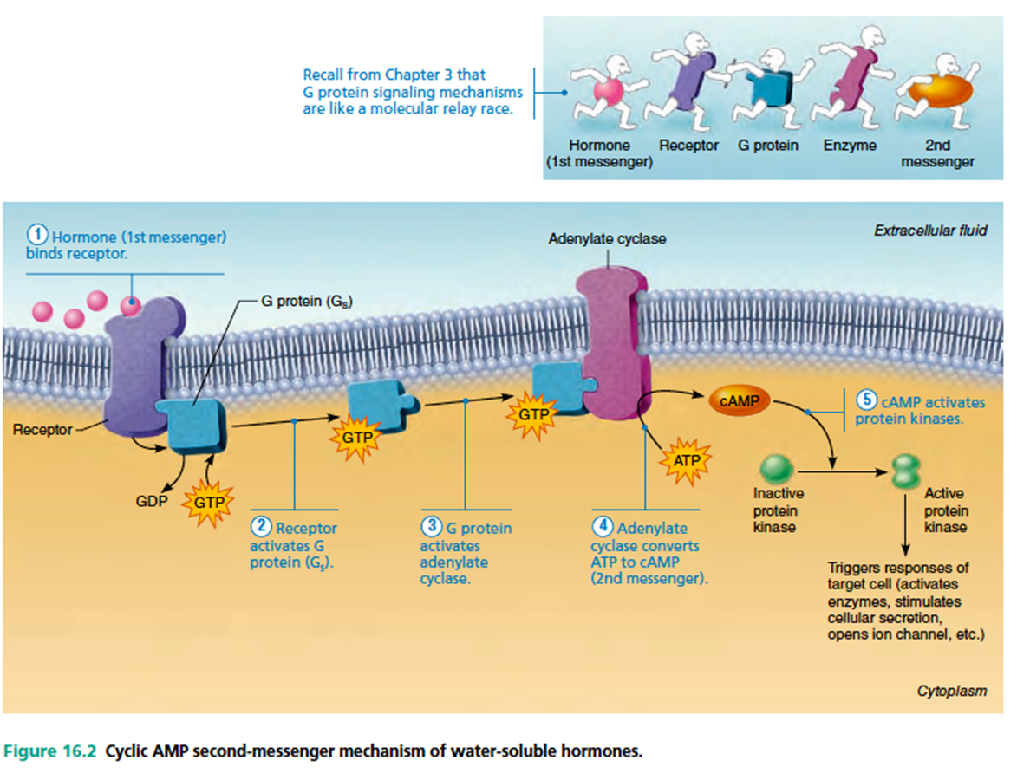
- Lipid-soluble hormones (steroid and thyroid hormones) act on receptors inside the cell (Nuclear receptors), which directly activate genes.
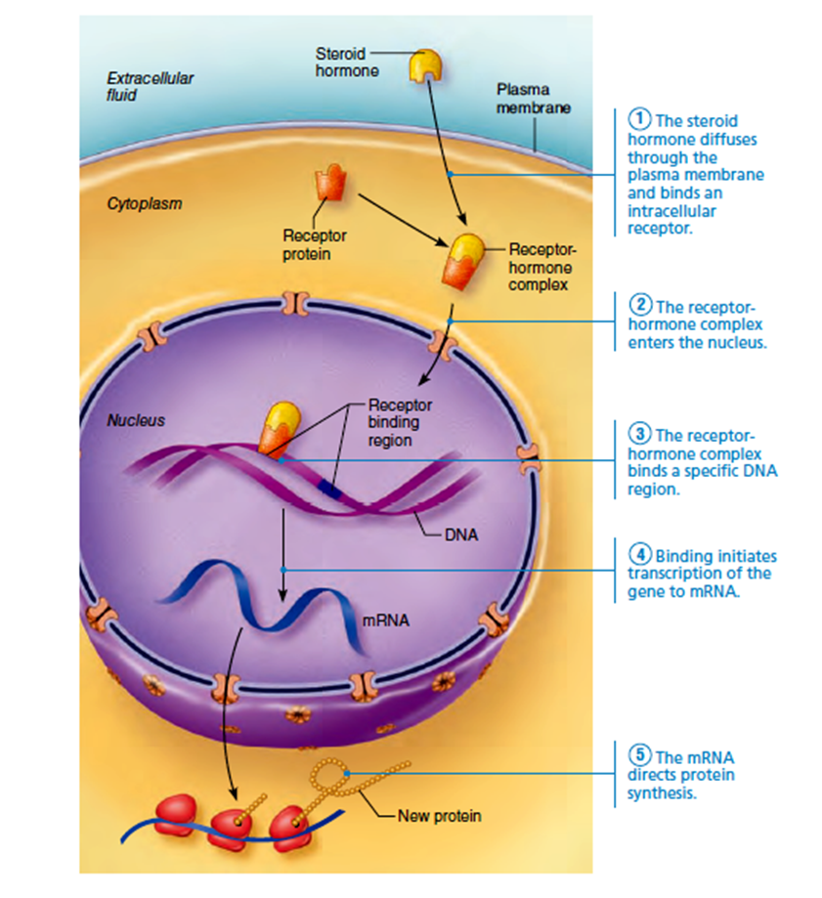

The nuclear receptors composed of two major families:
- The steroid family
- The nonsteroid family
1. Thyroid hormone receptor
2. The receptors for the active form of vitamin D and for retinoic acid (derived from vitamin A, or retinol).
Steroid hormones
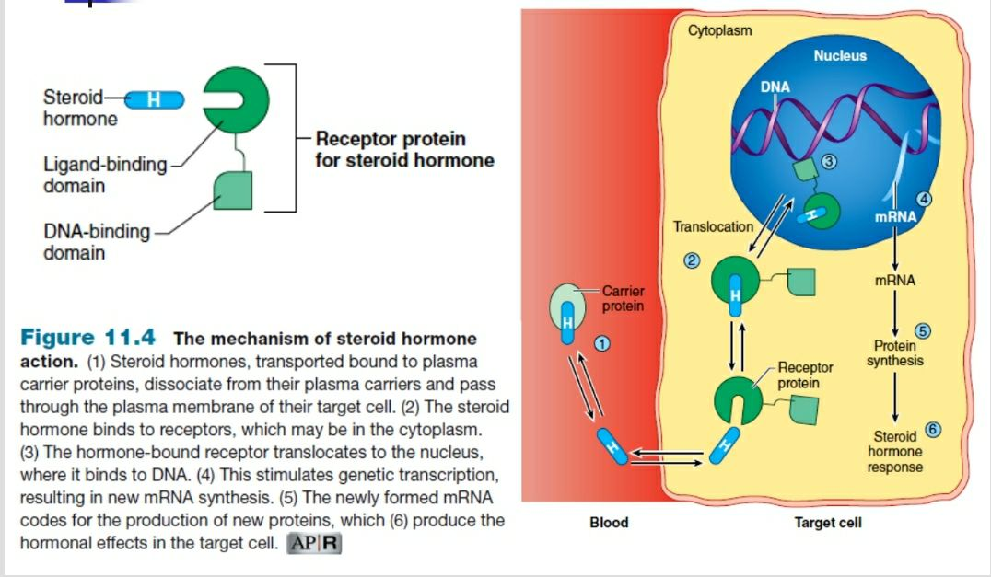
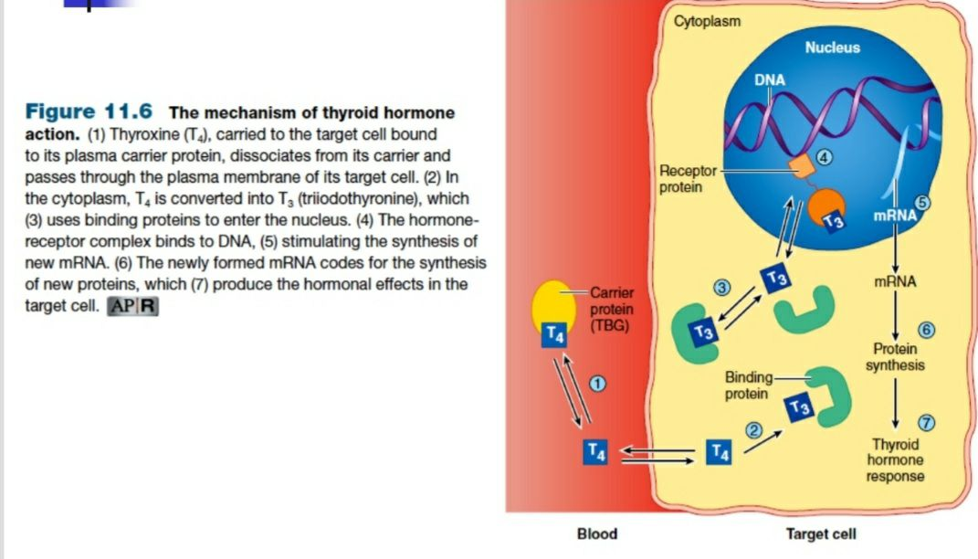
Nuclear Receptors
In fact, scientists have currently identified the hormone ligand for only about half of the approximately 70 different nuclear receptors that are now known.
The receptors for unknown hormone ligands are called orphan receptors.
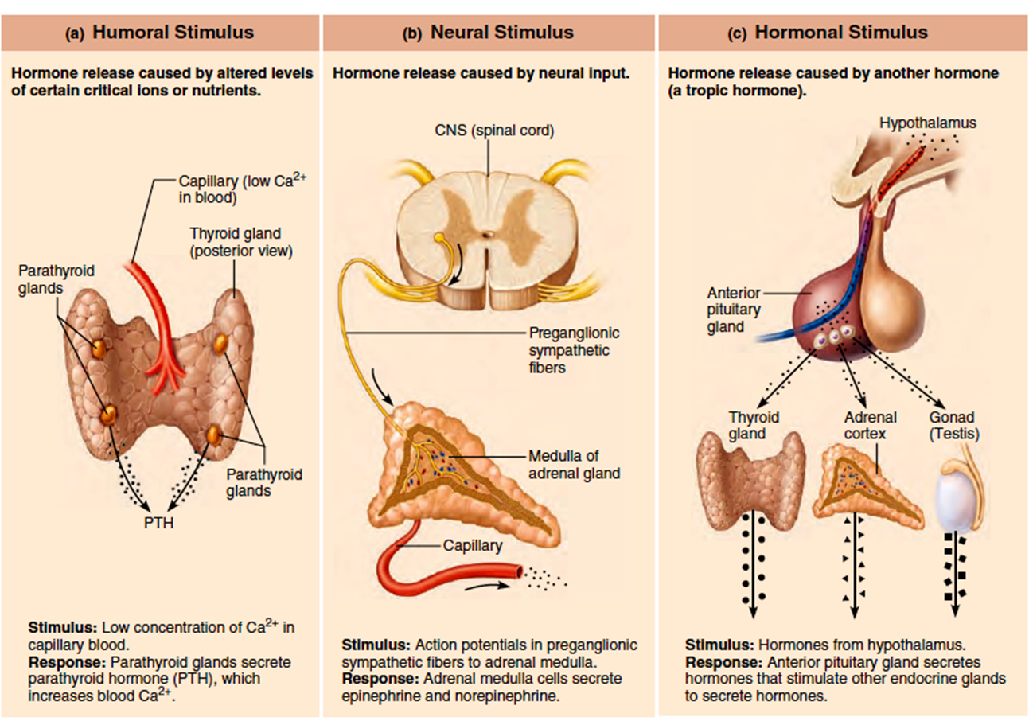
The Pituitary Gland and Hypothalamus
Pituitary gland is located in the diencephalon. In humans, the pituitary gland has two major lobes:
1. The posterior pituitary composed largely of neural tissue.
2. The anterior pituitary, or adenohypophysis composed of glandular tissue
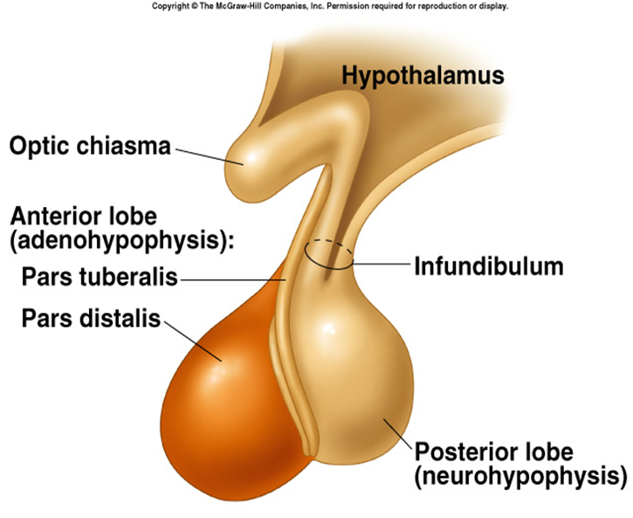
Posterior pituitary
It derives from a downgrowth of hypothalamic tissue and maintains its neural connection with the hypothalamus via a nerve bundle called the hypothalamic-hypophyseal tract.
Neurosecretory cells synthesize two neurohormones (antidiuretic hormone & oxytocin) and transport them along their axons to the posterior pituitary for storage.
When these hypothalamic neurons fire, they release the stored hormones into a capillary bed in the posterior pituitary for distribution throughout the body.
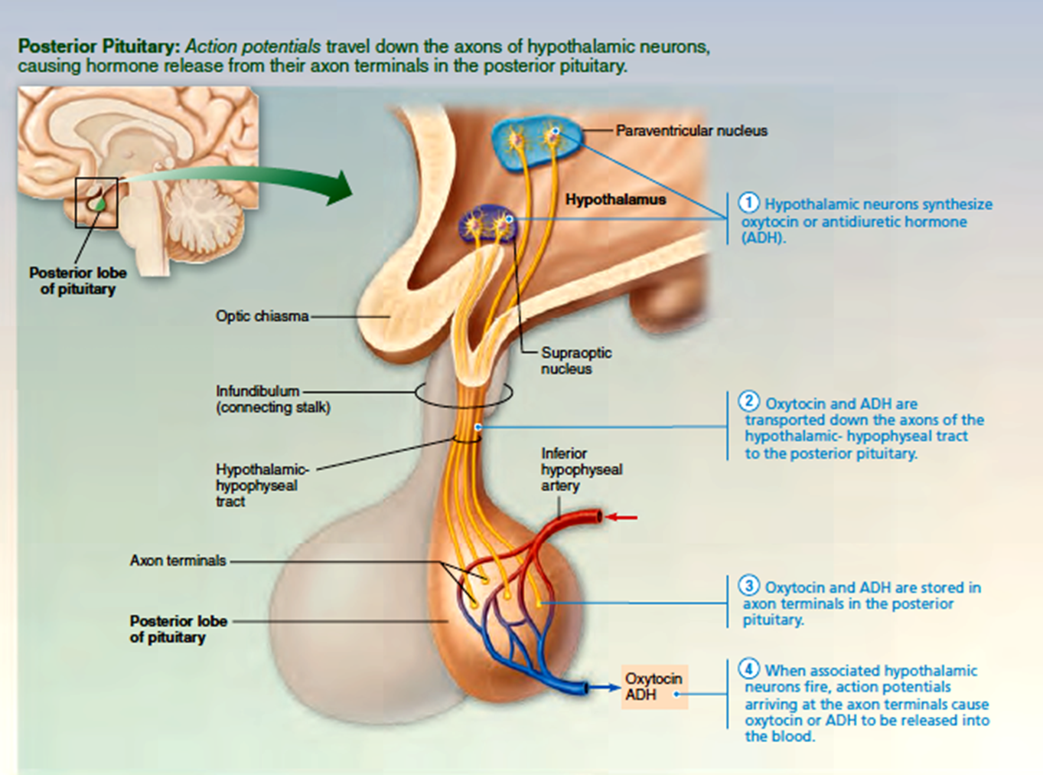
Anterior pituitary
There is no direct neural connection between the anterior lobe and hypothalamus, but there is a vascular connection.
The primary and secondary capillary plexuses and the intervening hypophyseal portal veins make up the hypophyseal portal system. Via the hypophyseal portal system, releasing and inhibiting hormones secreted by neurons in the ventral hypothalamus circulate to the anterior pituitary, where they regulate secretion of its hormones.
Hypothalamic control of the anterior pituitary
The vascular link between the hypothalamus and the anterior pituitary is thus called the hypothalamo-hypophyseal portal system.
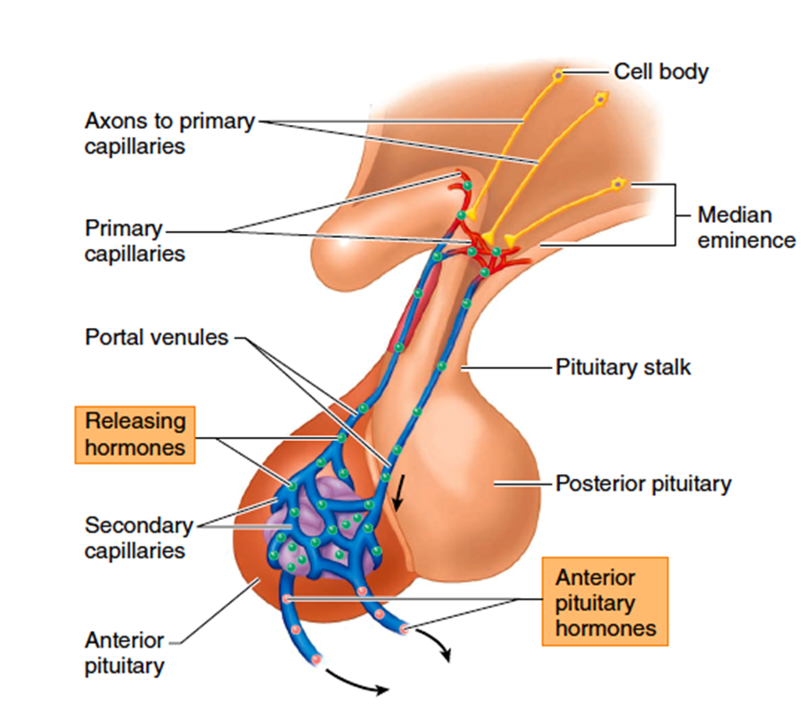
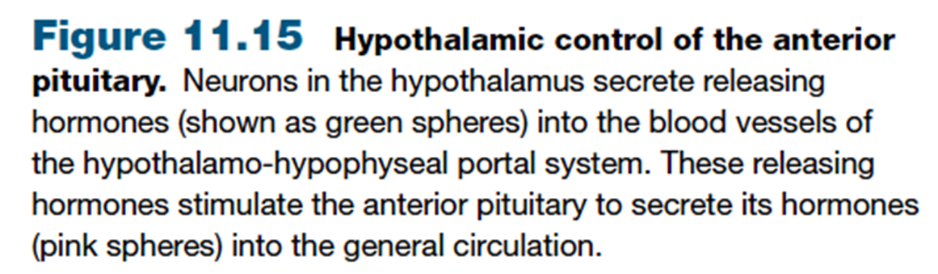
Hypothalamic control of the Anterior Pituitary
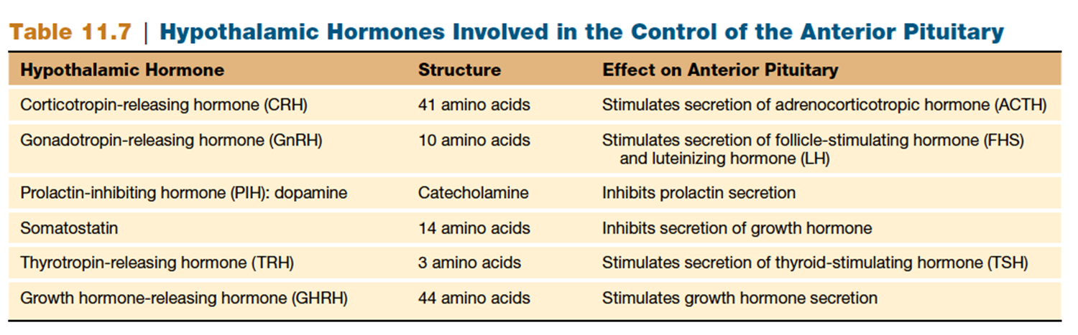
Thyrotropin-releasing hormone (TRH) stimulates the secretion of TSH.
Corticotropin-releasing hormone (CRH) stimulates the secretion of ACTH from the anterior pituitary.
Gonadotropin-releasing hormone, or GnRH, stimulates the secretion of both gonadotropic hormones (FSH and LH) from the anterior pituitary.
The anterior pituitary secretion of growth hormone is under the control of two polypeptide hormones from the hypothalamus.
Growth hormone–releasing hormone (GHRH) by the hypothalamus stimulates the anterior pituitary to secrete growth hormone.
Somatostatin from the hypothalamus inhibits growth hormone secretion
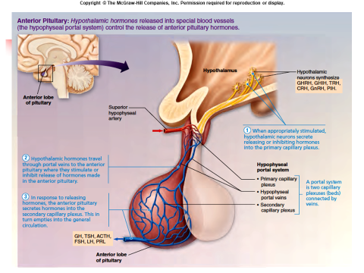

Anterior pituitary
The hormones secreted by the anterior pituitary are called trophic hormones.
Researchers have identified six anterior pituitary hormones, all of them proteins
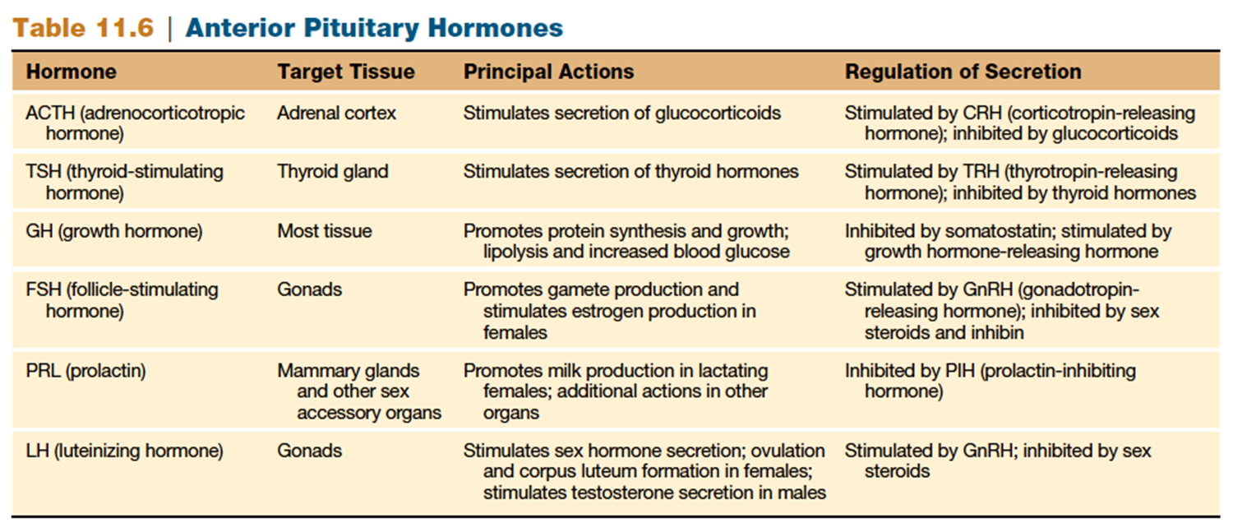
Anterior pituitary Hormones
1. Growth hormone (GH, or somatotropin): growth of cartilage and bones and protein synthesis.
2. Thyroid-stimulating hormone ( TSH, or thyrotropin ). TSH stimulates the thyroid gland to produce and secrete thyroxine (tetraiodothyronine, or T4 ) ,triiodothyronine ( T3 ).
3. Adrenocorticotropic hormone ( ACTH, or corticotropin ). ACTH stimulates the adrenal cortex to secrete the glucocorticoids, such as cortisol (hydrocortisone).
4. Follicle-stimulating hormone ( FSH, or folliculotropin). FSH stimulates the growth of ovarian follicles in females and the production of sperm cells in the testes of males
5. Luteinizing hormone ( LH, or luteotropin). This hormone and FSH are collectively called gonadotropic hormones.
In females, LH stimulates ovulation and the conversion of the ovulated ovarian follicle into an endocrine structure called a corpus luteum.
In males, LH stimulates the secretion of male sex hormones (mainly testosterone) from the interstitial cells (Leydig cells) in the testes.
6. Prolactin (PRL) This hormone is secreted in both males and females. Its best known function is the stimulation of milk production by the mammary glands of women after the birth of a baby.
Prolactin plays a supporting role in the regulation of the male reproductive system by the gonadotropins (FSH and LH) and acts on the kidneys to help regulate water and electrolyte balance.
A prolactin inhibiting hormone, identified as the neuro-transmitter dopamine, from the hypothalamus, inhibits the secretion of prolactin from the anterior pituitary.

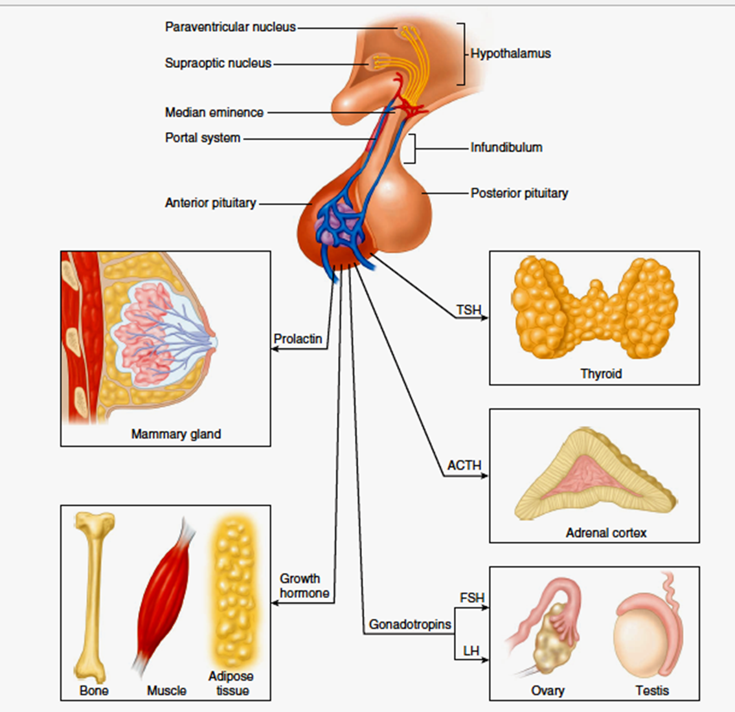

Four of the six anterior pituitary hormones:
1. Thyroid stimulating hormone (TSH)
2. Adrenocorticotropic hormone (ACTH)
3. Follicle stimulating hormone (FSH)
4. Luteinizing hormone (LH)
Are tropic hormones or tropins that regulate the secretory action of other endocrine glands.
Feedback Control of the Anterior Pituitary
The secretion of hypothalamus and anterior pituitary are controlled by the target glands they regulate. Anterior pituitary secretion of ACTH, TSH, and the gonadotropins (FSH and LH) is controlled by negative feedback inhibition from the target gland hormones.

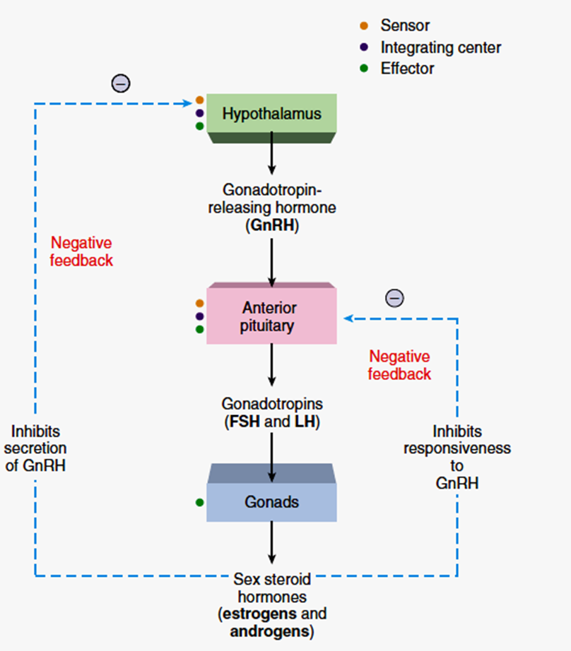
This inhibitory effect can occur at two levels:
(1) The target gland hormones can act on the hypothalamus to inhibit the secretion of releasing hormones.
(2) The target gland hormones can act on the anterior pituitary to inhibit its response to the releasing hormones.
Adrenal Glands
- Paired organs that cap the kidneys.
- Each gland consists of an outer cortex and inner medulla.
Adrenal medulla
Secretes catecholamine hormones, which complement the sympathetic nervous system in the “fight-or-flight” reaction.
Secrets mainly epinephrine, with lesser amounts of norepinephrine into the blood in response to stimulation by preganglionic sympathetic axons.
Adrenal cortex
Secretes steroid hormones that participate in the regulation of mineral and energy balance. It is stimulated hormonally by ACTH secreted from the anterior pituitary.
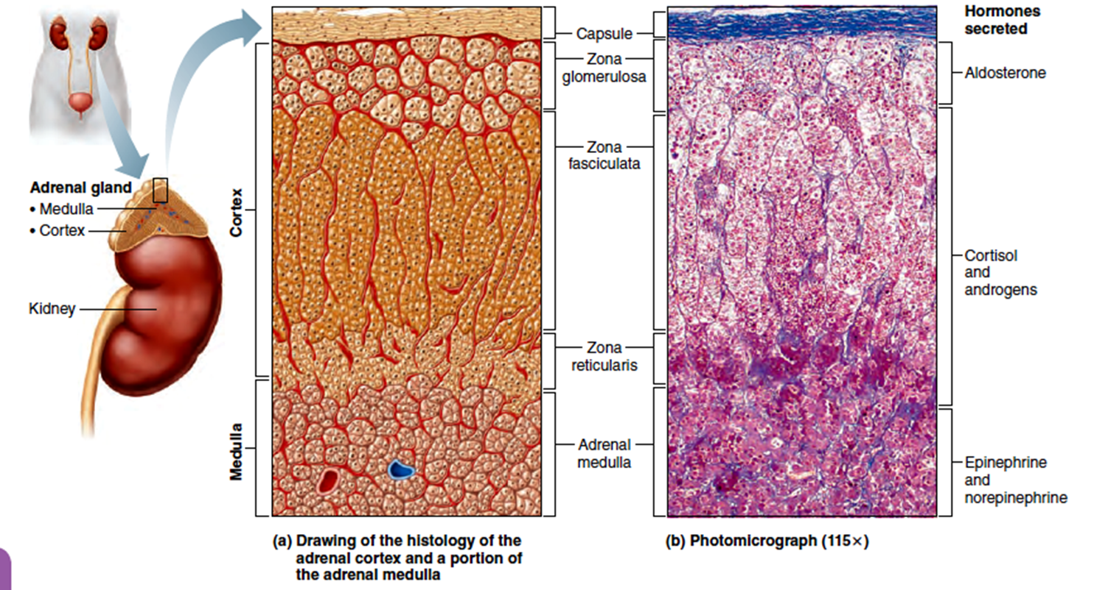
Functions of the Adrenal Cortex
The adrenal cortex secretes steroid hormones called corticosteroids, or corticoids.
Mineralcorticoids (aldosterone) Stimulate kidneys to reabsorb Na+ and secrete K+.
Glucocorticoids (cortisol, hydrocortisone) Stimulated by ACTH from the anterior pituitary.
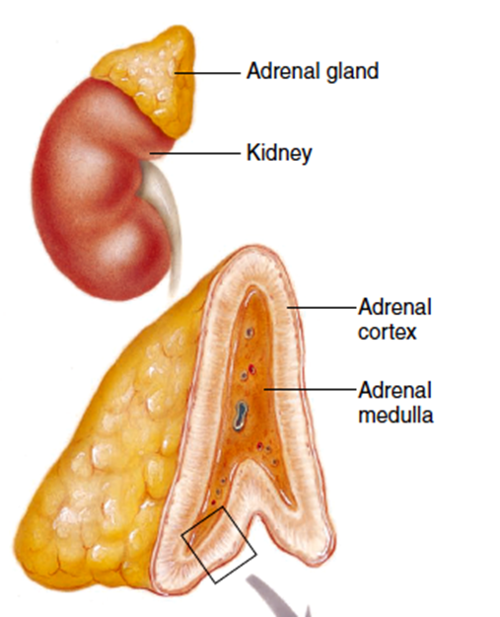

Cortisol and other glucocorticoids have many effects on metabolism. These effects include:
(1) stimulation of protein degradation.
(2) stimulation of gluconeogenesis (production of glucose from amino acids and other noncarbohydrate molecules)
(3) inhibition of glucose utilization, which help to raise the blood glucose concentration
(4) stimulation of lipolysis (breakdown of fat) and the consequent release of free fatty acids into the blood
These effects provide more energy molecules of glucose and fatty acids in the blood

Sex steroids
Supplement sex steroids secreted by the gonads
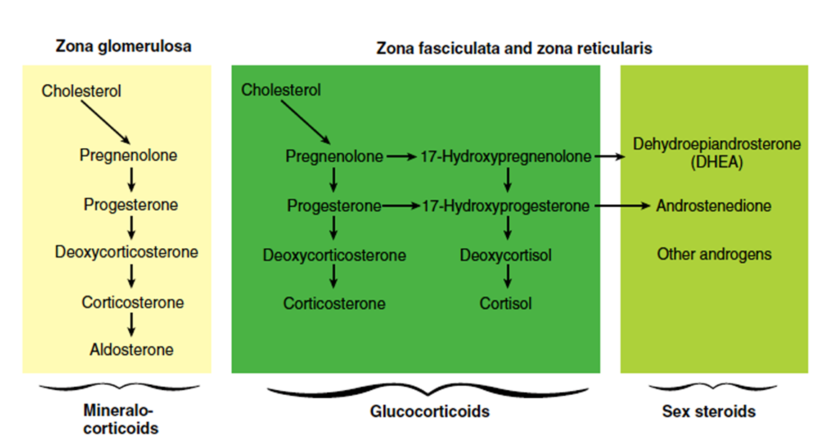
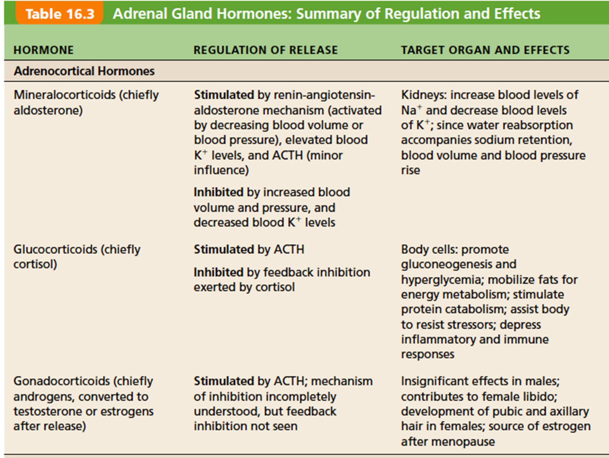
Functions of the Adrenal Medulla
The cells of the adrenal medulla secrete epinephrine and norepinephrine in an approximate ratio of 4 to 1.
The hormones from the adrenal medulla increase the cardiac output and heart rate, dilate coronary blood vessels, increase mental alertness, increase the respiratory rate, and elevate the metabolic rate.
The adrenal medulla is innervated by preganglionic sympathetic axons and secretes its hormones whenever the sympathetic nervous system is activated during “fight or flight”.
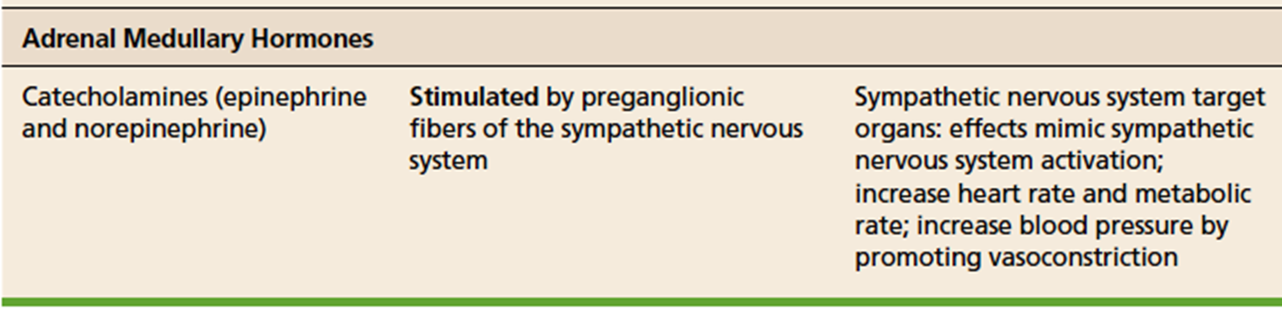
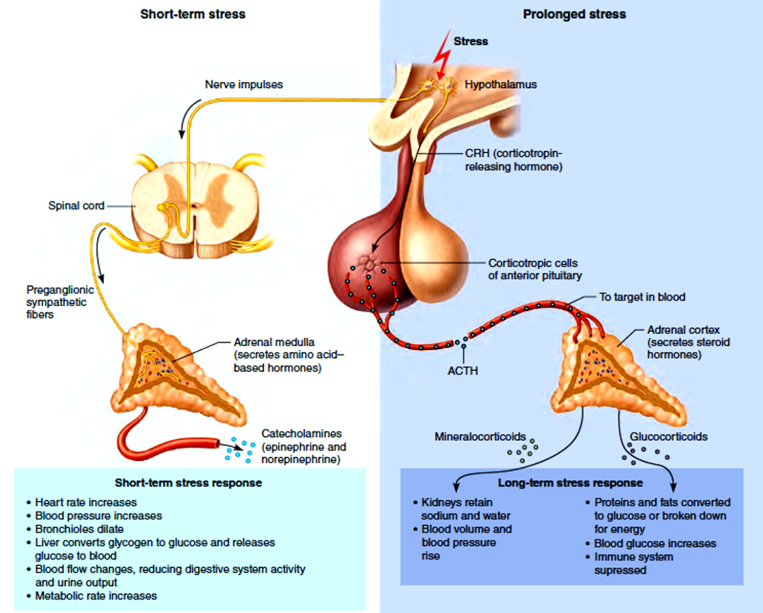
Thyroid Gland
Thyroid gland is located just below the larynx.
Thyroid is the largest of the purely endocrine glands.
Follicular cells secrete Thyroxine T4.
Parafollicular cells secrete calcitonin.
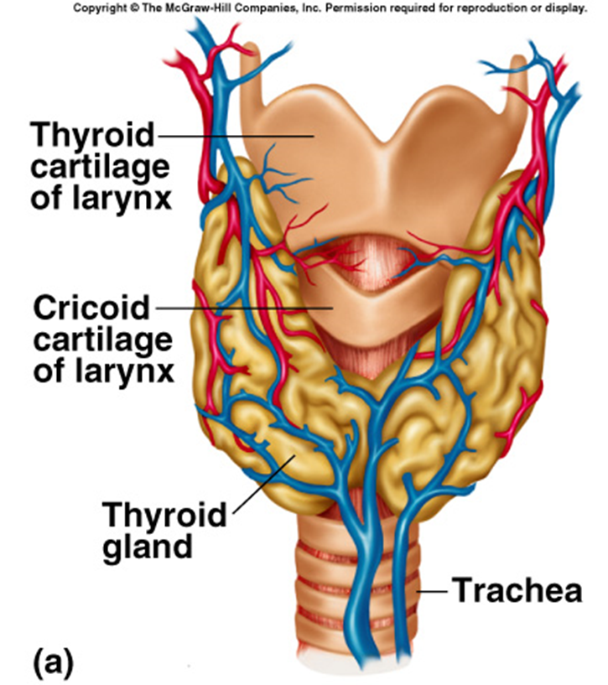
Thyroid hormone (TH) is actually two iodine-containing amine hormones, thyroxine, or T4, and triiodothyronine or T3.
T4 is the major hormone secreted by the thyroid follicles.
Most T3 is formed at the target tissues by conversion of T4 to T3.
Through the activation of genes, thyroid hormones (T4 and T3)
Stimulates protein synthesis.critical for normal skeletal and nervous system development and maturation and for reproductive capabilities.
Increasing basal metabolic rate and body heat production
Through this action, thyroxine (after it is converted into triiodothyronine,T3 ) elevates the basal metabolic rate ( BMR), which is the resting rate of calorie expenditure by the body.
Calcitonin
Inhibits the activity of osteoclasts, the bone cells that promote dissolution of the calcium phosphate crystals of bone. It also stimulates the urinary excretion of Ca+2 by the kidneys.
These actions would lower the blood Ca+2 concentrations and thus antagonize the effects of parathyroid hormone.
However, whereas parathyroid hormone and vitamin D are necessary for Ca+2 homeostasis, calcitonin is believed to have negligible importance in normal human physiology.
Parathyroid Glands
Embedded in the lateral lobes of the thyroid gland.
Parathyroid hormone (PTH): Only hormone secreted by the parathyroid glands. Single most important hormone in the control of blood [Ca2+]. Stimulated by decreased blood [Ca2+].
Promotes rise in blood [Ca2+] by acting on bones, kidney and intestines.
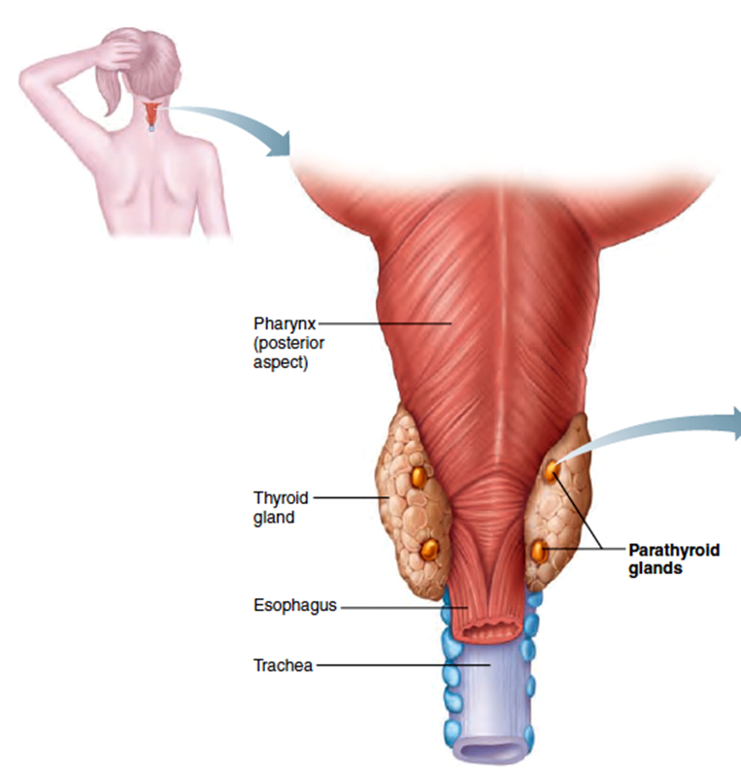

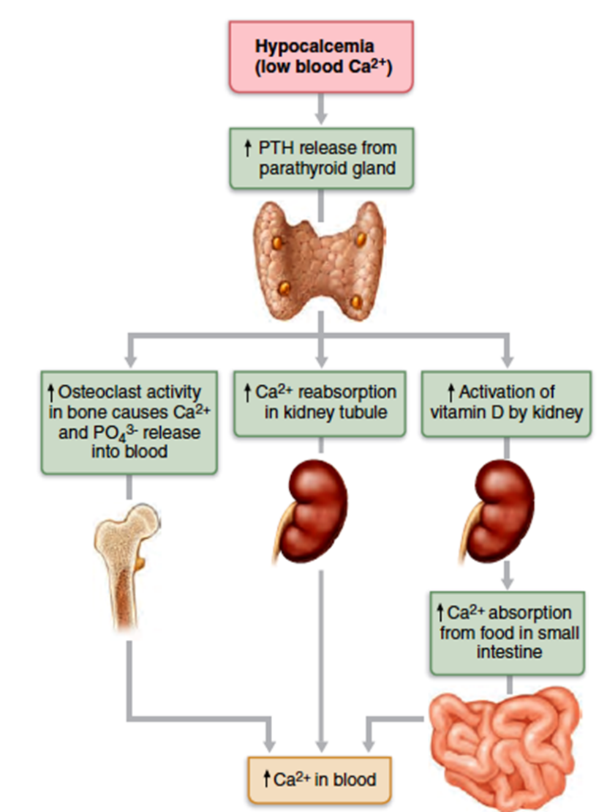
Pancreatic Islets (Islets of Langerhans)
Beta cells secrete insulin. Stimulus is increase in blood [glucose]. Promotes entry of glucose into cells. Converts glucose to glycogen and fat primarily the skeletal muscles, liver, and adipose tissue.
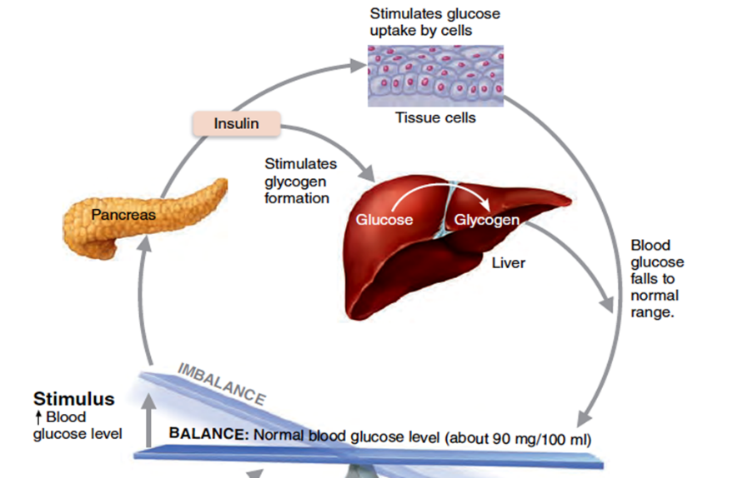
Alpha cells
Secrete glucagon. Stimulus is decrease in blood [glucose]. Stimulates glycogenolysis, lipolysis & ketogenesis (the formation of ketone bodies from free fatty acids by the liver).
These free fatty acids and ketone bodies serve as energy sources for cell respiration during times of fasting.
The Gonads and Placenta
The male and female gonads produce steroid sex hormones.
The paired ovaries produce, besides producing ova, or eggs, several hormones, most importantly estrogens and progesterone.
Alone, the estrogens are responsible for maturation of the reproductive organs and the appearance of the secondary sex characteristics of females at puberty.
Acting with progesterone, estrogens promote breast development and cyclic changes in the uterine mucosa (the menstrual cycle).
The male and female gonads produce steroid sex hormones.
The male testes produce sperm and male sex hormones, primarily testosterone.
During puberty, testosterone initiates the maturation of the male reproductive organs and the appearance of secondary sex characteristics and sex drive.
In addition, testosterone is necessary for normal sperm production and maintains the reproductive organs in their mature functional state in adult males.
The placenta is a temporary endocrine organ.
Besides sustaining the fetus during pregnancy, it secretes several steroid and protein hormones that influence the course of pregnancy.
Placental hormones include estrogens and progesterone (hormones more often associated with the ovary), and human chorionic gonadotropin (hCG).

