Ethical & Legal Issues of Mental Health Nursing

Definitions
Ethics: is the science that deals with the rightness and wrongness of actions.
Bioethics: is the term applied to these principles when they refer to concepts within the scope of medicine, nursing, and allied health.
Moral behavior: is defined as conduct that results from serious critical thinking about how individuals ought to treat others. Moral behavior reflects the way a person interprets basic respect for other persons, such as the respect for autonomy, freedom, justice, honesty, and confidentiality.
Values: are ideals or concepts that give meaning to the individual's life.
Values clarification: is a process of self-exploration through which individuals identify and rank their own personal values. This process increases awareness about why individuals behave in certain ways. Values clarification is important in nursing to increase understanding about why certain choices and decisions are made over others and how values affect nursing outcomes.
A right: Are a valid, legally recognized claim or entitlement, encompassing both freedom from government interference or discriminatory treatment and an entitlement to a benefit or service.
Ethical dilemma: is a situation that requires an individual to make a choice between two equally unfavorable alternatives.

Theoretical Perspectives
An ethical theory is a moral principle or a set of moral principles that can be used in assessing what is morally right or morally wrong. These principles provide guidelines for ethical decision making.
There are many ways to classify the theories of ethics. Some theories are: classical theory (ex. Hedonism), modern analytical theory (ex. Naturalism), Western & Eastern theories (ex. Utilitarianism), and other theories such as Islamic ethics, Buddhist ethics, and Hindu ethics.
One additional way to classify theories of ethics is to consider them consequential or non-consequential as follows

- Consequential theories are those that look at the consequences of acts. They claim that an action is right to the extent that it produces good consequences and wrong to the extent that is produces bad consequences.
-Non-consequential theories are those theories that maintain that certain acts are right and others are wrong because they have or do not have right-making characteristics.

Ethical Dilemmas
Ethical dilemmas arise when no explicit reasons exist that govern an action. Ethical dilemmas generally create an overwhelming emotional response. Often the reasons supporting each side of the argument for action are logical and appropriate. The actions associated With both sides are desirable in some respects and undesirable in others. In most situations, taking no action is considered an action taken.

to channels behavior in appropriate directions. The instincts are innate tendencies or inherited psychological dispositions. The major problem with this approach is that it has not actually explains behavior, it just describes it.

2. Drive Theory (Push theory)
According to the drive theory of motivation, individuals are motivated to achieve certain actions so as to lessen the internal tension and stress that is caused by unmet needs. For example, an individual might be motivated to drink a glass of water in order to decrease the internal state of thirst.
This theory is useful in explaining behaviors that have a strong biological component, such as hunger or thirst. The problem with the drive theory of motivation is that these behaviors are not always motivated purely by physiological needs. For example, people often eat even when they are not really hungry.

3. Arousal Theory (Optimal Stimulation as Motivators)
The arousal theory of motivation suggests that people take certain actions to either decrease or increase levels of arousal. When arousal levels get too low, for example, a person might watch and exciting movie or go for a jog. When arousal levels get too high, on the other hand, a person would probably look for ways to relax such as meditating or reading a book. According to this theory, we are motivated to maintain an optimal level of arousal, although this level can vary based on the individual or the situation.
4. Incentive Theory (Pull theory)
The incentive theory suggests that individuals are motivated to do things because of external rewards and valued external goals. For example, people might be motivated to go to work each day for the monetary reward of being paid. Behavioral learning concepts such as association and reinforcement play an important role in this theory of motivation.

Humanistic Theory (Human Potential as a Motivator)

Humanistic theories of motivation are based on the idea that people also have strong cognitive reasons to perform various actions. This is famously illustrated in Abraham Maslow's hierarchy of needs (Figure: 1), which presents different motivations at different levels. First, people are motivated to fulfil basic biological needs for food and shelter, as well as those of safety, love and esteem. Once the lower level needs have been met, the primary motivator becomes the need for self-actualization, or the desire to fulfil one's individual potential.

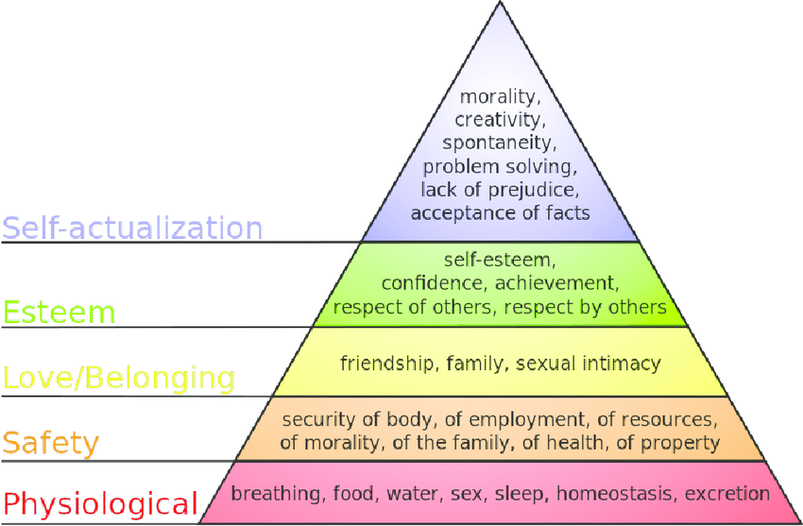

Nurses' implication of motives
Understanding motives in the patient help the nurse in the following ways:
1. To recognize motives behind the behavior of the patient;
2. To recognize patient's needs and desires;
3. To build a good relationship between the patient and health team members.
4. To provide priority care;
5. To satisfy patient's needs; and
6. To promote healing and health of the patient.

