Psychiatric mental health nursing

Part 2

Neurobiological and psychosocial theories

By
Mohammed Abbas Abdulsada

What is neurobiological psychology?
Also referred to as biological psychology, biopsychology, psychobiology, or neuroethology. Researchers in this field study how the central nervous system translates biologically relevant stimuli into natural behavior.
What is the neurobiological theory of language development?
The language bioprogram hypothesis proposes that humans have an innate, cognitive grammatical structure allowing them to develop and understand language. According to this theory, this system is embedded in human genetics and underpins the basic grammar of all languages.

psychoanalytic theory (Freud)
In simple terms, Sigmund Freud's theory suggests that human behavior is influenced by unconscious memories, thoughts, and urges. This theory also proposes that the psyche comprises three aspects: the id, ego, and superego. The id is entirely unconscious, while the ego operates in the conscious mind. The superego operates both unconsciously and consciously.
theory of psychosocial development (Erikson)
Erikson maintained that personality develops in a predetermined order through eight stages of psychosocial development, from infancy to adulthood. During each stage, the person experiences a psychosocial crisis that could positively or negatively affect personality development.
For Erikson (1958, 1963), these crises are psychosocial because they involve the psychological needs of the individual (i.e., psycho) conflicting with the needs of society (i.e., social).

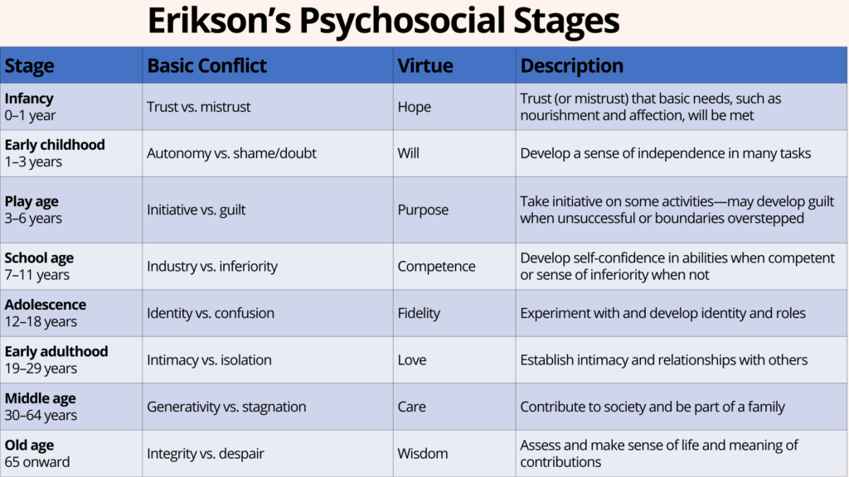

Adler’s theory
Adlerian theory purports that humans are social beings and therefore all behavior is socially embedded and has social meaning (Watts, 2000b). Adler emphasized the importance of relationships and being connected to others, including the larger community in which people reside.
Adlerian theory is built around seven key concepts, including unity of the individual, goal orientation, self-determination and uniqueness, social context, the feeling of community, mental health, and treatment. Adlerian therapy focuses on addressing patients' feelings of discouragement and inferiority.
What is the main goal of Adlerian theory?
Adlerian theory is a holistic approach to psychology that emphasizes the importance of overcoming feelings of inferiority and gaining a sense of belonging in order to achieve success and happiness.

Interpersonal theory

What is the concept of interpersonal theory?
the theory that personality development and behavior disorders are related to and determined by relationships between persons.

Harry Stack Sullivan's Interpersonal Psychodynamic
Theory Develops in response to negative feedback with feelings of discomfort, displeasure, and distress. The “Bad Me” creates anxiety. Not Me: the aspects of self that are so anxiety-provoking that the person does not consider them a part of the person.

Humanistic theory

Maslow's theory explained that every person is born with a set of basic needs: (1) physiological, (2) safety (3) belongingness or love, (4) self-esteem, and (5) self-actualization.

The basic beliefs of humanism include that people are generally good, have almost limitless potential, and all persons are unique individuals.

Maslow's humanistic theory came about as an alternative to psychoanalysis and behaviorism beliefs. The former espouses that people are mostly controlled by various urges they experience, while the latter believes that punishments and rewards are the root cause of most human deportment.

