Anemia (II)

Macrocytic anemia

Macrocytosis is a term used to describe erythrocytes that are larger than normal, typically when mean cell volume (MCV) is greater than 100 fL. Macrocytosis can occur at any age, but it is more common in older age groups because the causes of macrocytosis are more prevalent in older persons.

The most common cause of macrocytic anemia is megaloblastic anemia, which is associated with impaired DNA synthesis. Although DNA synthesis is impaired, RNA synthesis is unaffected, leading to accumulation of cytoplasmic components in a slowly dividing cell.
This results in a larger-than-normal cell. A significant number of erythroblasts in bone marrow fail to get full maturation and are destroyed within the bone marrow itself (ineffective erythropoiesis).Megaloblastic anemia is differentiated from other causes of macrocytic anemia by its specific bone marrow changes (megalobalsts which are large nucleated RBCs precursors) that are not usually present in non-megaloblastic causes of macrocytic anemia.

Etiology
A- Vitamin B12 deficiency
This may occur due to:
1- Pernicious anemia
2- Gastrectomy
3- Chronic malabsorption
B- Folate deficiency
This may occur due to:
1- Dietary deficiency
2- Increase requirement (as in pregnancy)
3- Alcoholism
4- Chronic malabsorption

C- Drug induced
Examples include:
1- Trimethoprim
2- Contraceptive pills
3- Methotrexate

Signs & symptoms
Symptoms of megaloblastic anemia are similar to that in other types of anemia but glossitis is more prominent in case of folate or B12 deficiency. The severity of anemia is usually higher than that of iron deficiency anemia.
Other symptoms or signs may give a clue to cause of anemia, such as chronic diarrhea, arthritis, or cachexia.

Pernicious anemia
Pernicious anemia is an autoimmune disorder in which the gastric mucosa is atrophic, with loss of parietal cells causing intrinsic factor deficiency.
In the absence of intrinsic factor, absorption of dietary vitamin B12 is extremely diminished
(less than 1%).
Absorption of vitamin B12 can be summarized in the following diagram:
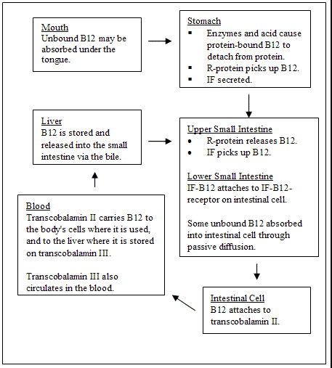
Pernicious anemia has an incidence of 25/100 000 population over the age of 40 years in developed countries. It is well known that it is more common in individuals with other autoimmune disease (Hashimoto’s thyroiditis, Graves’ disease, vitiligo, hypoparathyroidism or Addison’s disease) or a family history of these disorders or pernicious anemia.

Clinical manifestation and laboratory findings of Pernicious anemia
1- megaloblastic anemia
2- pancytopenia (anemia, leukopenia and thrombocytopenia)
3- peripheral neuropathy
4- psychosis
5- depression
6- possible increased risk of myocardial infarction and stroke

Diagnosis
-The finding of anti-intrinsic factor antibodies in the context of B12 deficiency is diagnostic of pernicious anemia without the need for further investigation.
-Antiparietal cell antibodies are present in over 90% of cases but are also present in 20%
of normal females over the age of 60 years
-Patients with low B12 levels and negative anti-intrinsic factor antibodies should have a Schilling test performed to determine whether there is B12 malabsorption, and if so, the cause of this malabsorption whether IF deficiency or other disorders in the gut.

Treatment
Vitamin B12 deficiency is treated with hydroxycobalamin 1000 μg i.m. in five doses 2 or 3 days apart, followed by maintenance therapy of 1000 μg every 3 months for life.
The reticulocyte count will peak by the 5th–10th day after therapy and may be as high as 50%. The hemoglobin will rise by 10 g/L every week. The response of the marrow is associated with a fall in plasma potassium levels and rapid depletion of iron stores.
A sensory neuropathy may take 6–12 months to correct; long-standing neurological damage may not improve.

Folate Deficiency
In contrast to vitamin B12, total body stores of folate are small and deficiency can occur in a matter of weeks. Many causes of folate deficiency are present including:
1- dietary deficiency
2- celiac disease and malabsorption in general
3- certain drugs including methotrexate and contraceptive pills
4- increased demands as in pregnancy and hemolytic anemia

Pregnancy-induced folate deficiency is the most common cause of megaloblastic anemia world-wide. Folate deficiency during early weeks of pregnancy increases the risk of fetal neural tube defects.
There is some evidence that supraphysiological supplementation (400 mg/day) can reduce the risk of coronary and cerebrovascular disease by reducing plasma homocysteine levels.

In case of folate deficiency, the picture of peripheral blood and bone marrow examination are very similar to B12 deficiency. For specific diagnosis, low serum folate level or RBC folate should be confirmed.
Oral folic acid 5 mg daily for 3 weeks will treat acute deficiency and 5 mg once weekly is adequate maintenance therapy.
Hemolytic anemia
The normal red cell lifespan of 120 days may be shortened by a variety of abnormalities.
The bone marrow may increase its output of red cells six- to eight-fold by:
(1) increasing the proportion of red cells produced.
(2) expanding the volume of active marrow
(3) releasing reticulocytes prematurely.

Hemolysis is the premature destruction of RBCs in the reticuloendothelial system (extrinsic hemolysis) or in blood vessels (intrinsic hemolysis). An elevated reticulocyte count in the setting of anemia signals a compensatory response by a normal marrow to premature loss of erythrocytes. The only other condition that causes anemia with reticulocytosis is acute bleeding.

Pathophysiology
There are two mechanisms of hemolysis:
A- Intravascular hemolysis: RBCs are destructed within blood vessels and released their contents to the circulation. RBCs are directly damaged by damaged endothelium, complement fixation and activation on the cell surface, and infectious agents.
B- Extravascular hemolysis: more common, involves removal and destruction of red blood cells by the macrophages of the spleen and liver.

Hemolytic anemias are classified into:
I- Acquired
1- Immune-mediated: Antibodies to red blood cell surface antigens
2- Microangiopathic: Mechanical disruption of red blood cell in circulation
3- Infection: Malaria, Clostridium infections
II- Hereditary
1- Enzymopathies: G6PD deficiency
2- Membranopathies: Spherocytosis
3- Hemoglobinopathies: Thalassemia and sickle cell disease

History and Physical Examination
1- anemia
2- jaundice
3- dark colored urine
4- hepatosplenomegaly
5- leg ulcer

Laboratory findings
1- normochromic normocytic anemia
2- elevated reticulocytes count
3- elevated total serum bilirubin, mainly the unconjugated form.
4- elevated serum lactate dehydrogenase (LDH)

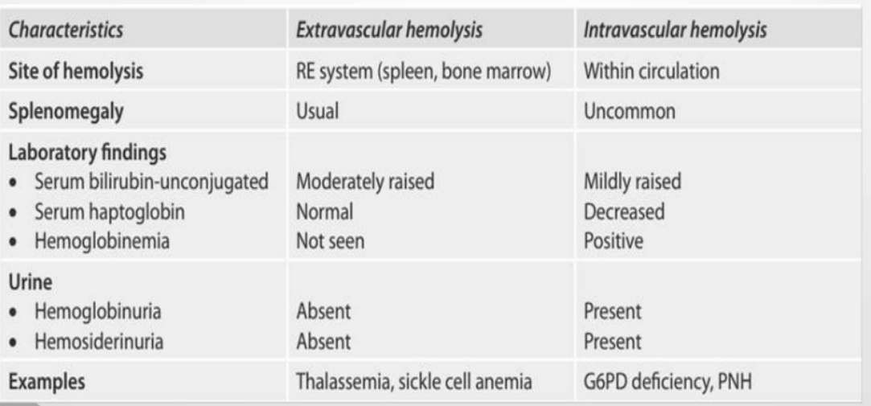
A comparison between extravascular & intravascular hemolysis

Modalities of treatment
1- Folic acid
Prophylactic folic acid is indicated because active hemolysis can consume folate and cause megaloblastosis.
2- Steroid
Corticosteroids are indicated in autoimmune hemolytic anemia.
3- Intravenous immunoglobulin G:
Intravenous immunoglobulin G (IVIG) has been used for patients with autoimmune hemolytic anemia, but only a few patients have responded to this treatment, and the responses have been transient.
4- Transfusion Therapy
One should avoid transfusions unless absolutely necessary. However, transfusions may be essential for patients with angina or a severely compromised cardiopulmonary status. It is best to administer packed red blood cells slowly to avoid cardiac stress.
5- Discontinuing Medications
Penicillin and other agents that can cause immune hemolysis should be discontinued in patients who develop hemolysis. The following is a partial list of medications that can cause immune hemolysis:
- Penicillin
- Cephalothin
- Ampicillin
One should discontinue oxidant medications such as sulfa drugs in patients with G-6-PD deficiency or those who have unstable hemoglobins.
6- Splenectomy
Splenectomy may be the first choice of treatment in some types of hemolytic anemia, such as hereditary spherocytosis. In other cases, such as in AIHA, splenectomy is recommended when other measures have failed.

^^^^^^^^^^^^^^^^^^^^^^^^^^^^^^^^^^^^^^^^^^^^^^^^^^^^^^^^^^^^^^^^^^^^^^^^^^^^^^^^^^^^^^^^^^^^^^^^^^^^^^^^^^^^^^^^^^^^^^^^^^^^^^^^^^^^^^^^^^^^^^^^^^^^^^^^^^^^^^^^^^^^^^^^^^^^^^^^^^^^^^^^^^^^^^^^^^^^^^^^^^^^^^^^^^^^^^^^^^^^^^^^^^^^^^^^^^^^^^^^^^^^^^^^^^^^^^^^^^

