Common Valvular Heart Diseases

Valvular heart diseases represent a major health problem all over the world. In the undeveloped countries, rheumatic fever remains a major cause of valvular heart disease, while degenerative disease is the most common etiology in the developed countries.
Obviously, the prevalence of valvular heart diseases increases with age, to as high as 13.2% in those 75 years of age and older. The aortic and mitral valves are by far the most commonly affected valves.
Valvular heart disease is characterized by damage to or a defect in one of the four heart valves: the mitral, aortic, tricuspid or pulmonary.
Physiologically, mitral valve controls the flow of blood from the left atrium and left ventricle; tricuspid valve controls the blood flow from right atrium and right ventricle. The pulmonary valve controls the flow of blood from the heart to the lungs, and the aortic valve governs blood flow between the heart and the aorta, and thereby the blood vessels to the rest of the body.
The basic function of the valve is to ensure the flow of blood with the proper force and proper direction at the proper time. In case of valvular heart disease, a certain valve may become too narrow and hardened (stenotic valve) and failed to be fully opened, while a diseased valve might be unable to close completely (incompetent).
According to the above pathophysiology, a stenotic valve forces blood to back up in the adjacent heart chamber, while an incompetent valve allows blood to leak back into the chamber it previously exited. Consequently, cardiac muscle enlarges and becomes thickened losing its elasticity and efficiency. At the same time, blood in cardiac chambers has higher tendency to clot leading to increased risk of stroke and pulmonary embolism.

Rheumatic heart disease

Rheumatic heart disease is cardiac inflammation and scarring secondary to an autoimmune reaction to infection with group A streptococci. It might present in the acute stage, in form of pancarditis, involving inflammation of the myocardium, endocardium, and epicardium. Some patients presented with chronic disease manifested by valvular fibrosis, resulting in stenosis and/or insufficiency.

Rheumatic fever is rarely seen before age 5 years and after age 25 years; it is most frequently observed in children and adolescents. The highest incidence is observed in children aged 5-15 years and in underdeveloped or developing countries.

Rheumatic valvular heart disease was previously regarded as the most common cause of valve replacement and repair surgeries, but this form of valvular heart disease is relatively uncommon nowadays.

Acute rheumatic fever
As previously mentioned, acute rheumatic fever usually affects children (most commonly between 5 and 15 years) or young adults, and has become very rare in Western Europe and North America, but still regarded as the most common cause of acquired heart disease in childhood and adolescence.
The condition is triggered by an immune-mediated delayed response to infection with specific strains of group A streptococci, which have antigens that may cross-react with cardiac myosin and sarcolemmal membrane protein.
Antibodies produced against the streptococcal antigens cause inflammation in the endocardium, myocardium and pericardium, as well as the joints and skin.

Clinical features
Acute rheumatic fever is a multisystem disorder that usually presents with:
fever, anorexia, lethargy and joint pain, 2–3 weeks after an episode of streptococcal pharyngitis.
However, there might be no history of sore throat. Arthritis occurs in approximately 75% of patients.
Other features include rashes, carditis and neurological changes.

The diagnosis, made using the revised Jones criteria which is based upon two or more major manifestations, or one major and two or more minor manifestations, along with evidence of preceding streptococcal infection.

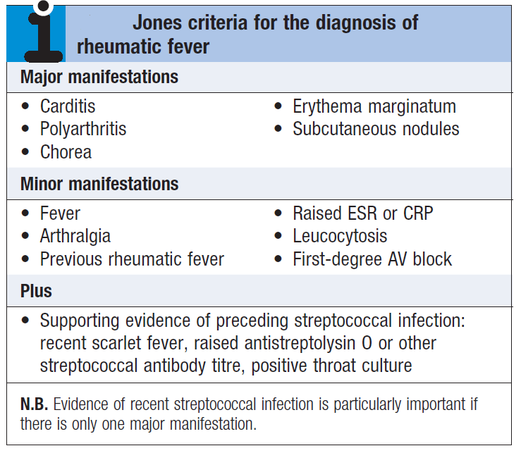

Carditis: which can be presented as:
- New onset of cardiac murmur, indicating valvular involvement.
- Chest pain indicating pericarditis.
- Heart failure.
- Arrhythmia
Arthritis: which is typically presented as an acute painful asymmetric and migratory inflammation
of the large joints typically affects the knees, ankles, elbows and wrists.
Skin: presented as subcutaneous nodules or erythema marginatum.

Investigations

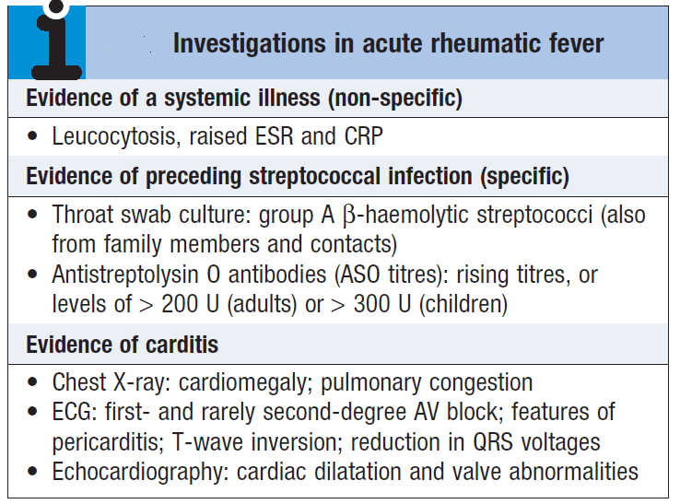

Management of acute rheumatic fever
- A single dose of benzyl penicillin (1.2 million U IM) (erythromycin or a cephalosporin can
be used for penicillin allergic patient for 10 days).
- Aspirin
This usually relieves the symptoms of arthritis rapidly and a response within 24 hours helps confirm the diagnosis. 60 mg/kg body weight/day, divided into six doses can be used as initial dose. Aspirin should be continued until the ESR has fallen, and then gradually tailed off.
- Corticosteroids
These produce more rapid symptomatic relief than aspirin and are indicated in cases with carditis or severe arthritis.
- Bed rest and supportive therapy.
Other clinical manifestations, such as heart failure or arrhythmia, should be treated accordingly.

Secondary prevention
Patients are susceptible to further attacks of rheumatic fever if another streptococcal infection occurs, and long-term prophylaxis with penicillin should be given as benzathine penicillin (1.2 million U IM monthly).
Treatment should be continued as follows:
Type | Duration after last attack
Rheumatic fever with carditis and residual heart disease (persistent valvular disease) | 10 years or until age 40 years (whichever is longer); lifetime prophylaxis may be needed
Rheumatic fever with carditis but no residual heart disease (no valvular disease) | 10 years or until age 21 years (whichever is longer)
Rheumatic fever without carditis | 5 years or until age 21 years (whichever is longer)

Long-term antibiotic prophylaxis prevents another attack of acute rheumatic fever but does not protect against infective endocarditis.

Chronic rheumatic heart disease
Chronic valvular heart disease develops in at least half of those affected by rheumatic fever with carditis. Two thirds of cases occur in women. Some episodes of rheumatic fever pass unrecognised and it is only possible to elicit a history of rheumatic fever or chorea in about half of all patients with chronic rheumatic heart disease.
The mitral valve is affected in more than 90% of cases; the aortic valve is the next most frequently involved, followed by the tricuspid and then the pulmonary valve. Isolated mitral stenosis accounts for about 25% of all cases.
The predominant pathology in chronic rheumatic heart disease is progressive fibrosis. Heart failure and conducting disorders are relatively common.
Most patients are presented with dyspnea on exertion, pitting edema, cough, chest pain and other non-specific symptoms and signs.
Patients with mild symptoms are treated medically while surgical treatment is mandatory in more severe symptoms.
Antibiotic prophylaxis against infective endocarditis is no longer routinely recommended.

Infective Endocarditis (IE)

IE is conventionally defined as an infection of the endocardial surface of the heart which may include: heart valves (native or prosthetic), the mural endocardium, or a septal defect.
IE usually leads to severe valvular insufficiency, which in turn may lead to intractable congestive heart failure and myocardial abscesses. If left untreated, IE is almost inevitably fatal. The causative organism is usually a bacterium, but may be a rickettsia, chlamydia or fungus.
Infective endocarditis typically occurs at sites of preexisting endocardial damage, but infection with particularly virulent or aggressive organisms (e.g. Staphylococcus aureus) can cause endocarditis in a previously normal heart valves.
Over three-quarters of cases are caused by streptococci or staphylococci. The viridans group of streptococci (Streptococcus mitis, Strep. sanguis) are commensals in the upper respiratory tract that may enter the blood stream on chewing or teeth-brushing, or at the time of dental treatment, and are common causes of subacute endocarditis.

Clinical features
The patient may present with acute or subacute endocarditis.
- Symptoms commonly are vague, emphasizing constitutional complaints:
(Fever and chills are the most common symptoms; anorexia, weight loss, malaise, headache, myalgias, night sweats, shortness of breath, cough, or joint pains are common complaints as well).
- Complaints may focus on primary cardiac effects:
(congestive heart failure due to valvular insufficiency)
- Secondary embolic phenomena.

Acute IE is a much more aggressive disease than subacute IE. The patient notices an acute onset of high-grade fevers and chills and a rapid onset of congestive heart failure. History of valvular heart disease is extremely important for case suspicion.
Physical signs
- Heart murmur.
- Petechiae - Common but nonspecific finding.
- Subungual (splinter) hemorrhages - Dark red linear lesions in the nailbeds
- Osler nodes - Tender subcutaneous nodules usually found on the distal pads of the digits
- Janeway lesions - Nontender maculae on the palms and soles.

- Roth spots - Retinal hemorrhages with small, clear centers; rare and observed in only 5% of patients.
- Splenomegaly

Investigations
- Blood culture is the crucial investigation because it may identify the infection and guide antibiotic therapy. Three to six sets of blood cultures should be taken prior to commencing therapy. The first two specimens will detect bacteraemia in 90% of culture-positive cases.
- Echocardiography is key for detecting and following the progress of vegetations, for assessing valve damage.
Diagnosis of infective endocarditis is done using modified Duke criteria.

Management
Mortality rate of IE is 20% or even higher in certain conditions.
A multidisciplinary approach, with cooperation between the physician, surgeon and microbiologist, increases the chance of a successful outcome.
Any source of infection should be removed as soon as possible; for example, a tooth with an apical abscess should be extracted.

Prevention
Until recently, antibiotic prophylaxis was routinely given to people at risk of infective endocarditis undergoing interventional procedures. However, as this has not been proven to be effective and the link between episodes of infective endocarditis and interventional procedures has not been demonstrated, antibiotic prophylaxis is no longer offered routinely for defined interventional procedures.

Dental Procedures
For patients with high cardiac risk, antibiotic prophylaxis is recommended for all dental procedures that involve manipulation of gingival tissue or the periapical region of teeth or perforation of the oral mucosa.

The following dental procedures do not require endocarditis prophylaxis:
- Routine anesthetic injections through noninfected tissue
- Taking dental radiographs
- Placement of removable prosthodontic or orthodontic appliances
- Adjustment of orthodontic appliances
- Placement of orthodontic brackets
- Shedding of deciduous teeth
- Bleeding from trauma to the lips or oral mucosa

Antibiotic prophylaxis is indicated for the following high-risk cardiac conditions:
- Prosthetic cardiac valve
- History of infective endocarditis
- Congenital heart disease (CHD) (except for the conditions listed, antibiotic prophylaxis is no longer recommended for any other form of CHD): (1) unrepaired cyanotic CHD, including palliative shunts and conduits; (2) completely repaired congenital heart defect with prosthetic material or device, whether placed by surgery or by catheter intervention, during the first 6 months after the procedure; and (3) repaired CHD with residual defects at the site or adjacent to the site of a prosthetic patch or prosthetic device (which inhibits endothelialization)
- Cardiac transplantation recipients with cardiac valvular disease

Antibiotic Prophylaxis Regimens
All doses shown below are administered once as a single dose 30-60 min before the procedure.
Standard general prophylaxis:
Amoxicillin
Adult dose: 2 g PO
Pediatric dose: 50 mg/kg PO; not to exceed 2 g/dose
Unable to take oral medication:
Ampicillin
Adult dose: 2 g IV/IM
Pediatric dose: 50 mg/kg IV/IM; not to exceed 2 g/dose

Allergic to penicillin:
Clindamycin
Adult dose: 600 mg PO
Pediatric dose: 20 mg/kg PO; not to exceed 600 mg/dose
Allergic to penicillin:
Cephalexin or other first- or second-generation oral cephalosporin in equivalent dose (do not use cephalosporins in patients with a history of immediate-type hypersensitivity penicillin allergy, such as urticaria, angioedema, anaphylaxis)
Adult dose: 2 g PO
Pediatric dose: 50 mg/kg PO; not to exceed 2 g/dose
Azithromycin or clarithromycin
Adult dose: 500 mg PO
Pediatric dose: 15 mg/kg PO; not to exceed 500 mg/dose

^^^^^^^^^^^^^^^^^^^^^^^^^^^^^^^^^^^^^^^^^^^^^^^^^^^^^^^^^^^^^^^^^^^^^^^^^^^^^^^^^^^^^^^^^^^^^^^^^^^^^^^^^^^^^^^^^^^^^^^^^^^^^^^^^^^^^^^^^^^^^^^^^^^^^^^^^^^^^^^^^^^^^^^^^^^^^^^^^^^^^^^^^^^^^^^^^^^^^^^^^^^^^^^^^^^^^^^^^^^^^^^^^^^^^^^^^^^^^^^^^^^^^^^^^^^^^^^^^^

