Biochemistry is the branch of science that deals with studying the biological processes at the cellular and molecular level using chemistry. It is useful in explaining the chemical reactions that take place during the biological activities such as growth, reproduction, digestion, absorption and excretion. The main subjects that will be discussed in the following lectures are:
- Metabolism of carbohydrates
- Metabolism of lipids
- Amino acids
- Nitrogen metabolism
- Enzymes
- Hormones
- Vitamins
- Minerals and trace elements
- Water and electrolytes
- Nucleic acids
- Liver function

One of the most widely used term in biochemistry is metabolism, so first of all this term should be clarified. Metabolism is a term used to define the interconversion of chemical substances within the body, the possible pathways taken by certain molecules, their relationships, and the processes that regulate the flow of metabolites through these pathways.

Traditionally, metabolic pathways are classified into three categories:
(1) The anabolic pathways: these are involved in the conversion of smaller precursors into larger and more complex substances (the synthesis of protein from amino acids). Anabolic pathways are endothermic (require energy or heat from their environment).
2) The catabolic pathways: these are involved in the degradation of larger molecules, producing energy (ATP). These reactions are exothermic.
(3) The amphibolic pathways: these serve both anabolic and catabolic processes. A well-known example of an amphibolic pathway is Krebs cycle, which involves both the catabolism of carbohydrates and fatty acids and the synthesis of anabolic precursors for amino-acid synthesis (e.g. oxaloacetate and a ketoglutarate).
Understanding the normal metabolism is vital for a proper understanding of the abnormalities that cause diseases. In certain circumstances, significant changes might occur in the normal metabolism as an adaptation to a specific condition such as starvation, fasting, and exercise, as well as lactation and pregnancy. On the other hand, abnormal metabolism may be caused by nutritional deficiency abnormal hormonal secretion, enzyme deficiency or the actions of toxins or drugs.
There is a persistent requirement for energy throughout the day to maintain the normal function of organs within the human body. The amount of energy required depends on many factors including body surface area, age, physical activity and many other factors. The main source of the required energy is the catabolism of macromolecules present in digested food which are carbohydrates, lipids and proteins. The most important one of these macromolecules as a source of energy is the carbohydrates. All the products of digestion are metabolized to a common product, acetyl-CoA, which is then oxidized by the citric acid cycle.

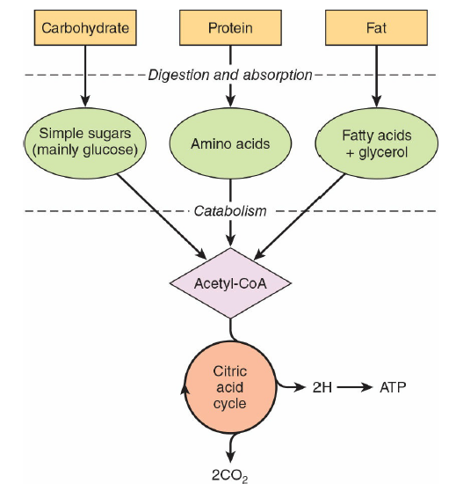

CARBOHYDRATES METABOLISM

Carbohydrates, including sugar and starch, are widely distributed in plants and animals. They are organic substances containing C, H and O usually in the ratio of 1:2:1. They perform multiple functions, such as being structural components as in RNA and DNA (ribose and deoxyribose sugars) and providing a source of energy (glucose).
Carbohydrates are aldehyde or ketone derivatives of polyhydroxy (more than one OH group) alcohols, or compounds that yield these derivatives on hydrolysis.
Sugar is a carbohydrate that is soluble in water, often has a name ending with ( _ose ) such as glucose, maltose, etc.
The main two types of sugars are:
- Monosaccharides:
They are also called simple sugars, being soluble in water, their common examples include:
1. Fructose
2. Glucose
3. Galactose
B- Disaccharides:
Composed of 2 monosaccharides joined together, soluble in water, must be broken down to monosaccharides before being absorbed within the digestive system, common examples:
1. sucrose: glucose + fructose
2. lactose: glucose + galactose
3. maltose: glucose + glucose

Oligosaccharides consist of 3-9 monosaccharides joined together, only partially digestible in the digestive system, present in some types of plants (onion, soya beans), useful for healthy digestion. Polysaccharides consist of polymers of chains of mono and disaccharides all joined together, tasteless, insoluble in cold water, and the main groups of polysaccharides are: - starch (in plants)
- dextrin
- cellulose
- pectin
- glycogen (in animals): which is a polymer of glucose units, stored in liver and muscles.

In summary, carbohydrates can be classified into
1. monosaccharides: include glucose, fructose and galactose.
2. disaccharides: include sucrose, maltose, and lactose
3. oligosaccharides: contain 3-9 simple sugars (monosaccharide), e.g. maltotriose (Glucose + Glucose + Glucose).
4.polysaccharides: these are polymeric carbohydrate molecules composed of long chains of monosaccharide units bound together by glycosidic linkages and on hydrolysis give the constituent monosaccharides or oligosaccharides.

Examples of homopolysaccharides
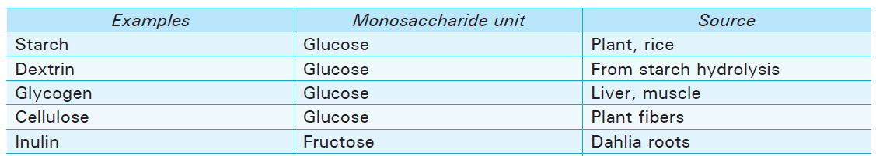

Regarding glucose, it is derived from:
(1) the breakdown of carbohydrates in the diet (grains, starchy vegetables, and legumes) or in body stores (glycogen).
(2) endogenous synthesis from protein or from the glycerol components of triglycerides.

When energy intake exceeds expenditure, the excess is converted to fat and glycogen for storage in adipose tissue and liver or muscle, respectively. When energy expenditure exceeds caloric intake, endogenous glucose formation occurs from the breakdown of carbohydrate stores and from noncarbohydrate sources (e.g., amino acids, lactate, and glycerol).
Insulin, glucagon, and epinephrine maintain the glucose concentration in the blood within a fairly narrow interval under diverse conditions (feeding, fasting, or severe exercise).

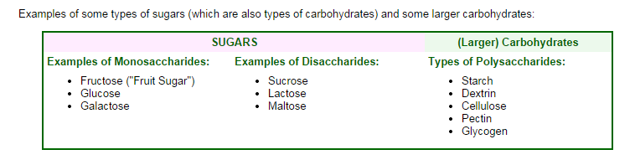

BIOCHEMICAL IMPORTANCE OF CARBOHYDRATE
1. Carbohydrates are important constituents of the cell structure in the form of glycolipid, glycoproteins, heparin, cellulose, starch and glycogen.
2. Carbohydrates serve as an important source and store of energy.
3. Carbohydrates play an important role in the metabolism of amino acids and fatty acids.
4. Lactose promotes the growth of desirable bacteria in the small intestine. It also increases calcium absorption.
5. They protect friction surfaces such as blood vessels, trachea, etc. against mechanical damage.
6. It plays an important role in maintaining osmotic and ionic regulation of the body.
7. It works as an intracellular cementing material.
8. It spares protein.
9. Heparin is a carbohydrate, which works as an anticoagulant in the body.

Digestion and absorption of carbohydrates
Polysaccharides and oligosaccharides must be hydrolyzed to their component monosaccharides before being absorbed. The digestion of starch begins with salivary amylase, but this activity is much less important than that of pancreatic amylase in the small intestine.
Two important groups of enzymes are essential for digestion of carbohydrates:
1- Amylase: converts polysaccharides into disaccharides (salivary &pancreatic amylase).
2- Disaccharidases: converts disaccharides into monosaccharides to be finally absorbed; disaccharidases are: maltase, sucrase, isomaltase and lactase.
Carbohydrate digestion is rapid and carbohydrate absorption occurs primarily in the upper small intestine. However, carbohydrate digestion and absorption can occur along the entire length of the small intestine and is shifted toward the ileum when the diet contains less readily digested carbohydrates.
The final products of the digestive action of the carbohydrates in human beings are glucose, fructose and galactose. It is important to mention that despite the absence of digestive enzymes in the stomach, the presence of HCl leads to hydrolysis of sucrose into fructose + glucose.

Monosaccharides
Only D-glucose and D-galactose are actively absorbed in the human small intestine. D-fructose is not actively absorbed but has a rate of diffusion greater than would be expected by passive diffusion.
The sodium-dependent glucose transporter is responsible for the active transport of glucose or galactose with an equimolar amount of sodium against a concentration gradient into the cytoplasm of the enterocyte. The complete mechanism of fructose absorption in the human intestine is not understood. When fructose is given alone in solution, 40-80% of subjects have malabsorption, and some subjects can absorb less than 15g fructose. Flatulence and diarrhea are common if doses of fructose over 50g are given by mouth. However, if fructose is given in combination with glucose or starch, fructose is completely absorbed, even in subjects who malabsorbs fructose alone.
Since fructose rarely occurs in the diet in the absence of other carbohydrates, fructose malabsorption is really only a problem for studies involving oral fructose loads.

Disaccharides
Intestinal brush border glucosidases (lactase, sucrose and, maltase) tend to be inducible. For example, a high sucrose intake will increase the rate of absorption due to the induction of intestinal sucrase activity. Lack of brush border glucosidases results in an inability to absorb specific carbohydrates. This occurs rarely, except for lactase deficiency which is common in non-Caucasian populations. The latter may be complete or partial and results in a reduced ability to digest and absorb lactose.

Metabolism of glucose
Glucose is the primary energy source for the human body. After absorption, the metabolism of glucose proceeds according to the body's requirements.
This metabolism results in :
(1) Energy production by conversion to carbon dioxide and water ( by glycolysis and citric acid cycle).
(2) Storage as glycogen in the liver or triglycerides in adipose tissue ( glycogenesis).
(3) Conversion to ketoacids, amino acids, or protein ( by pentose monophosphate pathway ).

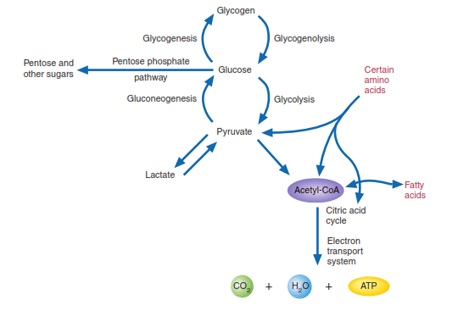

Major Pathways in Carbohydrate Metabolism
Inside the cells, glucose has 3 main pathways:
I- glycogenesis: when excess glucose is converted to its storage form, glycogen, by glycogenesis.
II- the pentose phosphate pathway: glucose can be converted to ribose-5-phosphate (a component of nucleotides) and NADPH (a powerful reducing agent)
III- production of energy: by glycolysis and further steps.

Production of energy from glucose:
Under aerobic conditions, this process occurs in 3 steps:
1- Glycolysis
In glycolysis, also referred to as the Embden-Meyerhof-Parnas pathway, each glucose molecule is split and converted into two units of pyruvate with the liberation of two ATP molecules. Glycolysis consists of 10 reactions, occurs in two stages:
Stage 1. Glucose is phosphorylated twice and cleaved to form two molecules of glyceraldehyde-3phosphate (G-3-P ), two ATP are consumed at this stage.
Stage 2. Glyceraldehyde-3-phosphate is converted to pyruvate. Four ATP and two NADH molecules are produced. Because two ATP were consumed in stage1, the net production of ATP per glucose molecule is 2.
The net products of glycolysis are: 2 pyruvate molecules, 2 ATP, 2NADH
2- Pyruvate oxidation and citric acid cycle
Pyruvate, the other product of glycolysis, is still an energy-rich molecule, which can yield a substantial amount of ATP. This depends on the cell type and the availability of oxygen.
- Under aerobic conditions:
Pyruvate is converted into acetyl-CoA which in turn enters the citric acid cycle(Krebs cycle), to be oxidized, with the formation of CO2 and the reduced molecules NADH and FADH2.
Therefore, the total numbers of molecules generated in the oxidation of pyruvate and the Krebs cycle is:
8 NADH - - 2 FADH₂ -2 ATP - 6 CO₂
3- The electron transport system,
A series of oxidation-reduction reactions transfers electrons from NADH and FADH2 to O2 to form water. The energy that is released during electron transport is coupled to a mechanism that synthesizes ATP.
The net products of ATP in this step is 32 ATP:
Each NADH produced in Glycolysis is worth 2 ATP (2 x 2 = 4).
The NADH is worth 3 ATP, but it costs an ATP to transport the NADH into the mitochondria, so there is a net gain of 2 ATP for each NADH produced in glycolysis.
Each NADH produced in the conversion of pyruvate to acetyl COA and Krebs Cycle
is worth
3 ATP, (8 x 3 = 24)
Each FADH₂ is worth 2 ATP (2 x 2 = 4)
4 + 24 + 4 = 32
So, the net ATP production of aerobic respiration is 36

Under anaerobic conditions, further oxidation of pyruvate is continued. A number of cells and organisms compensate by converting this molecule to a more reduced organic compound and regenerating the NAD required for glycolysis to continue. This process of NAD regeneration is referred to as lactate fermentation.
In rapidly contracting muscle cells, the demand for energy is high, after the O2 supply is depleted, lactic acid fermentation provides sufficient NAD to allow glycolysis (with its low level of ATP production) to continue for a short time.
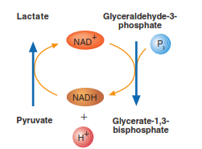

Net Engergy Production from Aerobic Respiration
Glycolysis: 2 ATP …… Krebs Cycle: 2 ATP
Electron Transport Phosphorylation: 32 ATP
Net Energy Production: 36 ATP

Net Engergy Production from anaerobic Respiration
only 2 atp + NAD

Cori cycle :
Refers to the metabolic pathway in which lactate produced by anaerobic glycolysis in the muscles moves to the liver and is converted to glucose, which then returns to the muscles and is metabolized back to lactate with ATP production.

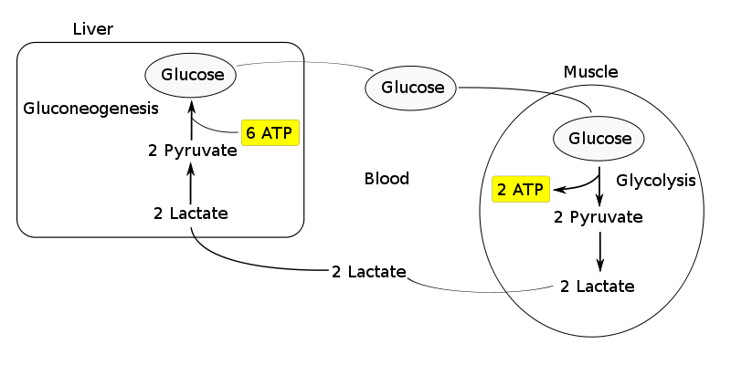
CORI CYCLE

GLUCONEOGENESIS
Gluconeogenesis, the formation of new glucose molecules from non-carbohydrate precursors, occurs primarily in the liver. Precursor molecules include lactate, pyruvate, glycerol, and certain keto acids (molecules derived from amino acids). Under certain conditions (i.e., metabolic acidosis or starvation) the kidney can make small amounts of new glucose. Between meals, adequate blood glucose levels are maintained by the hydrolysis of liver glycogen. When liver glycogen is depleted (e.g., owing to prolonged fasting or vigorous exercise), the gluconeogenesis pathway provides the body with adequate glucose. Brain and red blood cells rely exclusively on glucose as their energy source. Only D-glucose and D-galactose are actively absorbed in the human small intestine. D-fructose is not actively absorbed but has a rate of diffusion greater than would be expected by passive diffusion. Glucose-Alanine Cycle: convert amino acid to glucose

THE PENTOSE PHOSPHATE PATHWAY
The pentose phosphate pathway is an alternative metabolic pathway for glucose oxidation in which no ATP is generated. Its principal products are NADPH, a reducing agent required in several anabolic processes, and ribose-5-phosphate, a structural component of nucleotides and nucleic acids.

The pentose phosphate pathway occurs in the cytoplasm in two phases: oxidative and nonoxidative.
In the oxidative phase of the pathway, the conversion of glucose-6-phosphate to ribulose-5-phosphate is accompanied by the production of two molecules of NADPH. The nonoxidative phase involves the isomerization and condensation of a number of different sugar molecules. Three intermediates in this process that are useful in other pathways are ribose-5-phosphate, fructose-6-phosphate, and glyceraldehyde-3-phosphate. A substantial amount of the NADPH required for reductive processes (i.e., lipid biosynthesis) is supplied by the oxidative phase. For this reason, this pathway is most active in cells in which relatively large amounts of lipids are synthesized, (e.g., adipose tissue, adrenal cortex, mammary glands, and the liver). NADPH is a powerful antioxidant as well.

Role of different hormones in carbohydrate metabolism:
The carbohydrate metabolism is regulated & the normal blood sugar level maintained by a balance between the actions of insulin, glucocorticoids, growth hormones, adrenalin & thyroid hormones.
Insulin
- Insulin increases utilization of glucose in energy production & lipogenesis, decreases glucose formation from glycogen as well as non-carbohydrates & indirectly enhances carbohydrate storage in tissues.
- It increases glucose uptake from the extracellular fluid by muscles, adipocytes, mammary glands, lens & many other extrahepatic tissues.
- In enhances glycolysis in muscles, liver & other tissues.
- NADPH formation is stimulated by insulin inducing synthesis of G-6-P Dehydrogenases (G6PD).

Glucagon
- Glucagon is stimulated by a fall in blood sugar level; it is antagonistic to insulin & increases blood sugar, lowers liver glycogen.
- It increases glycogenolysis in the liver by activating glycogen phosphorylase.
- It decreases hepatic glycogenesis & thus reduces the removal of blood glucose by the liver

Adrenalin:
- Adrenaline or epinephrine has glycogenolytic action as it increases blood glucose by enhancing hepatic glycogenolysis.
- It has gluconeogenic action as it increases hepatic gluconeogenesis.
- It reduces the utilization of blood glucose by increasing adipose tissue lipolysis.

Glucocorticoids:
- Adrenal Glucocorticoids tend to raise blood sugar. They help to maintain hepatic glycogen during fasting & Glucocorticoids act as antagonists to insulin.
- It increases gluconeogenesis in the liver by inducing synthesis of key gluconeogenesis enzymes.
- 3- They decrease amino acid incorporation into protein by increasing protein catabolism in extrahepatic tissues.

Growth hormone:
Growth hormone (GH) is antagonistic to insulin in most of its effects on carbohydrate metabolism.
- It increases hepatic gluconeogenesis & mobilizes fatty acids from adipocytes for utilization.
- GH reduces insulin sensitivity & thereby decrease the hypoglycemic effects of insulin.
- It can also increase muscle & cardiac glycogen level probably by reducing glycolysis.

Thyroid hormones:
- Thyroid hormones raise blood sugar; reduce glucose tolerance & increases glucose utilization.
- Increases hepatic glycogenolysis.

