Metabolism of lipids

Lipids are a class of compounds that are soluble in organic solvents but are nearly insoluble in water and that contain nonpolar carbon-hydrogen bonds.
Lipids play a large role in the physiology of human body as they represent the main energy storage substances and important structural component of cells.
Lipids include different molecules present in the body, but the main types of lipids of clinical interest are:

1- Cholesterol
Cholesterol is the major sterol in the animal tissues, it is present in tissues and in plasma either as free cholesterol or as a storage form as cholesteryl ester and both forms are transported in lipoproteins.
Cholesterol has two sources:
A- endogenous: synthesized in liver, represents the major source.
B- exogenous: from diet, represent the minor source.

Functions of cholesterol:
- It is a major constituent of the plasma membrane and of plasma lipoproteins.
- It is a precursor of bile salts.
- It is a precursor of steroid hormones that include adrenocortical hormones, sex hormones, and placental hormones.
- It is a precursor of vitamin D.
- It is required for the nerve transmission.

2- Triglycerides (TG)
These are esters of glycerol with three fatty acids, also known as triacylglycerols. TG represents the major component of dietary lipid and can be synthesized in liver as well.

TG represent major energy reservoir, and are transported in plasma in lipoproteins.

3- Fatty acids
Fatty acids are a class of compounds containing a long hydrophobic hydrocarbon chain and a terminal carboxylate group. They exist free in the body as well as fatty acyl esters in more complex molecules such as triglycerides or phospholipids.

Fatty acids can be oxidized in all tissues, particularly liver and muscle to provide energy. They are also structural components of membrane lipids such as phospholipids and glycolipids. Esterified fatty acids, in the form of triglycerides are stored in adipose cells.

Sources of fatty acids are:
- Diet
- Adipolysis
- endogenous synthesis
Essential fatty acids are unsaturated fatty acid that is vital to human health, but cannot be synthesized in the body. There are three types of EFAs:
arachidonic acid, linoleic acid, and linolenic acid.

4- phospholipids
A class of lipids that are a major component of all cell membranes, synthesized in the smooth endoplasmic reticulum from phosphatidic acid & 1,2-diacylglycerol, intermediates in the production of triacylglycerols.

Digestion and absorption of lipids
Triacylglycerols (fats, triglycerides) constitute more than 90% of dietary lipid, and are the major form of energy storage in humans, the rest are phospholipids, free fatty acids (FFAs), cholesterol, and fat-soluble vitamins.
Salivary enzymes (water soluble) in the mouth have no effect on lipids triacylglycerols which are water insoluble.

In Stomach:
Most of triacylglycerols change physically to small globules or droplets called chyme which floats above other material. Gastric lipase hydrolyzes about 10% of triacylglycerols are hydrolyzed into 2 fatty acids and one monoacylglycerol.

In small intestine:
Chyme enters into small intestine and is emulsified with bile salts.
Pancreatic lipase further hydrolyzes ester bonds to form more fatty acids and glycerol, these fatty acids, monoacyglycerols, free cholesterol, and bile salts make small droplets: called micelles which are small enough to transport the poorly soluble fatty acids and glycerols to the surface of the enterocytes to be absorbed.
So, lipids cannot be directly absorbed by the small intestine unless being converted into micelles, on the other hand, micelles cannot be formed in the absence of bile salts. This is why in cases of obstructive liver diseases, there will be severe malabsorption of fat due to bile acid deficiency which prevents the formation of micelles.

After absorption and entering the enterocytes, monoacylglycerols and free fatty acids are repackaged to form triacylglycerols. These new TAGs combine with membrane lipids (phospholipids and cholesterol) and lipoproteins to form chylomicrons.

Chylomicrons transport TAGs from intestinal cells to the bloodstream through the lymphatic system.
90% of TAGs in chylomicrons and other lipoproteins is hydrolyzed by lipoprotein lipase, an enzyme that is found in capillary endothelial cells, so, monoglycerols and fatty acids released from digestion of TAGs then diffuse into cells.
Insides the cells, fatty acids and glycerols will either:
1- used for energy production (β oxidation in liver)
2- stored in specialized cells (adipocytes) as a major energy reserve in the body. These cells are the largest cell in the body and are present underneath the skin and around vital organs.
3- be converted in liver into many vital substances such as phospholipids, which are necessary for the formation of nerve and brain tissues.

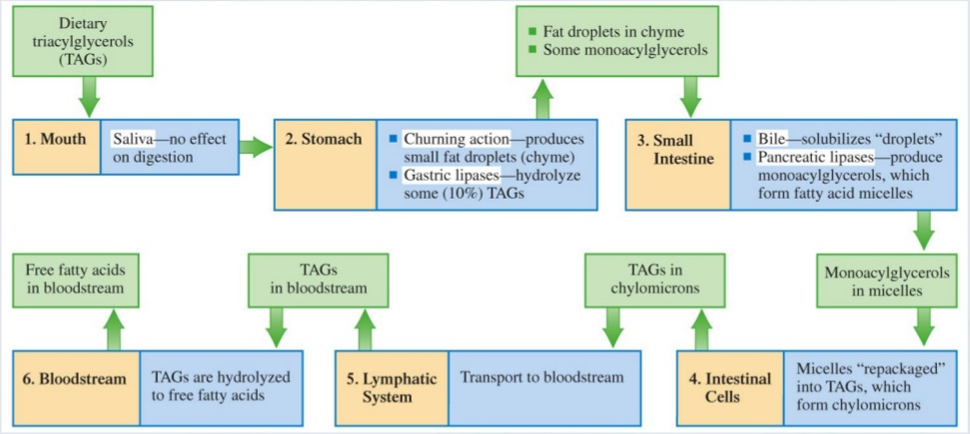

Regarding cholesterol, some of the cholesterol in the small intestine is dietary cholesterol, and some is excreted there by the liver, arriving via the bile. Of the total cholesterol that passes through the small intestine, only half is typically absorbed, and the rest is eliminated in the feces.

Cholesterol synthesis
Cholesterol is synthesized by virtually all tissues in humans, although liver, intestine, adrenal cortex, and reproductive tissues, including ovaries, testes, and placenta, make the largest contributions to the body’s cholesterol pool.
The synthesis of cholesterol begins with a molecule of acetyl CoA and one molecule of acetoacetyl-CoA, which are dehydrated to form 3-hydroxy-3-methylglutaryl CoA (HMG-CoA). This molecule is then reduced to mevalonate by the enzyme HMG-CoA reductase. This step is an irreversible step in cholesterol synthesis which is blocked by cholesterol lowering drugs like statins.
Both dietary cholesterol, and that synthesized de novo, are transported through the circulation in lipoprotein particles.
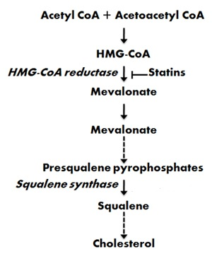

Biosynthesis of cholesterol is directly regulated by the cholesterol levels present. When too much intake of cholesterol from food is detected there is a reduction in endogenous cholesterol synthesis. The main regulatory mechanism is the sensing of intracellular cholesterol in the endoplasmic reticulum.

The Reverse cholesterol transport is a multistep process by which peripheral cholesterol returns back to liver, this process is mediated by HDL. Cholesterol in turn will be excreted by liver in bile and ultimately in feces. It is believed to be a critical mechanism by which HDL exert a protective effect on the development of atherosclerosis.

Lipoproteins
The lipoproteins are macromolecular complexes of lipids (cholesterol, triglycerides, phospholipids) and proteins (apolipoproteins, enzymes), held by non-covalent forces.
The basic structure of lipoproteins is a hydrophobic core of triglycerides and/or cholesteryl esters surrounded by a layer of amphipathic phospholipids, unesterified cholesterol and proteins. The hydrophilic surface protects the hydrophobic core from the aqueous environment.
Factors that stimulate hepatic lipoprotein synthesis generally lead to elevated plasma cholesterol and TG levels.

Lipoproteins are classified according to their density into:
1- Chylomicrons: carry triglycerides from the intestines to the liver, skeletal muscle, and to adipose tissue.
2- Very-low-density lipoproteins (VLDL) carry (newly synthesized) triglycerides from the liver to adipose tissue.
3- Intermediate-density lipoproteins (IDL) are intermediate between VLDL and LDL. They are not usually detectable in the blood when fasting.

4- Low-density lipoproteins (LDL) carry 3,000 to 6,000 fat molecules (phospholipids, cholesterol, triglycerides, etc.) around the body.
LDL particles are sometimes referred to as "bad" lipoprotein because high concentrations correlate with atherosclerosis progression.
5- High-density lipoproteins (HDL) collect fat molecules (phospholipids, cholesterol, triglycerides, etc.) from the body's cells/tissues, and take it back to the liver. HDLs are sometimes referred to as "good" lipoprotein because higher concentrations correlate with low rates of atherosclerosis progression.

APOLIPOPROTEINS
These are proteins that bind lipids to form lipoproteins. They transport the lipids through the lymphatic and circulatory systems.
They have three functions:
(1) they provide the structural element to the lipoprotein particles.
(2) they act as ligands for specific receptors.
(3) they also act as activators or inhibitors of specific enzymes involved in lipoprotein metabolism.

Apolipoprotein A
Apolipoprotein A-I
Apolipoprotein A-I (apo A-I) is the major protein of HDL, constituting 70–80% of HDL protein. It is synthesized primarily in the liver and small intestine. It is essential in reverse cholesterol transport pathway.
Epidemiological studies have shown that plasma apo A-I concentrations, like those of HDL-cholesterol (HDL-C), are inversely related to cardiovascular risk.

Apolipoprotein B
This lipoprotein exists in two forms; apolipoprotein B-100 (apo B-100), which is made in the liver and is the structural protein of VLDL, IDL and LDL, and apo B-48, which is synthesized in the intestine and is incorporated into chylomicrons.

Increased plasma concentrations of apo B-containing lipoproteins confer an increased risk or the development of atheroma.

Apolipoprotein C
There are three apolipoprotein Cs, all of which are synthesized in the liver. In plasma, they transfer between the triglyceride-rich lipoproteins (chylomicrons, VLDL and their remnants) and HDL.

β oxidation of fatty acids
Beta-oxidation is the catabolic process by which fatty acid molecules are broken down in the mitochondria to generate acetyl-CoA, which enters the citric acid cycle, and NADH and FADH2, which are co-enzymes used in the electron transport chain. So, it is a process of energy production.
There are three parts of the process by which fatty acids are broken down to obtain energy:
1. Activation of the fatty acid by binding to Coenzyme-A – the product is called acyl Co-A
2. Transport of acyl Co-A to mitochondrial matrix.
3. Repeated oxidation (fatty acid spiral) to produce acetyl Co-A, FADH2 and NADH, which occurs in 4 steps:
Step 1: Oxidation: FAD is the oxidizing agent, and one FADH2 molecule is a produced.
Step 2: Hydration: A molecule of water is added across the trans double bond.

Step 3: Oxidation:
– The beta-hydroxyl group is oxidized to a keto functional group with NAD+ serving as the oxidizing agent.
Step 4: Chain Cleavage: The fatty acid chain is broken between the alpha and beta carbons by reaction with a coenzyme A molecule.
The result is an acetyl CoA molecule and a new acyl CoA molecule that is shorter by two carbon atoms.
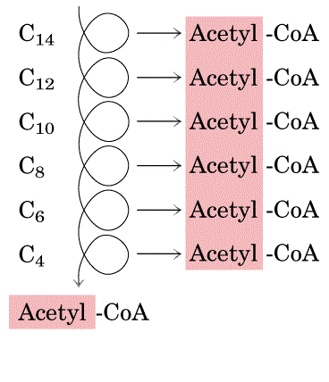

It is important to notice the difference between the designations acyl CoA and acetyl CoA; acyl refers to a random-length fatty acid carbon chain that is covalently bonded to coenzyme A, whereas acetyl refers to a two-carbon chain covalently bonded to coenzyme A.

Ketone bodies
When there is an adequate balance between lipid and carbohydrate metabolism, most of the acetyl CoA produced from the B-oxidation pathway is further processed through the citric acid cycle.
The first step of the citric acid cycle involves the reaction between oxaloacetate and acetyl CoA, so sufficient oxaloacetate must be present for the acetyl CoA to react with.
In conditions such as starvation or uncontrolled diabetes mellitus, oxaloacetate will enter gluconeogenesis pathway rather than citric acid cycle leaving excess acetyl-CoA.
Accumulation of acetyl-CoA will lead to ketogenesis in the liver, ketone bodies in turn can be used as a source of energy when glucose is unavailable.
Ketone body is one of the three substances:
- acetoacetate
- B- hydroxybutyrate
- acetone
The first ketone body to be produced is acetoacetate, some of these acetoacetate produced is converted to the second ketone body, B- hydroxybuterate.
The acetoacetate and B-hydroxybutyrate synthesized by ketogenesis in the liver are released to the blood stream where acetone, the third ketone body is produced.
Acetone present in the blood stream is a volatile substance that is mainly excreted by exhalation. Its sweet odor is detectible in the breath of a diabetic.

Acetoacetate and B-hydroxybutyrate are acids. Their presence in blood causes a slight but significant decrease in blood pH which can result in acidosis. Diabetic ketoacidosis, a life-threatening complication of diabetes mellitus, is associated with severe metabolic acidosis and hyperglycemia due to severe insulin deficiency.

This deficiency of insulin leads to inability to use glucose as a source of energy, this leads to activation of fatty acid oxidation as an alternative pathway for energy production.

**************************************************************************************************************************************************************

