vitamins (II)

Water soluble vitamins have specific features differentiate them from fat soluble vitamins.
They are: - easily absorbed and transported in the body.
- cannot be stored in large quantities in the body.
- rarely reach toxic levels from food sources.
Water soluble vitamins include:

1- Vitamin B1—Thiamine
Thiamine, also known as vitamin B1, forms the coenzyme thiamine pyrophosphate (TPP). It is required for the essential decarboxylation reactions catalyzed by the pyruvate and 2-oxoglutarate complexes.
It is present in various types of food but most abundant in cereal, and liver; and because of enrichment of flour with vitamin B1, the availability of this vitamin has considerably increased.

Absorption, Transport, Metabolism, and Excretion
Thiamine absorption occurs primarily in the proximal small intestine by simple passive diffusion.
Absorbed thiamine undergoes intracellular phosphorylation, mainly to the pyrophosphate, but in plasma, 90% of transferred thiamine is present in the free form. Thiamine is carried by portal blood to the liver and then to other organs to be used and stored.
Approximately 30 mg is stored in the body, with 80% as pyrophosphate (TPP), 10% as triphosphate (TTP), and the rest as thiamine and its monophosphate.
About half of body stores are found in skeletal muscle, with much of the remainder in heart, liver, kidneys, and nervous tissues.
Thiamine cellular uptake is reduced in diabetes and ethanol ingestion.

Functions
1- essential coenzyme for proper production of energy at mitochondria.
2- nervous system composition and function
3- biosynthesis of lipids and acetylcholine

Deficiency
Thiamine deficiency might be caused by decreased dietary intake, chronic alcoholism, long term renal dialysis, use of diuretics in elderly patients.
Beriberi is the disease resulting from thiamine deficiency. Clinical signs of thiamine deficiency primarily involve the nervous (dry beriberi) and cardiovascular (wet beriberi) systems.
Toxicity
No known toxicity has been reported.

2- Vitamin B2, Riboflavin
Vitamin B2 refers to riboflavin and its related metabolites, which act as cofactors to several reduction-oxidation enzymes.
It is an essential component of Flavin Adenine Dinucleotide (FAD) and flavin mononucleotide (FMN), coenzymes that are involved in many redox reactions which play a vital role in electron transfer and production of energy.
It is present in various types of animal and plant diets and fortified cereals.

Absorption, Transport, Metabolism, and Excretion
Most dietary riboflavin is taken in as a complex of food protein with the coenzymes FMN and FAD. The vitamin is primarily absorbed in the proximal small intestine by a saturable transport system that is rapid and proportional to intake, with bile salts appear to facilitate uptake.
The transport of flavins in human blood involves loose binding to albumin and tight binding to numerous globulins, with major binding noted to several classes of immunoglobulins (IgA, IgG, and IgM).
After being intracellular, riboflavin is converted to coenzymes (FAD, FMN) within the cellular cytoplasm of most tissue but particularly in the small intestine, liver, heart, and kidney.
At first, riboflavin is converted in FMN, the second step is the conversion of FMN into FAD. The main pathway of B2 excretion is through renal system.

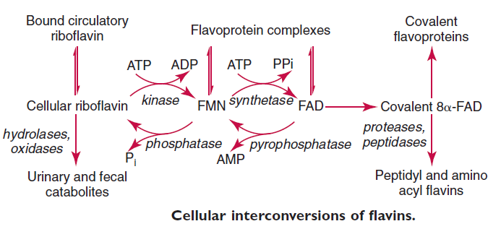

Functions
1- plays an essential role in electron transfer of the respiratory chain, thus being involved in energy production.
2- drug metabolism in conjunction with the cytochrome P450 enzymes.
3- lipid metabolism.
4- antioxidative

Deficiency
Because flavin coenzymes are widely distributed in intermediary metabolism, the consequences of deficiency may be widespread which may include:
(1) sore throat
(2) hyperemia
(3) edema of the pharyngeal and oral mucous membranes
(4) cheilosis
(5) angular stomatitis
(6) glossitis
(7) seborrheic dermatitis
(8) normochromic, normocytic anemia

Toxicity
No known toxicity.

3- Vitamin B6: Pyridoxine, Pyridoxamine, and Pyridoxal
The vitamin B6 group comprises three natural forms: pyridoxine (pyridoxol) (PN), pyridoxamine (PM), and pyridoxal (PL), all are converted to pyridoxal phosphate, which is required for synthesis, catabolism, and interconversion of amino acids.
Vitamin B6 is widely distributed in animal and plant tissues, where the phosphorylated forms, particularly PLP, predominate, but significant loss occurs during thermal processing of foods.

Absorption, Transport, Metabolism, and Excretion
Food sources of animal origin contain mainly PLP with some PMP, whereas plant sources also contain pyridoxine- 5-glucoside, which is absorbed in a different manner. The phosphorylated sources are hydrolyzed by the intraluminal action of intestinal alkaline phosphatase, but pyridoxine-5-glucoside readily absorbed by the mucosal cells through a process of passive diffusion.
At the intracellular level, all types of vitamin B6 are converted into PLP which can enter directly into subcellular organelles such as hepatocyte mitochondria and can bind for catalytic function with numerous specific apoenzymes throughout the cell.

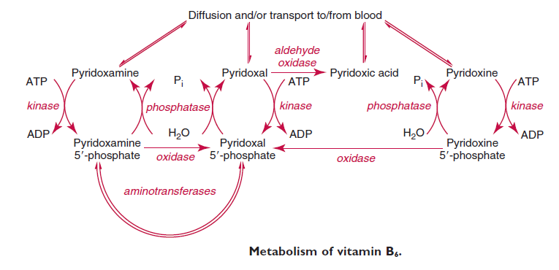

Functions
As a coenzyme PLP, vitamin B6 functions in more than 100 reactions that regulate the metabolism of macronutrients, such as proteins, carbohydrates, and lipids.

Deficiency
A deficiency of vitamin B6 alone is uncommon, but might exists with other medical conditions or use of certain drugs such as INH( isoniazid) which used in the treatment of tuberculosis.
Clinical manifestation of B6 deficiency include:
1- anemia
2- dermatitis
3- cheilosis

Toxicity
Extremely high doses might cause neuropathy.

4- Vitamin B12, Cyanocobalamin
Vitamin B12, also known as cyanocobalamin, is a water soluble hematopoietic vitamin that is required for the maturation of erythrocytes. The generic term vitamin B12 refers to a group of physiologically active substances chemically classified as cobalamins.
Because plants do not use this vitamin, the main dietary sources are meat and meat products, dairy products, fish and fortified ready-to-eat cereals.

Absorption, Transport, Metabolism, and Excretion
The uptake of vitamin B12 from the intestine into the circulation is a complex mechanism, involving five separate vitamin B12–binding molecules, receptors, and transporters.
The steps of vitamin B12 absorption and transport are:
1- Vitamin B12 released from food in the stomach is bound to haptocorrin (R protein, a salivary protein) and travels with it into the intestine, where the haptocorrin is digested by pancreatic enzymes.
2- Liberated vitamin B12 then binds to intrinsic factor (IF), a glycoprotein that is produced by the gastric mucosa.
3- When the vitamin B12–IF complex reaches the distal ileum, it is bound by receptors on the surface of mucosal epithelial cells and then enters the cells.
4- The vitamin B12–IF complex is dissociated within the mucosal epithelial cells, with vitamin B12 then binding with transcobalamin II (TcII).
5- The B12-TcII complex is then transported across the cell membrane released into the plasma of the mucosal capillaries and subsequently to the blood in the portal vein.
It is stored in the liver and is released to plasma to meet physiologic demands. If the quantity of vitamin B12 exceeds the capacity of hepatocyte receptors, most of the excess is excreted by the kidneys.

Functions
Vitamin B12 is required as a coenzyme form for more than 12 different enzyme systems, it is essential for RBC maturation.

Deficiency
Deficiency of vitamin B12 in humans is associated with megaloblastic anemia and neuropathy. The most common cause of vitamin B12 deficiency is pernicious anemia, an autoimmune disease in which chronic atrophic gastritis results from antibodies to gastric parietal cells and IF.

The hematologic effects of vitamin B12 deficiency are indistinguishable from those of folate deficiency. Classical morphological changes in the blood, in approximate order of
appearance, are as follows:
1-hypersegmentation of neutrophils,
2-macrocytosis,
3-anemia,
4-leukopenia,
5-thrombocytopenia, with megaloblastic changes in bone marrow accompanying peripheral blood changes.

The cause of the hematologic abnormalities is thought to be an imbalance of decreased deoxyribonucleic acid (DNA) synthesis and adequate ribonucleic acid (RNA) synthesis caused by the secondary block in folate metabolism caused by vitamin B12 deficiency.
Many immature cells die in the bone marrow, possibly by apoptosis, leading to the release of bilirubin and lactate dehydrogenase (LD) into the blood. This is termed ineffective erythropoiesis.

Toxicity
No adverse effects have been associated with excess vitamin B12 intake from food or supplements in healthy people.

5- Vitamin C—Ascorbic Acid
Vitamin C (L-ascorbic acid) serves as a reducing agent in several important hydroxylation reactions in the body.
Excellent sources of the vitamin include fruits and leafy green vegetables.

Absorption, Transport, Metabolism, and Excretion
Gastrointestinal absorption of ascorbic acid occurs through a combination of sodium-dependent active transport at low concentrations and simple diffusion at high concentrations.
The absorbed ascorbic acid moves rapidly from the intestinal cell into the blood through a process of facilitated diffusion.
Vitamin C is found in most tissues, but glandular tissues, such as pituitary, adrenal cortex, corpus luteum, and thymus, have the highest amounts, and the retina has 20 to 30 times the plasma concentration.

Functions
1- a cofactor for protocollagen hydroxylase in connective tissue.
2- synthesis of adrenal hormones.
3- synthesis of corticosteroids and aldosterone;
4- hydroxylation of cholesterol in the formation of bile acids
5- folate metabolism and leukocyte functions

Deficiency
Severe deficiency of vitamin C leads to the classic disease of scurvy which is associated with spontaneous bleeding, bone pain, bleeding and sore gums, and echymosis.

6- Biotin
Biotin (also known as vitamin H) is an important vitamin for a number of carboxylation reactions, It is available in many types of animal and plants foods.
Biotin is a coenzyme for carboxylase enzymes, involved in the synthesis of fatty acids, isoleucine, and valine, and in gluconeogenesis.

Deficiency
Symptoms include anorexia, nausea, vomiting, glossitis, pallor, depression, and a dry scaly dermatitis.

7- Folic Acid
Folic acid serves as a carrier of one-carbon groups in many metabolic reactions. It is required for the biosynthesis of compounds such as choline, serine, glycine, and purines.
The terms Folate and folic acid are used interchangeably.
The principal food sources of folate are liver, spinach, and other dark green leafy vegetables,

Absorption, Transport, Metabolism, and Excretion
Folate is absorbed from dietary sources such as those listed previously, mainly as reduced methyl- and formyl-tetrahydropteroylpolyglutamates. After cellular uptake, most of the folate is reduced and methylated and enters the circulation as 5-methyltetrahydrofolate (THF), circulating loosely bound to albumin.
Once within the cell, 5-methyl THF is demethylated and converted to the polyglutamyl to helps to retain folate within the cell because it is unable to cross cell membranes.
Folic acid and vitamin B12 metabolism is linked by the reaction that transfers a methyl group from 5- methyltetrahydrofolate to cobalamin. In cases of cobalamin deficiency, folate is “trapped” as 5-methyltetrahydrofolate and is “metabolically dead.” It cannot be recycled as tetrahydrofolate back into the folate pool to serve as the main one-carbon unit acceptor for many biochemical reactions. Eventually, cellular depletion of methylenetetrahydrofolate ensues, causing a reduction in thymidylic acid synthesis, which, in turn, results in megaloblastic anemia and neuropathies.

Folic acid and vitamin B12 metabolism is linked by the reaction that transfers a methyl group from 5- methyltetrahydrofolate to cobalamin. In cases of cobalamin deficiency, folate is “trapped” as 5-methyltetrahydrofolate and is “metabolically dead.” It cannot be recycled as tetrahydrofolate back into the folate pool to serve as the main one-carbon unit acceptor for many biochemical reactions.
Eventually, cellular depletion of methylenetetrahydrofolate ensues, causing a reduction in thymidylic acid synthesis, which, in turn, results in megaloblastic anemia and neuropathies.

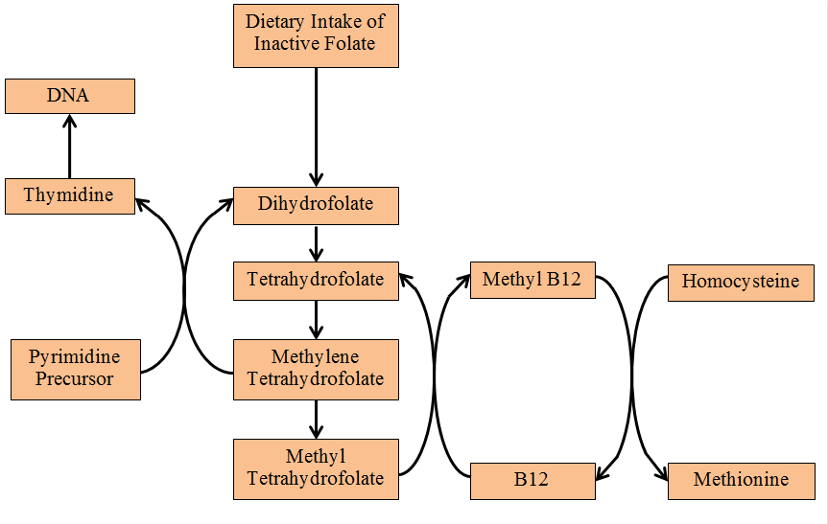

Functions
(1) used in the synthesis of thymidine (and incorporation into DNA)
(2) used in the synthesis of purines (precursors of RNA and DNA)
(3) necessary for the methylation of homocysteine to methionine which is important in the metabolism of DNA, RNA, hormones, neurotransmitters, membrane lipids, and proteins.

Deficiency
1- Megaloblastic anemia
2- sensory loss and neuropsychiatric changes
3- serious outcomes during pregnancy:
- preterm delivery
- infant low birth weight
- fetal growth retardation.
- increased the risk of neural tube defects (NTDs)

Toxicity
No adverse effects have been reported from the consumption of folate-fortified foods.

8- Niacin and Niacinamide
Niacin and niacinamide (nicotinamide and nicotinic acid amide) are converted to the ubiquitous redox coenzymes nicotinamide-adenine dinucleotide (NAD)+ and nicotinamide-adenine dinucleotide phosphate (NADP)+.
Pellagra is the classic deficiency disease of the human that has been most often found among those who subsist chiefly on corn, which is low in both niacin and tryptophan concentrations.
The typical presentation of pellagra is that of a chronic wasting disease associated with dermatitis, dementia, and diarrhea (3D).

9- Pantothenic Acid
Pantothenic acid is a component of coenzyme A (CoA) that is required for the metabolism of fat, protein, and carbohydrate via the citric acid cycle.
It is widely available in foods so its deficiency is extremely rare as well as toxicity.

14-11-2018

