Enzymes (part 1)

A chemical reaction, although theoretically probable, becomes practically possible only with the help of catalysts. They enter into the reaction, but come out of the reaction without any change.
Catalysts are substances which accelerate the rate of chemical reactions, but do not change the equilibrium.
Catalysis is defined as the acceleration of a chemical reaction by some substance which itself undergoes no permanent chemical change. The catalysts of biochemical reactions are enzymes and are responsible for bringing about almost all of the chemical reactions in living organisms. Without enzymes, these reactions take place at a rate far too slow for the pace of metabolism, these rates are not fast enough to sustain life.
Enzyme catalysis is very rapid; usually 1 molecule of an enzyme can act upon about 1000 molecules of the substrate per minute. Lack of enzymes will lead to block in metabolic pathways causing inborn errors of metabolism.
Enzymes are proteins with catalytic properties (accelerate chemical reactions).
The substance upon which an enzyme acts, is called the substrate. The enzyme will convert the substrate into the product or products.

Chemical Nature of Enzymes
All known enzymes are proteins. They are high molecular weight compounds made up principally of chains of amino acids linked together by peptide bonds. They can be denatured and precipitated with salts, solvents and other reagents.
In general, enzymes are characterized by:
- Almost all enzymes are proteins.
- They are heat labile.
- They are water-soluble.
- They can be precipitated by protein precipitating reagents (ammonium sulfate or trichloroacetic acid).
- They contain 16% weight as nitrogen.

Cofactors and coenzymes
Many enzymes require the presence of other compounds (cofactors) before their catalytic
activity can be exerted. A cofactor is a non-protein chemical compound that is required for the enzyme’s biological activity.
This entire active complex is referred to as the holoenzyme; i.e., apoenzyme (protein portion) plus the cofactor is called the holoenzyme.
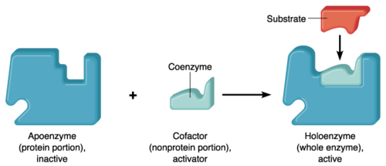

Cofactor may be:
1. A coenzyme - a non-protein organic substance which is thermostable and loosely attached to the protein part.
2. A prosthetic group - an organic substance which is thermostable and firmly attached to the protein or apoenzyme portion.
3. A metal-ion-activator - these include K+, Fe++, Fe+++, Cu++, Co++, Zn++, Mn++, Mg++, and Ca++.

The Catalytic Activity of Enzymes
Like all other catalysts, enzymes are characterized by two fundamental properties:
First, they increase the rate of chemical reactions without themselves being consumed or permanently altered by the reaction. So, they are neither used up in the reaction nor do they appear as reaction products.
Second, they increase reaction rates without altering the chemical equilibrium between reactants and products.

Chemical Equilibrium
The principles of enzymatic catalysis are illustrated in the following example, in which a molecule acted upon by an enzyme (referred to as a substrate [S]) is converted to a product (P) as the result of the reaction.
In the absence of the enzyme, the reaction can be written as follows:
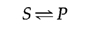
The chemical equilibrium between S and P is determined by the ratio of the forward and reverse reaction rates (S→P and P→S, respectively).
In the presence of the appropriate enzyme, the conversion of S to P is accelerated, but the equilibrium between S and P is unaltered. Therefore, the enzyme must accelerate both the forward and reverse reactions equally. The reaction can be written as follows:
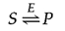

Mode of action of enzymes
In order for a metabolic reaction to proceed, the substrate must first be converted to a higher energy state, called the transition state. The energy required to reach the transition state (the activation energy) constitutes a barrier to the progress of the reaction, limiting the rate of the reaction. Enzymes (and other catalysts) act by reducing the activation energy, thereby increasing the rate of reaction. The increased rate is the same in both the forward and reverse directions, since both must pass through the same transition state.
The catalytic activity of enzymes involves the binding of their substrates to form an enzyme-substrate complex (ES). The substrate binds to a specific region of the enzyme, called the active site. While bound to the active site, the substrate is converted into the product of the reaction, which is then released from the enzyme. The enzyme-catalyzed reaction can thus be written as follows:
Note that E appears unaltered on both sides of the equation, so the equilibrium is unaffected. However, the enzyme provides a surface upon which the reactions converting S to P can occur more readily. This is a result of interactions between the enzyme and substrate that lower the energy of activation and favor formation of the transition state.

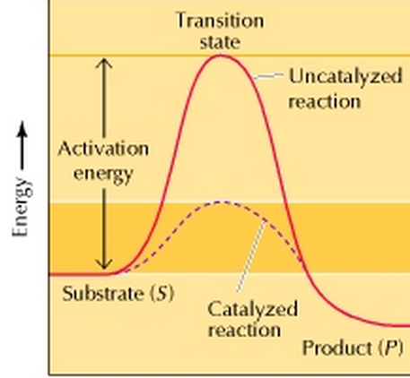
The reaction illustrated is the simple conversion of a substrate S to a product P. Because the final energy state of P is lower than that of S, the reaction proceeds from left to right. For the reaction to occur, however, S must first pass through a higher energy transition state. The energy required to reach this transition state (the activation energy) represents a barrier to the progress of the reaction and thereby determines the rate at which the reaction proceeds. In the presence of a catalyst (e.g., an enzyme), the activation energy is lowered and the reaction proceeds at an accelerated rate.

Naming and Classification
Except for some of the originally studied enzymes such as pepsin, rennin, and trypsin, most
enzyme names end in "ase". The International Union of Biochemistry (I.U.B.) initiated standards of enzyme nomenclature which recommend that enzyme names indicate both the substrate acted upon and the type of reaction catalyzed.

Enzymes can be classified by the kind of chemical reaction catalyzed.
I. Addition or removal of water
A. Hydrolases - these include esterases, carbohydrases, nucleases, deaminases, amidases, and proteases.
B. Hydrases such as fumarase, enolase, aconitase and carbonic anhydrase.
II. Transfer of electrons
A. Oxidases
B. Dehydrogenases
III. Transfer of a radical
A. Transglycosidases - of monosaccharides
B. Transphosphorylases and phosphomutases - of a phosphate group
C. Transaminases - of amino group
D. Transmethylases - of a methyl group
E. Transacetylases - of an acetyl group
IV. Splitting or forming a C-C bond
A. Desmolases
V. Changing geometry or structure of a molecule
- Isomerases
VI. Joining two molecules through hydrolysis of pyrophosphate bond in ATP or other
tri-phosphate
- Ligases

Mechanism of action of enzymes
The basic mechanism by which enzymes catalyzes chemical reactions begins with the binding of the substrate (or substrates) to the active site on the enzyme. The active site is the specific region of the enzyme which combines with the substrate.

The binding of the substrate to the enzyme causes changes in the distribution of electrons in the chemical bonds of the substrate and ultimately causes the reactions that lead to the formation of products. The products are released from the enzyme surface to regenerate the enzyme for another reaction cycle.

The active site has a unique geometric shape that is complementary to the geometric shape of a substrate molecule, similar to the fit of puzzle pieces. This means that enzymes specifically react with only one or a very few similar compounds.

Although the simple example discussed previously involved only a single substrate molecule, most biochemical reactions involve interactions between two or more different substrates. For example, the formation of a peptide bond involves the joining of two amino acids. For such reactions, the binding of two or more substrates to the active site in the proper position and orientation accelerates the reaction.

The enzyme provides a template upon which the reactants are brought together and properly oriented to favor the formation of the transition state in which they interact.

In general, 3 main mechanisms of action of the enzymes are suggested:
1- Lock and Key model:
This is the simplest model of enzyme-substrate interaction, it states that the three-dimensional structure of the active site of the enzyme is complementary to the substrate. Thus, enzyme and substrate fit each other.
Substrate fits on the enzyme, similar to lock and key. (The lock can be opened by its own key only). However, this theory suggests a rigid structure for enzymes, which could not explain the flexibility shown by enzymes.
This is illustrated in graph below:
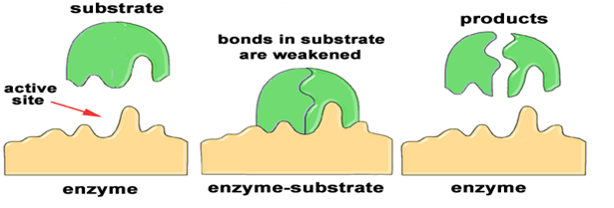

2- Induced Fit model:
In many cases, the configurations of both the enzyme and substrate are modified by substrate binding, a process called induced fit.
In such cases the conformation of the substrate is altered so that it more closely resembles that of the transition state. At first, substrate binds to a specific part of the enzyme. This leads to more secondary binding and conformational changes.

The substrate induces conformational changes in the enzyme, such that precise orientation of catalytic groups is affected.

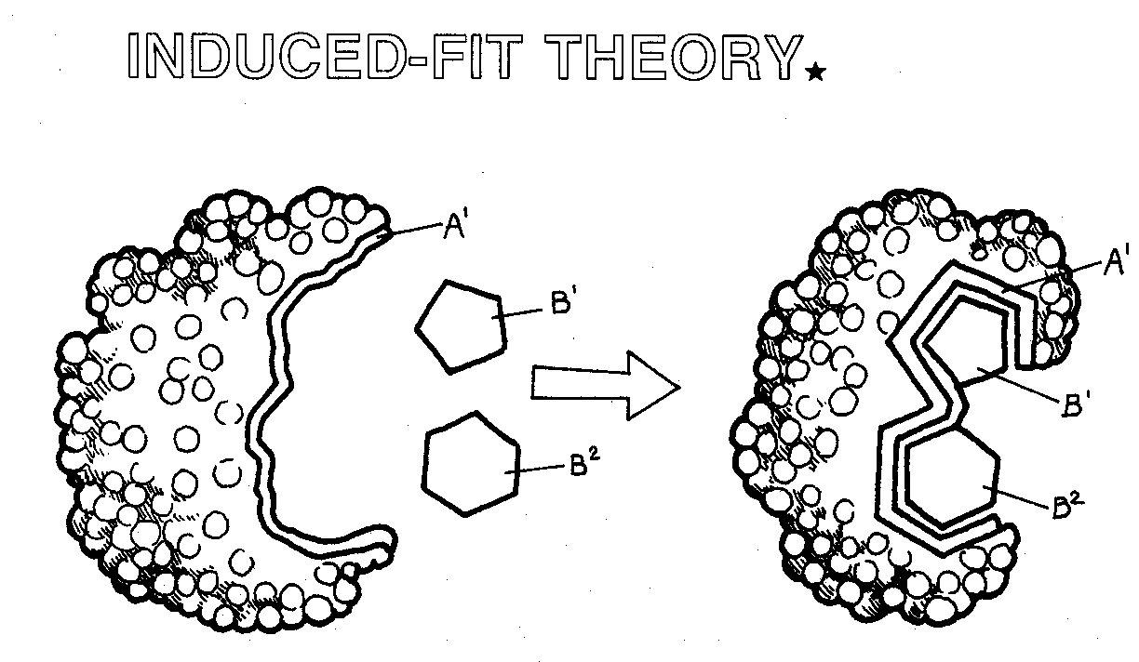
In the induced-fit model, substrate binding distorts the conformations of both substrate and enzyme. This distortion brings the substrate closer to the conformation of the transition state, thereby accelerating the reaction.

3- Direct catalysis
Many enzymes participate directly in the catalytic process. In such cases, specific amino acid side chains in the active site may react with the substrate and form bonds with reaction intermediates. The acidic and basic amino acids are often involved in these catalytic mechanisms, as illustrated in the following figure:

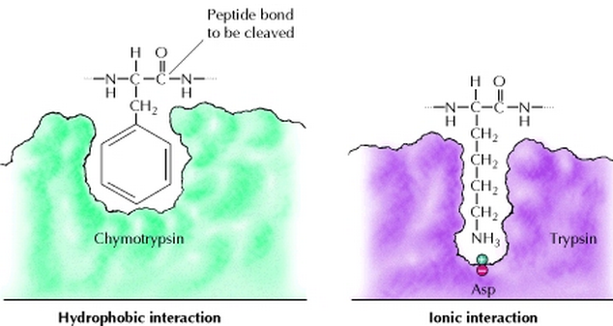

In this figure, the amino acid adjacent to the peptide bond to be cleaved is inserted into a pocket at the active site of the enzyme. In chymotrypsin, the pocket binds hydrophobic amino acids; the binding pocket of trypsin contains a negatively charged aspartate residue that binds basic amino acids via an ionic interaction.
^^^^^^^^^^^^^^^^^^^^^^^^^^^^^^^^^^^^^^^^^^^^^^^^^^^^^^^^^^^^^^^^^^^^^^^^^^^^^^^^^^^^^^^^^^^^^^^^^^^^^^^^^^^^^^^^^^^^^^^^^^^^^^^^^^^^^^^^^^^^^^^^^^^^^^^^^^^^^^^^^^^^^^^^^^^^^^^^^^^^^^^^^^^^^^^^^^^^^^^^^^^^^^^^^^^^^^^^^^^^^^^^^^^^^^^^^^^^^^^^^^^^^^^^^^^^
An example of the effect of an enzyme deficiency on the physiology of the body.
G6PD deficiency
The G6PD enzyme is part of the pentose monophosphate shunt. It catalyzes the oxidation of glucose-6-phosphate and the reduction of nicotinamide adenine dinucleotide phosphate (NADP+) to nicotinamide adenine dinucleotide phosphate (NADPH). NADPH maintains glutathione in its reduced form, which acts as a scavenger for dangerous oxidative metabolites.
The pentose monophosphate shunt is the only source for NADPH in red blood cells. Therefore, red blood cells depend on G6PD activity to generate NADPH for protection. Thus, red blood cells are more susceptible to oxidative stresses than other cells. In persons with G6PD deficiency, oxidative stresses can denature hemoglobin and cause intravascular hemolysis.

