Hormones (part I)

**Introduction**

Hormones are chemical messengers, secreted by cells of specialized tissues called endocrine glands, and transported by blood to stimulate specific functions of distant tissues or organs.

They play key role in the intercellular communication and coordination of responses. Together with nervous and immune systems, the hormones are important constituents of the **signaling****system**of the body that mediates interactions between various tissues.

It is now well established that some hormones can act on the adjacent cells in a given tissue (*paracrine function*) as well as on the cells in which they are synthesized (*autocrine function*).

Examples: interleukin-2 is autocrine hormone for it is being produced by T cells and stimulates proliferation of T cells; and prostaglandins have paracrine function since they act on nearby cells.

So, the concept that hormones stimulate distant tissues or organs only is not accurate.

In general, hormones regulate the following processes:

1. Metabolism
2. Growth
3. Reproduction
4. Adaptation to the environment

**Chemical Structure of Hormones**

Substances of different origin and chemical nature may serve as hormones. Based on their chemical nature, the hormones have been categorized into the following four groups:

***1. Lipid hormones:***

Most lipid hormones are derived from cholesterol**,** such as adrenocortical hormones, sex hormones and calcitriol. Others are derived from arachidonic acid**,** such as prostaglandins. The cholesterol-derived hormones contain a steroid nucleus and are *lipophilic* in nature; they readily traverse the cell membrane of their target cells and interact with the *cytoplasmic receptors*.

**2. *Amino acid hormones:***

These hormones are produced by enzymatic modification of an amino acid molecule.

For example, both *epinephrine* and *thyroxine* are derived from tyrosine molecule.

**3. *Peptide and protein hormones:***

These hormones are made up of amino acids, joined by peptide bonds.

Smallest of them is thyrotropin releasing hormone (TRH), a hypothalamic-releasing factor, which consists of only three amino acids.

Other examples include:

1. Antidiuretic hormone (9 amino acids)
2. Glucagon (29 amino acids)
3. Parathormone (84 amino acids)
4. Growth hormone (191 amino acids).

**4. *Glycoprotein hormones:***

A glycoprotein hormone consists of peptide chain to which carbohydrate moieties are covalently attached. The latter are necessary for the biological activity of these hormones.

Examples include:

1. pituitary hormones (TSH, LH and FSH)
2. chorionic gonadotropin (hCG) of placental origin.

**Biosynthesis of hormones**

Biosynthetic mechanisms for hormones are diverse. Some hormones are initially synthesized as large precursor proteins which are converted to the biologically active forms by removal of specific peptide sequences.

*Insulin* (MW 5500), for example, is initially synthesized as an inactive precursor**, pre-pro-insulin** (MW 11,500). A sequential removal of two peptide sequences results in

production of an insulin molecule.

Likewise, *parathormone* (PTH), an 84 amino acid peptide, is formed fromthe 115 amino acid precursor, **pre-pro-parathormone** bysuccessive removal of two peptide segments.

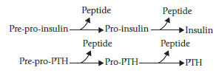

Perhaps the most exaggerated example is that of thyroxine, a single amino acid hormone, which is processed from a 115 amino acid glycoprotein precursor, **thyroglobulin.**

**Transportation of hormones**

The peptide hormones circulate in the blood in free form, unbound to any transport protein. This is due to their polar (hydrophilic) nature.

In contrast, the steroid hormones and the thyroid hormones are predominantly hydrophobic in nature and therefore, cannot circulate in blood entirely in an unbound form. They are mostly transported to their site of action by carrier proteins, where they exert their action and are inactivated by further metabolism.

In fact, carrier proteins have two major functions:

1. play a key role in hormone transport.
2. prevents rapid clearance of the hormone and thereby, prolongs its half-life.

Because of this, the half-life of the steroids and thyroid hormones, which mostly exist in bound states, is much longer than that of the peptide hormones which is less than 30 minutes.

***The peptide hormones circulate free (unbound), whereas the steroid and thyroid hormones are mostly bound with***

***carrier proteins. The latter act as circulating reservoir of hormone, and also prolong its half-life.***

Only the free form of a hormone, and not the bound form, is able to interact with the cellular receptors. Therefore, it is the free form that is responsible for inducing metabolic and biological effects in target cells. The bound form merely acts as a *circulating reservoir*, releasing the free hormone in the immediate vicinity of the target tissue, as required.

Therefore, the **ratio of** **free: bound forms**, and not the total circulating hormone concentration, is true reflection of the observed biological activity.

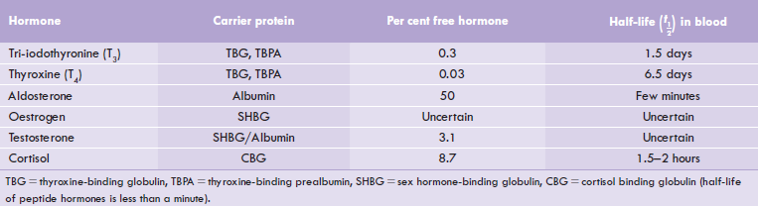

**Target Tissue Concept**

The physiological and biochemical effects of a given hormone are elicited only in a specific tissue, known as its target tissue. A target tissue has specific receptors with which the hormone interacts. The hormone-receptor interaction triggers a series of events that subsequently lead to elicitation of the biological effects of the hormone.

For example:

* Target tissue for thyroid-stimulating hormone (TSH) is the thyroid gland, where this hormone stimulates synthesis and secretion of the iodothyronines (T3 and T4).

Receptors are cell-associated recognition molecules that play a crucial role in the hormone action.

-*The receptors for water-soluble hormones* (peptides, proteins, or glycoproteins) are present on the **cell surface**. Interaction of hormones with receptors stimulates certain molecules namely second messengers, which mediate biochemical functions intracellularly.

-*The receptors for lipophilic hormones* such as the steroids and the thyroid hormones are **located intracellularly**.

The lipophilic hormones readily traverse the cell membrane because of their hydrophobic nature and enter the cell. Intracellularly, they interact with specific receptors located either in the cytosol (e.g. steroid hormones) or within the nucleus (e.g. thyroid hormones) to form hormone-receptor complexes.

The latter serves as the intracellular messengers, through which biochemical functions are mediated.

**Mechanism of Hormonal Action**

In general, a hormone maintains its activity according to the following steps:

1. The hormone binds to a site on the extracellular portion of the receptor.
2. Binding of the hormone to the receptor activates a G protein
3. This initiates the production of a second messenger like cyclic AMP, (cAMP)
4. The second messenger, in turn, initiates a series of intracellular events such as phosphorylation and activation of enzymes leading to release of Ca2+ into the cytosol from stores within the endoplasmic reticulum.
5. In the case of cAMP, these enzymatic changes activate the transcription factor CREB (cAMP response element binding protein) which leads to:
6. Specific gene activation and formation of specific mRNA.
7. Then, translation to produce the desired protein by ribosomes.

The biochemical response is achieved finally.



**Feedback Concept (regulation of hormonal secretion)**

Blood levels of the target tissue hormones (e.g. thyroid gland) have an effect (mostly inhibitory) on the secretary activities of either the hypothalamus or pituitary.

A highly control system of feedback effects, termed the **short** **feedback loop** and **long feedback loop,** exists which relies on a precise signaling, and it helps to maintain the circulating plasma concentration of the hormones to the required levels.

Such feedback mechanism is best illustrated by the **hypothalamo-pituitary-target gland axis:**

**1-**The hypothalamic-releasing factor stimulates the release of the anterior pituitary hormone (called *tropic* *hormone*).

2-The tropic hormone enhances the synthesis and/or secretion of the hormone from the target gland.

3-The blood level of the target gland hormone thereby rises and exerts inhibitory effect (i.e. *negative feedback effect*) on the anterior pituitary and the hypothalamic secretions.

4-The net result of these inhibitions is that secretion of the tropic pituitary hormone decreases. Diminished level of the pituitary hormone decreases stimulus for the target gland, so that secretion of the target gland hormone also falls.

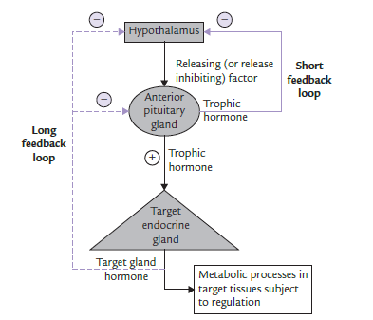

**The concept of feedback**

In this way, a self-regulatory loop is formed referred to as **long feedback loop**.

The pituitary hormone may also directly cause feedback inhibition of the hypothalamic secretion (i.e. **short feedback loop**). Defect in this axis can disturb the normal regulation and cause hormonal disorders.

In some cases, the feedback modulator of a given hormone may be a metabolite, the circulating level of which is controlled by the hormone itself.

For example, raised blood glucose concentration is the most potent (positive) modulator of insulin synthesis and secretion from the B-cells of pancreas.

Similarly, decreased serum calcium is a potent stimulus for parathormone (PTH), which in turn mobilizes calcium from the bony reservoir to restore the serum calcium levels.

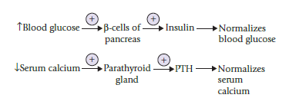

In addition to the negative feedback mechanisms, those for *positive feedback modulation* are also known. A classic example is stimulation for release of luteinizing hormone (form anterior pituitary) by increased plasma levels of estrogen.

It is noteworthy to mention that estrogen itself is released from ovarian follicles in response to the luteinizing hormone (LH).

The estrogen-mediated release of LH secretion is called **LH surge**, which induces ovulation during menstrual cycle. Failure of feedback mechanisms may disturb the precisely controlled systems described above.

In the context of this subject, the unique relationship between dopamine and prolactin should be mentioned. ***Dopamine secretion by hypothalamus will inhibit prolactin secretion from pituitary gland.***

**In classical endocrinology, the hormones are:**

1. *Pituitary hormones*
2. *Thyroid hormones*
3. *Parathyroid hormones*
4. *Pancreatic hormones*
5. *Suprarenal cortical hormones*
6. *Suprarenal medullary hormones*
7. *Ovarian hormones*
8. *Testicular hormones*
9. *Hypophyseal hormones.*

**Pituitary hormones**

The pituitary gland is a tiny organ, the size of a pea, found at the base of the brain. It is considered as the “master gland” of the body because it produces many hormones that travel throughout the body, directing certain processes or stimulating other glands to produce other hormones.

Pituitary gland comprises:

1. Anterior lobe
2. Posterior lobe

Each lobe has a different hormonal function.

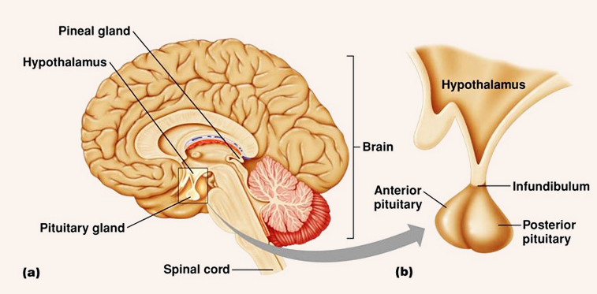

**Anterior Pituitary Hormones**

The anterior lobe of pituitary gland secretes the following hormones:

• Growth hormone (GH)

• Thyroid stimulating hormone (TSH)

• Follicular stimulating hormone (FSH)

• Luteinizing hormone (LH)

• Adrenocorticotropic hormone (ACTH)

• Prolactin (PRL)

• Alpha-melanocyte stimulating hormone (a-MSH).

**Posterior Pituitary Hormones**

The posterior lobe of pituitary gland (or neurohypophysis) is regarded as part of the endocrine system, although it is not glandular as is the anterior pituitary. Instead, it is largely a collection of axonal projections from the hypothalamus that terminate behind the anterior pituitary which serves as a site for the secretion of neurohypophysial hormones **(oxytocin and vasopressin)** directly into the blood.

^^^^^^^^^^^^^^^^^^^^^^^^^^^^^^^^^^^^^^^^^^^^^^^^^^^^^^^^^^^^^^^^^^^^^^^^^^^^^^^^^^^^^^^^^^^^^^^^^^^^^^^^^^^^^^^^^^^^^^^^^^^^^^^^^^^^^^^^^^^^^^^^^^^^^^^^^^^^^^^^^^^^^^^^^^^^^^^^^^^^^^^^^^^^^^^^^^^^^^^^^^^^^^^^^^^^^^^^^^^^^^