Nucleic Acids (part II)

Summary
Before starting in more details of nucleic acids and protein synthesis, we have to summarize the following facts:
- A nucleic acid is a macromolecule with acid property. As it was isolated from nucleus of cells, it is called nucleic acid.
-It is made up of carbon, hydrogen, oxygen, nitrogen and phosphorus.
-A nucleic acid molecule is a long chain polymer, composed of monomeric units, called nucleotides.
-Each nucleotide consists of nucleoside and a phosphate group.
-Each nucleoside consists of a pentose sugar and a nitrogenous base.
-The sugar is ribose in case of RNA and deoxyribose in case of DNA.
-Nitrogenous bases are of two types namely: purine and pyrimidine.
-There are two main purine bases, adenine and guanine.
-Similarly, there are three main pyrimidine bases, these are: cytosine, thymine and uracil.
-Cytosine and thymine are found in DNA.
-Cytosine and uracil are found in RNA.
-In DNA, four different nucleosides are present, these are:
adenosine, guanosine, cytosine and thymine.
-In RNA deoxyribose sugar is replaced by ribose sugar and the base thymine is replaced by uracil.
-Nucleotides: a nucleotide is derived from nucleoside by the addition of a molecule of phosphoric acid.

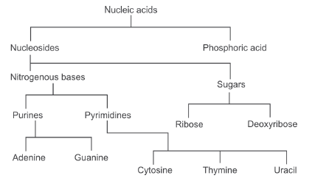

Structure of DNA
DNA molecules consists of two polynucleotide chains running in opposite directions and coiled in such a way that adenine of one strand is always in front of thymine of other strand. Guanine of one chain always faces cytosine in complementary strand.
These pairs of bases (A:T, G:C) are bonded by weak hydrogen bonds.
This arrangement of bases is called base pairing rules and the overall structure is called as double helical structure.
In each DNA molecule, the deoxyribose sugar is attached to a phosphoric acid at one side and a nitrogenous base at other side. The phosphoric acid molecule is linked to sugar at carbon atom no. 3 or 5.
At one end of polynucleotide chain, third carbon of sugar is free called as 3’ end and at the other end 5th carbon of sugar is free, called as 5’ end. The 3’ end of one chain lies close to 5’ end of other chain. Hence two strands of DNA are anti parallel.
The polynucleotide chains of DNA molecule are linked by nucleotides of adjacent chain.
In mammalian cells, DNA is always formed in nucleus where it exists in combination with basic proteins (histones) giving rise to structures, which are called chromosomes.

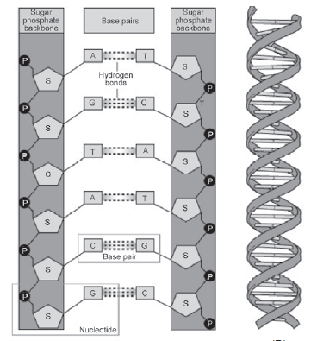
Structure of DNA

Important notes about DNA structures should be kept in mind:
• The number of purine bases equals the number of pyrimidine bases.
• The number of adenine bases equals the number of thymine bases.
• The number of guanine bases equals the number of cytosine bases.
• The two polynucleotide chains run in opposite directions (one in 3’ → 5’ and the other in 5’ → 3’).
• Within the double helix adenine and thymine are connected by two hydrogen bonds on the opposite strand while guanine and cytosine are connected by three hydrogen bonds with cytosine on the opposite strand.
• The intertwined strands make two grooves of different widths, referred to as the major groove and the minor groove, which may facilitate binding with specific proteins.
The functions of DNA are vital for inheritance, coding for proteins and the genetic blueprint of life.
Structure and function of RNA
Both RNA and DNA are sugar-phosphate polymers and both have nitrogen bases attached to the sugars of the backbone, but they differ in the following features:
Difference | DNA | RNA
Site | Found in nucleus | Found in nucleus & cytoplasm
Bases & Sugars | DNA is a long polymer with a deoxyribose and phosphate backbone and four different bases: adenine, guanine, cytosine and thymine | RNA is a polymer with a ribose and phosphate backbone and four different bases: adenine, guanine, cytosine, and uracil
Definition: | A nucleic acid that contains the genetic instructions used in the development and functioning of all known living organisms | RNA, single-stranded chain of alternating phosphate and ribose units with the bases adenine, guanine, cytosine, and uracil bonded to the ribose. RNA molecules are involved in protein synthesis and sometimes in the transmission of genetic information.
Function | Medium of long-term storage and transmission of genetic information | The main job of RNA is to transfer the genetic code need for the creation of proteins from the nucleus to the ribosome. this process prevents the DNA from having to leave the nucleus, so it stays safe. Without RNA, proteins could never be made.
Predominant Structure | Typically a double- stranded molecule with a long chain of nucleotides | A single-stranded molecule in most of its biological roles and has a shorter chain of nucleotides
Stability | Less reactive | More reactive
Effects of UV ray | DNA can be damaged by exposure to Ultraviolet rays | RNA is more resistant to damage by Ultra-violet rays.

Types of RNA
1- Messenger RNA (mRNA)
mRNA accounts for just 5% of the total RNA in the cell, it is the most heterogeneous of the 3 types of RNA in terms of both base sequence and size.
It carries the genetic code copied from the DNA during transcription in the form of triplets of nucleotides called codons. Each codon specifies a particular amino acid, but one amino acid can be coded by many different codons. Although there are 64 possible codons or triplet bases in the genetic code, only 61 of them represent amino acids; the remaining 3 are stop codons.

2- Ribosomal RNA (rRNA)
rRNAs are found in the ribosomes and account for 80% of the total RNA present in the cell.
rRNAs combine with proteins in the cytoplasm to form ribosomes, which act as the site of protein synthesis and has the enzymes needed for the process.

3- Transfer RNA (tRNA)
tRNA is the smallest of the 3 types of RNA having about 75-95 nucleotides. tRNAs are an essential component of translation, where their main function is the transfer of amino acids during protein synthesis.
Each of the 20 amino acids has a specific tRNA that binds with it and transfers it to the growing polypeptide chain.

The process of protein synthesis
The synthesis of proteins takes two steps: transcription and translation.
Transcription takes the information encoded in DNA and encodes it into mRNA, which heads out of the cell’s nucleus and into the cytoplasm.
During translation, the mRNA works with a ribosome and tRNA to synthesize proteins.
In other words:
DNA >>>_transcription _>> RNA >>>_translation _>>> protein

- Transcription
The first step in transcription is the partial unwinding of the DNA molecule so that the portion of DNA that codes for the needed protein can be transcribed. Once the DNA molecule is unwound at the correct location, an enzyme called RNA polymerase helps line up nucleotides to create a complementary strand of mRNA. Since mRNA is a single-stranded molecule, only one of the two strands of DNA is used as a template for the new RNA strand.

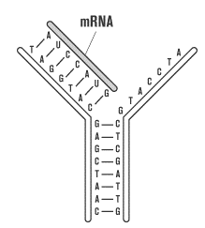
The new strand of RNA is made according to the rules of base pairing:
- DNA cytosine pairs with RNA guanine
- DNA guanine pairs with RNA cytosine
- DNA thymine pairs with RNA adenine
- DNA adenine pairs with RNA uracil
For example, the mRNA complement to the DNA sequence TTGCAC is AACGUG.
After transcription, the new RNA strand is released and the two unzipped DNA strands bind together again to form the double helix.
Because the DNA template remains unchanged after transcription, it is possible to transcribe another identical molecule of RNA immediately after the first one is complete.
A single gene on a DNA strand can produce enough RNA to make thousands of copies of the same protein in a very short time.

- Translation
In translation, mRNA is sent to the cytoplasm, where it binds with ribosomes, the sites of protein synthesis. Ribosomes have three important binding sites: one for mRNA and two for tRNA. The two tRNA sites are labeled the A site and P site.
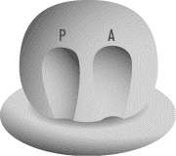
Once the mRNA is in place, tRNA molecules, each associated with specific amino acids, bind to the ribosome in a sequence defined by the mRNA code. tRNA molecules can perform this function because of their special structure. tRNA is made up of many nucleotides that bend into the shape of a cloverleaf. At its tail end, tRNA has an acceptor stem that attaches to a specific amino acid. At its head, tRNA has three nucleotides that make up an anticodon.
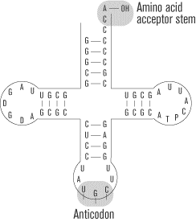
Structure of tRNA, lower stem is the anticodon stem, the upper stem is acceptor stem for aminoacid, on the left the ribosome binding stem, on the right the stem that has the ability to recognize specific enzymes.
An anticodon pairs complementary nitrogenous bases with mRNA. For example, if mRNA has a codon AUC, it will pair with tRNA’s anticodon sequence UAG. tRNA molecules with the same anticodon sequence will always carry the same amino acids, ensuring the consistency of the proteins coded for in DNA.

The Process of Translation
Translation begins with the binding of the mRNA chain to the ribosome. The first codon, which is always the start codon methionine, fills the P site and the second codon fills the A site. The tRNA molecule whose anticodon is complementary to the mRNA forms a temporary base pair with the mRNA in the A site. A peptide bond is formed between the amino acid attached to the tRNA in the A site and the methionine in the P site.
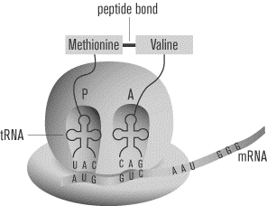
The ribosome now slides down the mRNA, so that the tRNA in the A site moves over to the P site, and a new codon fills the A site, (One way to remember this is that the A site brings new amino acids to the growing polypeptide at the P site.) The appropriate tRNA carrying the appropriate amino acid pairs bases with this new codon in the A site. A peptide bond is formed between the two adjacent amino acids held by tRNA molecules, forming the first two links of a chain.
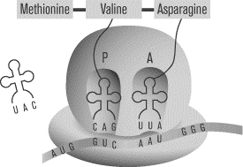
The ribosome slides again. The tRNA that was in the P site is let go into the cytoplasm, where it will eventually bind with another amino acid. Another tRNA comes to bind with the new codon in the A site, and a peptide bond is formed between the new amino acid to the growing peptide chain.
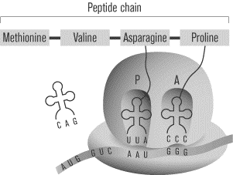
The process continues until one of the three stop codons enters the A site. At that point, the protein chain connected to the tRNA in the P site is released. Translation is complete.

So, translation is composed of three events occurred in an obligatory sequence:
1st: initiation
2nd: elongation
3rd: termination





