Nitrogen metabolism

Nitrogen is a fundamental component of amino acids, which are the molecular building components of protein. Proteins comprise not only structural components such as muscle, tissue and organs, but also enzymes and hormones essential for the functioning of all living things.
Amino acid catabolism is part of the larger process of the metabolism of nitrogen-containing molecules. Nitrogen enters the body in a variety of compounds present in food, the most important being amino acids contained in dietary protein.
Nitrogen leaves the body as urea, ammonia, and other products derived from amino acid metabolism.
Unlike fats and carbohydrates, amino acids are not stored by the body, that is, no protein exists whose major function is to maintain a supply of amino acids for future use.
For this reason, amino acids are obtained from:
1- The diet
2- Synthesized de novo
3- Produced from normal protein degradation.
Any amino acids in excess of the biosynthetic needs of the cell are rapidly degraded.

For proper understanding of nitrogen metabolism, it is important to discuss the following concepts:
Amino acid pool
Free amino acids are present throughout the body, for example, in cells, blood, and the extracellular fluids. The "nitrogen or amino acid pool" is a grand mixture of amino acids available in the cell.
This pool is supplied by three sources:
1) amino acids provided by the degradation of body proteins.
2) amino acids derived from dietary protein.
3) synthesis of non-essential amino acids from simple intermediates of metabolism.

Conversely, the amino pool is depleted by three routes:
1) synthesis of body protein.
2) amino acids consumed as precursors of essential nitrogen-containing small molecules.
3) conversion of amino acids to glucose, glycogen, fatty acids, ketone bodies.
Although the amino acid pool is small (comprised of about 90–100 g of amino acids) in comparison with the amount of protein in the body (about 12 kg in a 70-kg man), it is conceptually at the center of whole-body nitrogen metabolism.

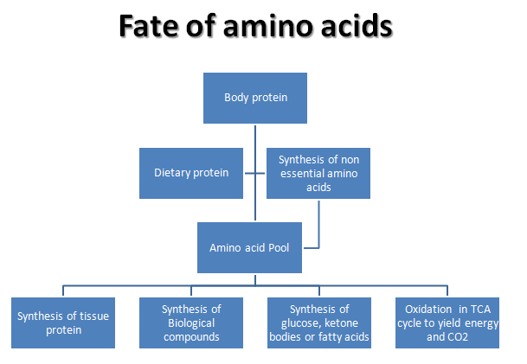

Nitrogen balance is a measure of nitrogen input minus nitrogen output.
Positive nitrogen balance is associated with periods of:
- Growth
- Hypothyroidism
- tissue repair
- pregnancy
This means that the intake of nitrogen into the body is greater than the loss of nitrogen from the body, so there is an increase in the total body pool of protein.
Negative nitrogen balance is associated with:
- burns
- serious tissue injuries
- fevers
- hyperthyroidism
- wasting diseases
- during periods of fasting.
This means that the amount of nitrogen excreted from the body is greater than the amount of nitrogen ingested.
A negative nitrogen balance can be used as part of a clinical evaluation of malnutrition.

Protein turnover
Most proteins in the body are constantly being synthesized and then degraded, permitting the removal of abnormal or unneeded proteins.
Rate of turnover
In healthy adults, the total amount of protein in the body remains constant, because the rate of protein synthesis is just sufficient to replace the protein that is degraded. This process, called protein turnover, leads to the hydrolysis and resynthesis of 300–400 g of body protein each day.
The rate of protein turnover varies widely for individual proteins. Short-lived proteins (for example, many regulatory proteins and misfolded proteins) are rapidly degraded, having half-lives measured in minutes or hours. Long-lived proteins, with half-lives of days to weeks, constitute the majority of proteins in the cell.
Structural proteins, such as collagen, are metabolically stable, and have half-lives measured
in months or years.
Protein degradation:
There are two major enzyme systems responsible for degrading damaged or unneeded proteins:
- the ATP-dependent ubiquitin-proteasome system of the cytosol.
- the ATP-independent degradative enzyme system of the lysosomes.
Proteasomes degrade mainly endogenous proteins, that is, proteins that were synthesized within the cell. Lysosomal enzymes degrade primarily extracellular proteins, such as plasma proteins that are taken into the cell by endocytosis, and cell-surface membrane proteins that are used in receptor-mediated endocytosis.

Digestion of dietary proteins
Most of the nitrogen in the diet is consumed in the form of protein, typically amounting to 70–100 g/day.
Proteins are generally too large to be absorbed by the intestine. They must, therefore, be hydrolyzed to yield di- and tripeptides as well as individual amino acids, which can be absorbed. Proteolytic enzymes responsible for degrading proteins are produced by three different organs: the stomach, the pancreas, and the small intestine.

Transport of amino acids into cells
The concentration of free amino acids in the extracellular fluids is significantly lower than that within the cells of the body. This concentration gradient is maintained because active transport systems, driven by the hydrolysis of ATP, are required for movement of amino acids from the extracellular space into cells.
At least seven different transport systems are known that have overlapping specificities for different amino acids. The small intestine and the proximal tubule of the kidney have common transport systems for amino acid uptake; therefore, a defect in any one of these systems results in an inability to absorb particular amino acids into the gut and into the kidney tubules.
Amino acids are absorbed by the small intestine by primary active transport.

REMOVAL OF NITROGEN FROM AMINO ACIDS
The presence of the α-amino group keeps amino acids safely locked away from oxidative breakdown. Removing the α-amino group is essential for producing energy from any amino acid and is an obligatory step in the catabolism of all amino acids.
Once removed, this nitrogen can be incorporated into other compounds or excreted, with the carbon skeletons being metabolized.
Transamination and oxidative deamination reactions will be discussed here as they represent the major reactions in amino acids catabolism:

A. Transamination: the funneling of amino groups to glutamate
The first step in the catabolism of most amino acids is the transfer of their α-amino group to α-ketoglutarate. The products are an α-keto acid (derived from the original amino acid) and glutamate.
α-Ketoglutarate plays a pivotal role in amino acid metabolism by accepting the amino groups from most amino acids, thus becoming glutamate. Glutamate produced by transamination can be oxidatively deaminated, or used as an amino group donor in the synthesis of nonessential amino acids.
This transfer of amino groups from one carbon skeleton to another is catalyzed by a family of enzymes called aminotransferases (formerly called transaminases).
These enzymes are found in the cytosol and mitochondria of cells through out the body especially those of the liver, kidney, intestine, and muscle.
The general process of transamination is reversible and is catalyzed by transaminases, also called amino transferases that require B6-phosphate as coenzyme.

Substrate specificity of aminotransferases:
Each aminotransferase is specific for one or, at most, a few amino group donors.
Aminotransferases are named after the specific amino group donor, because the acceptor of the amino group is almost always α-ketoglutarate.
The two most important aminotransferase reactions are catalyzed by alanine aminotransferase (ALT) and aspartate aminotransferase (AST).

Transamination is used both for the catabolic as well as anabolic processes because it is a reversible process, so, it is also useful for the synthesis of non essential amino acids.
The resultant α-Keto acid can be completely oxidized to provide energy, glucose, fats or ketone bodies depending upon the cellular requirement.

Plasma AST and ALT are elevated in nearly all liver diseases, but are particularly high in conditions that cause extensive cell necrosis, such as:
- severe viral hepatitis
- toxic injury
- prolonged circulatory collapse
ALT is more specific than AST for liver disease, but the latter is more sensitive because the liver contains larger amounts of AST.

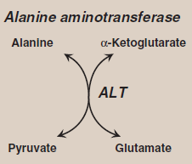

B- The oxidative deamination of amino acids (Glutamate dehydrogenase)
In contrast to transamination, reactions that transfer amino groups, oxidative deamination by glutamate dehydrogenase, results in the liberation of the amino group as free ammonia (NH₃). These reactions occur primarily in the liver and kidney. They provide α-keto acids that can enter the central pathway of energy metabolism, and ammonia, which is a source of nitrogen in urea synthesis.
As described earlier, the amino groups of most amino acids are ultimately funneled to glutamate by means of transamination with α-ketoglutarate.
Glutamate is unique in that it is the only amino acid that undergoes rapid oxidative deamination, a reaction catalyzed by glutamate dehydrogenase. Therefore, the sequential action of transamination (resulting in the collection of amino groups from most amino acids onto α-ketoglutarate to produce glutamate) and the oxidative deamination of that glutamate (regenerating α-ketoglutarate) provide a pathway whereby the amino groups of most amino acids can be released as ammonia.
Glutamate dehydrogenase is unusual in that it can use either NAD⁺ or NADP⁺ as a coenzyme.

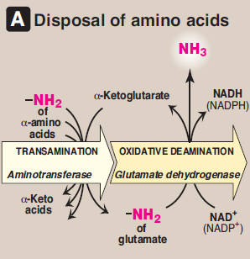 | 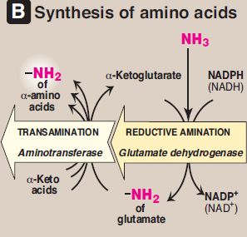
Combined actions of aminotransferase and glutamate dehydrogenase reactions.

Transport of ammonia to the liver
Two mechanisms are available in humans for the transport of ammonia from the peripheral tissues to the liver for its ultimate conversion to urea.
The first, found in most tissues, uses glutamine synthetase to combine ammonia (NH₃) with glutamate to form glutamine, a nontoxic transport form of ammonia. The glutamine is transported in the blood to the liver where it is cleaved by glutaminase to produce glutamate and free ammonia.
The second transport mechanism, used primarily by muscle, involves transamination of pyruvate (the end product of aerobic glycolysis) to form alanine.
Alanine is transported by the blood to the liver, where it is converted to pyruvate, again by transamination.

METABOLISM OF AMMONIA
Ammonia is produced by all tissues during the metabolism of a variety of compounds, and it is disposed of primarily by formation of urea in the liver. However, the level of ammonia in the blood must be kept very low, because even slightly elevated concentrations (hyperammonemia) are toxic to the central nervous system (CNS).
There must, therefore, be a metabolic mechanism by which nitrogen is moved from peripheral tissues to the liver for ultimate disposal as urea, while at the same time maintaining low levels of circulating ammonia.

Sources of ammonia
Amino acids are quantitatively the most important source of ammonia, because most of our diets are high in protein and provide excess amino acids, which travel to the liver and undergo transdeamination, the linking of aminotransferase and glutamate dehydrogenase reactions, producing ammonia.
However, substantial amounts of ammonia can be obtained from other sources:
1. From glutamine:
The kidneys generate ammonia from glutamine by the actions of renal glutaminase and glutamate dehydrogenase.
Most of this ammonia is excreted into the urine as NH₄⁺, which provides an important mechanism for maintaining the body’s acid-base balance through the excretion of H⁺.
2. From bacterial action in the intestine:
Ammonia is formed from urea by the action of bacterial urease in the lumen of the intestine.
This ammonia is absorbed from the intestine by way of the portal vein and is almost quantitatively removed by the liver via conversion to urea.
3. From amines:
Amines obtained from the diet, and monoamines that serve as hormones or neurotransmitters, give rise to ammonia by the action of amine oxidase .
4. From purines and pyrimidines:
In the catabolism of purines and pyrimidines, amino groups attached to the rings are released as ammonia.

Although ammonia is constantly produced in the tissues, it is present at very low levels in blood. This is due both to the rapid removal of blood ammonia by the liver, and the fact that many tissues, particularly muscle, release amino acid nitrogen in the form of glutamine or alanine, rather than as free ammonia.
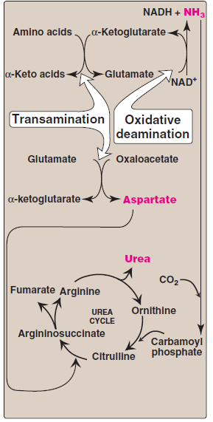
UREA CYCLE
Urea is the major disposal form of amino groups derived from amino acids, and accounts for about 90% of the nitrogen-containing components of urine. One nitrogen of the urea molecule is supplied by free ammonia, and the other nitrogen by aspartate. Urea cycle requires enzymes that are present in both mitochondria and cytoplasm.
Urea is produced by the liver, and then is transported in the blood to the kidneys for excretion in the urine.
Fate of urea:
Urea diffuses from the liver, and is transported in
the blood to the kidneys, where it is filtered and excreted in the urine.
A portion of the urea diffuses from the blood into the intestine, and is cleaved to CO₂ and NH₃ by bacterial urease. This ammonia is partly lost in the feces, and is partly reabsorbed into the blood.
In patients with kidney failure, plasma urea levels are elevated, promoting a greater transfer of urea from blood into the gut. The intestinal action of urease on this urea becomes a clinically important source of ammonia, contributing to the hyperammonemia often seen in these patients.
Oral administration of neomycin reduces the number of intestinal bacteria responsible for this NH₃ production.
*********************************************************************************************************
In summary
Nitrogen enters the body in a variety of compounds present in food, the most important being amino acids contained in dietary protein.
Nitrogen leaves the body as urea, ammonia, and other products derived from amino acid metabolism.
Free amino acids in the body are produced by hydrolysis of dietary protein by proteases in the stomach and intestine, degradation of tissue proteins, and de novo synthesis.
This amino acid pool is consumed in the synthesis of body protein, metabolized for energy, or its members serve as precursors for other nitrogen-containing compounds.
Note that body protein is simultaneously degraded and resynthesized a process known as protein turnover.
For many proteins, regulation of synthesis determines the concentration of the protein in the cell, whereas the amounts of other proteins are controlled by selective degradation.
The ATP-dependent ubiquitin/proteasome and ATP-independent lysosomal acid hydrolases are the two major enzyme systems that are responsible for degrading damaged or unneeded proteins.
Nitrogen cannot be stored, and amino acids in excess of the biosynthetic needs of the cell are immediately degraded.
The first phase of catabolism involves the transfer of the α-amino groups by B6 phosphate -dependent transamination, followed by oxidative deamination of glutamate, forming ammonia and the corresponding α-keto acids.
A portion of the free ammonia is excreted in the urine, some is used in converting glutamate to glutamine, but most is used in the synthesis of urea, which is quantitatively the most important route for disposing of nitrogen from the body.
The two major causes of hyperammonemia (with its CNS effects) are liver disease and inherited deficiencies of enzymes in the urea cycle.
------------------------------------------------------------------------------------------------------------------------------------------------------------------------------------------------------------------------------------------------

