
Lab1 Cytology 2021-2020

Why do we study Cytology??

Cytology, commonly known as cell biology, studies cell structure and the interaction of cells with other cells and the larger environment in which they exist. Microscopic and molecular studies of cells can focus on either single or single-celled organisms.
That fact that we as humans are made up of millions of tiny cells, and that other life forms around us are similarly constituted. Recognizing the similarities and differences of cells is the most importance in cytology. Microscopic examination can help identify different types of cells. Looking at the molecules which form a cell, sometimes called molecular biology, helps in further description and identification. All fields of biology depend on the understanding of cellular structure. The field of genetics exists because we understand cell structure and components.

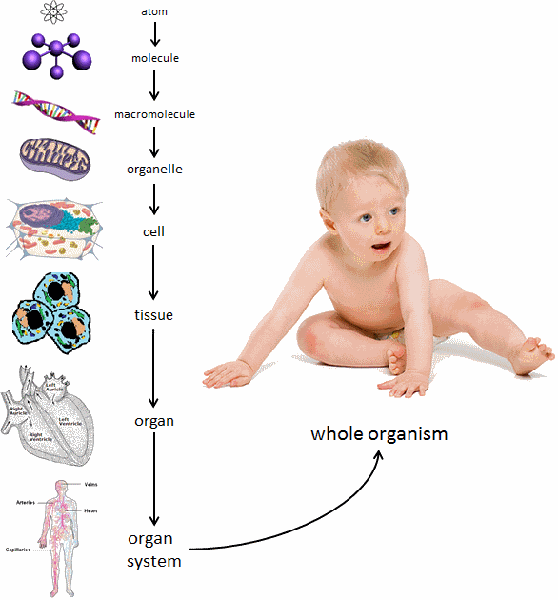

From atom to the whole organism, different levels of organization in which cells are the building blocks of life.
Lab1 Cytology 2021-2020
Microscope
Microscope is an is an instrument that uses visible light and magnifying lenses to examine small objects not visible to the naked eye, or in finer detail than the naked eye allows.
- Types of Microscope:
- Light Microscope.
- 2- Electron Microscope.
- 3- Dissecting Microscope.

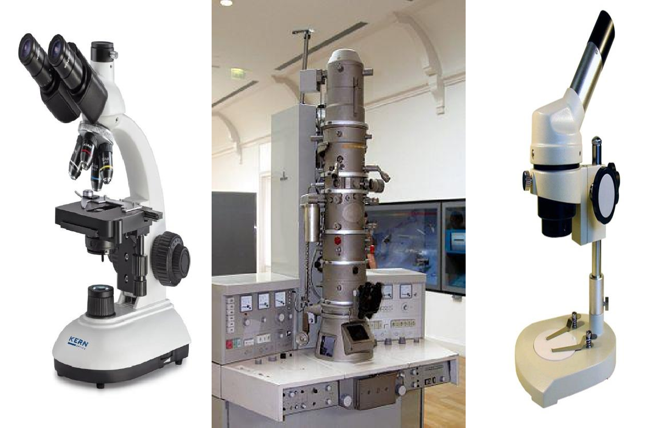

Figure (1) Types of Microscope

Lab1 Cytology 2021-2020
Parts of Microscope
- Ocular lenses (eye lenses): is located at the top of the microscope, alone can magnifying objects 10X. Some lenses have a pointer used to point on a specific part.

Body tube: connect the eye lenses to the nose piece of microscope.

- Revolving nose: a rotating disc holds the objective lenses, also used to change the objective lenses from one power to another.
- Objective lenses: located near the object and they are four types:

Scanning objective lenses (4X).

  - Low power objective lenses (10X).

  - High power objective lenses (40X).

  - Oil immersion objective lenses (100X).

    - Oil immersion lens must use with a drop of oil.

Total magnifying = ocular lenses x objective lenses

- Arm: connect the base to the tube.

- Stage: In which the slide is placed.

- Clips: two clips which hold the slide.

- Coarse adjustment: used to adjustment the distance between the stage and objective lenses (low power).

Lab1 Cytology 2021-2020
- Fine adjustment: used to adjustment the distance between the stage and objective lenses (High power).
- Condenser: used to focus the light onto the object.

Light source.

- Base.

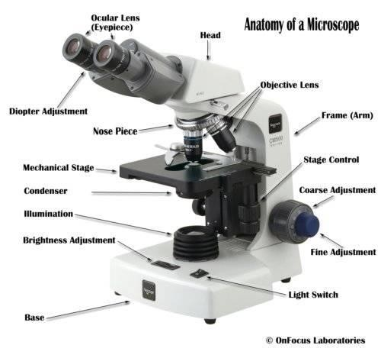

Figure (2) Anatomy of Light Microscope

