
Lab2 Cytology 2021-2020

How to make a Slide
Slide: a rectangular piece of glass or plastic on which you place the specimen.
Cover slide: thin square piece of glass or plastic which you place it over the specimen on the slide.
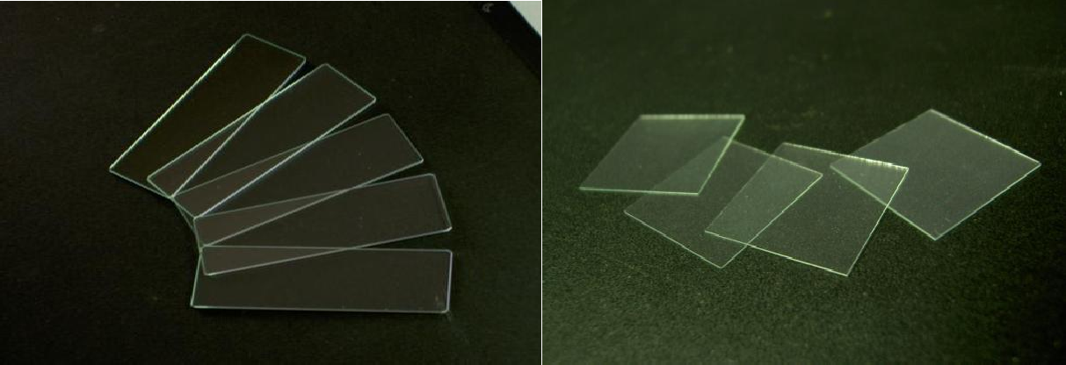
Figure (1) Glass slide and Slide cover

How to make plant cells slide?
- Take the onion and slice it into small pieces and take thin an inside layer and put it on the slide.
- Stain the specimen with one of these dyes (Iodine , Methylene blue , Crystal Violate) in order to increase the contrast.
- After that place the cover slide slowly to ensure not making gas bubbles and then use a towel to ensure the absorption of the excess dyes.
- Examine your slide under the microscope.
- Caution “the dyes will stain the skin or clothes, they are also harmful if they are ingested.

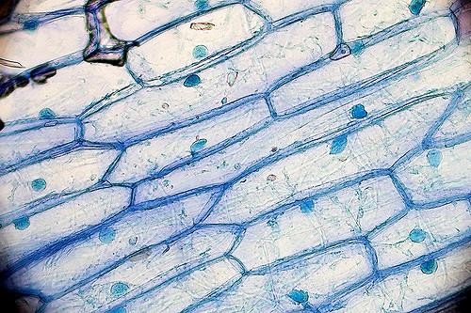

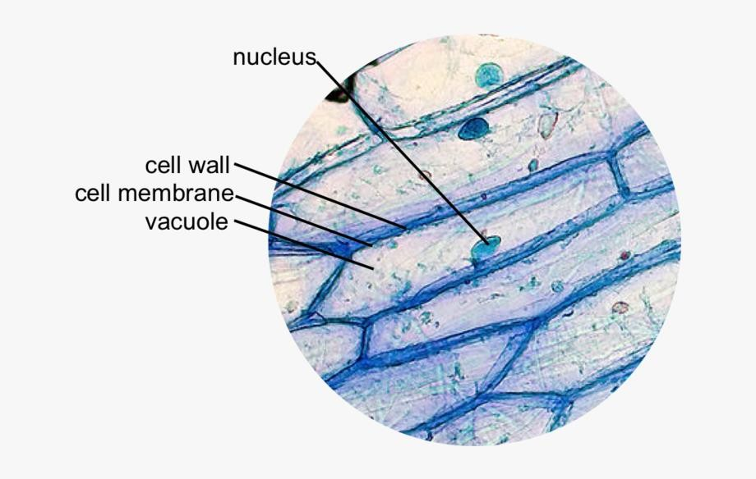
Figure (2) Onion Epithelial cells under microscope

How to make Animal cells slide?
  - In order to gain animal cells slide we use a swap and put it inside the mouth (check) and then put it on the slide.
  - Adding drops of the dye (methylene blue).
  - Put the cover slide and then use a towel at the edges of the slide to ensure absorption of the excess dyes.
  - Examine your slide under microscope.
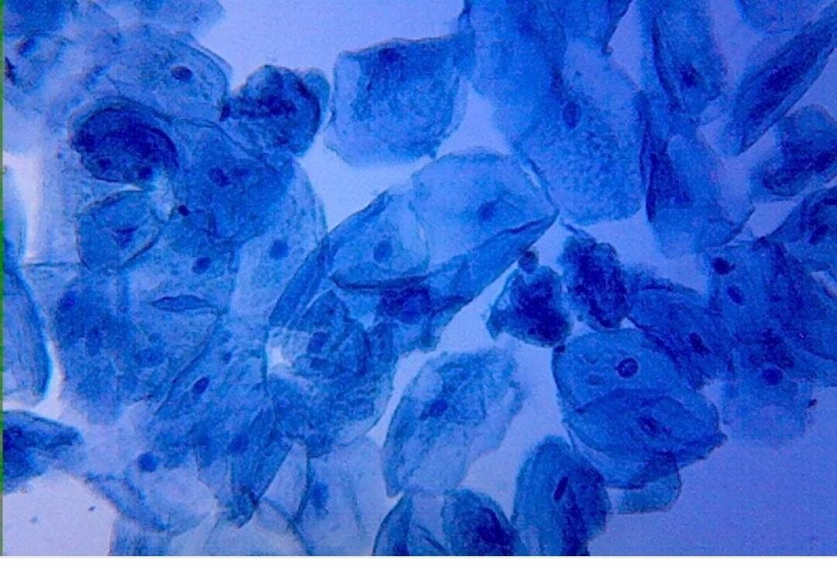

Figure (3) Human check Epithelial cells under microscope

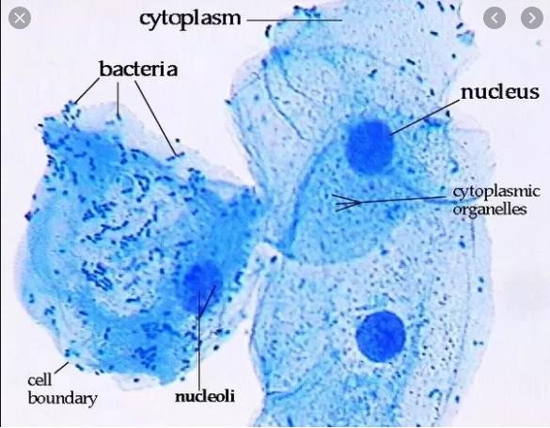

Figure (4) Human check Epithelial cells under microscope (100x)

Homework: Differences between Plant and Animal cell.

