Non-living cellular components

(Cytoplasmic inclusions)
The non-living cell inclusions include Ergastic substances and cytoskeleton elements:
- Ergastic substances: These are non-living cell inclusions of cytoplasm like
- Reserve food materials (starch, protein, and oils).
- Secretory products (nectar, pigments, and enzymes).
- Excretory products (alkaloids, resins, latex, and tannins).
- Mineral crystals (prismatic, cystoliths, raphides, druses).
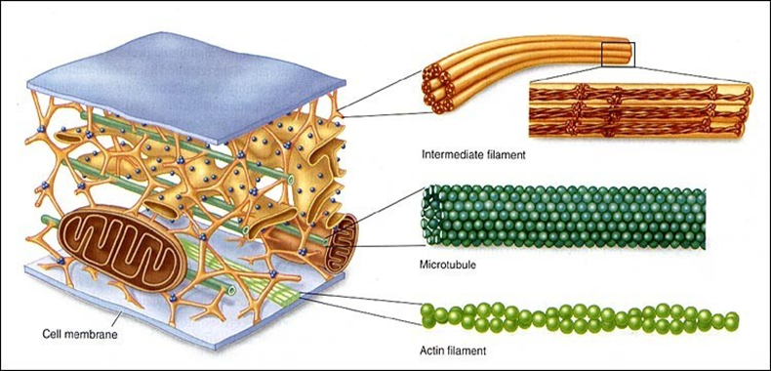
- Cytoskeleton: It is a complex network of interconnected microfilaments and microtubules of protein fibres present in cytoplasm. The microfilaments are composed of actin and microtubules are composed of tubulins. It helps in mechanical support, cell motility, cell division and maintenance of the shape of the cell (Figure 4.1).
Figure 4.1: Cytoskeleton: Intermediate filaments, microtubules and actin Filament.

Starch grain

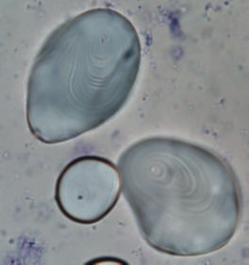
Starch grains are small granules found in the leaves, roots, stems, fruits and seeds of plants. These grains serve as energy reserves for plants.

Figure 4.2: Starch grains in potato tissue.

Pigments granules

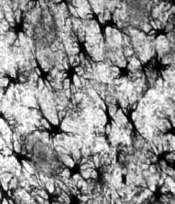
Pigments such as melanin synthesized by melanocytes. It is located in skin and it contributes to the color of skin and protect it from the Ultraviolet rays.

Figure 4.3: Melanophores pigments in frog skin.

Crystals

Crystals function in physical protection against grazing animals is implicated by the size, shape and placement of crystals in some tissues and organs.

Types of crystals
1-Prismatic crystal
2- Raphides crystals
3- Druses crystals
4- Cystolith crystals
Figure 4.4: Crystal in plant cells

Vacuoles:
A vacuole is a membrane-enclosed fluid filled sac found in the cells of plants including fungi. (Figure 4.5 -A and B).

Vacuoles appear to have three main functions, they:
    - Contribute to the rigidity of the plant.
    - Store nutrient and non-nutrient chemicals.
    - Break-down complex molecules including material may be harmful for the cell.
    - Play a major role in autophagy, endocytosis and exocytosis.

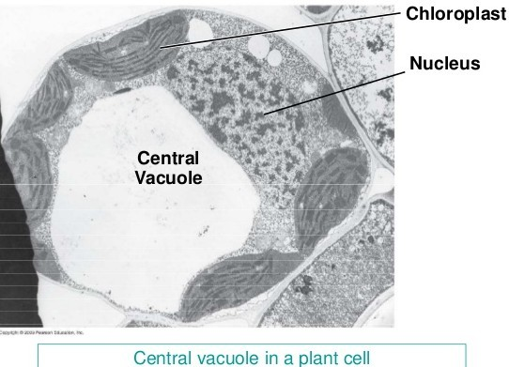
A
B

Figure 4.5: Vacuoles: A in plant cell and B in animal cell
