
Lab5 Cytology 2021-2020

Chromosomes and Nucleic acids Structures
Genetics: is a branch of biology that deals with heredity, which means the traits that passes from the parents to the children “offspring” through genes.
Chromosomes: are complex of DNA and protein called Chromatin that condensed during cell division.
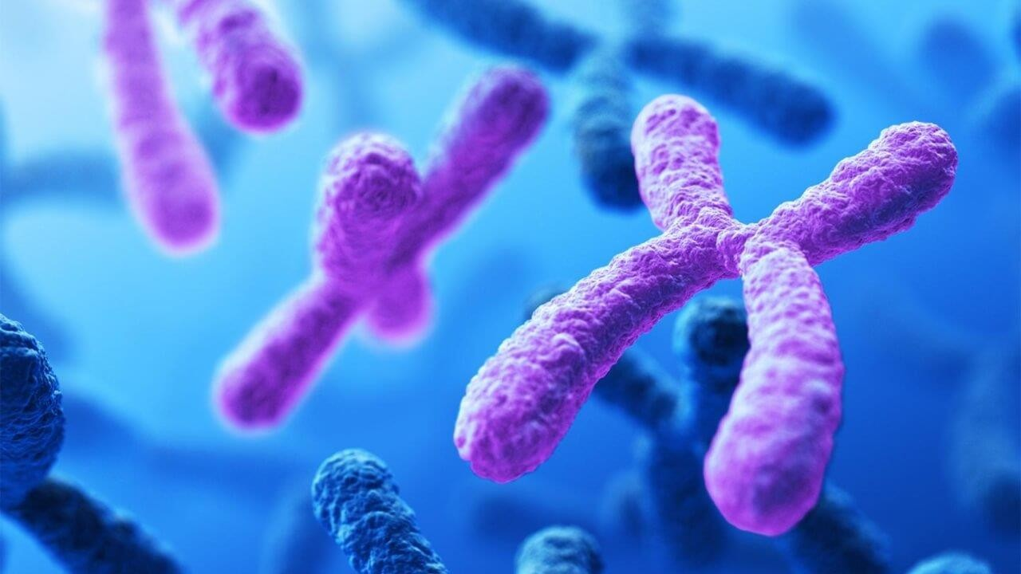

Figure (1) the shape of Chromosome

- The DNA warps twice around group of Histone protein to form

Nucleosome.
- Each chromosome is formed by two Chromatids they are held together by

Centromer.

- Gene: is a sequence of DNA or RNA that code for a molecule that has a function or trait in the organism.
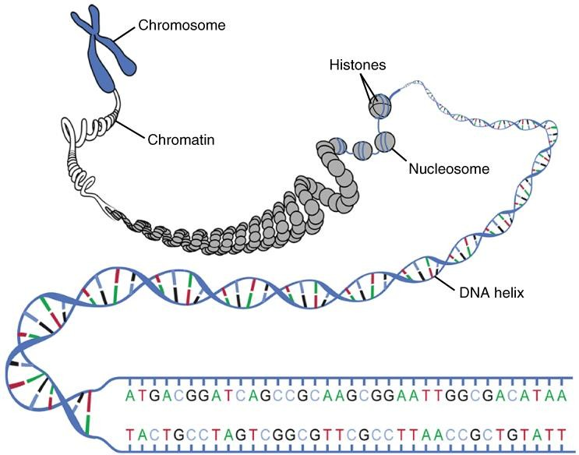

Figure (2) DNA macrostructure

  - DNA and RNA are molecular structures composed of repeated nucleotides called polynucleotide.
  - The Blocks “Nucleotides” are formed from:

Nitrogenous bases: Purines (A,G) , Pyrimidines (C,T) in DNA but Pyrimidines in RNA are (C,U).
    - Ribose sugar: Deoxyribose in DNA , ribose in RNA. 3- Phosphate group.

  - Nitrogenous base + Pentose sugar = Nucleoside.

Nucleoside attached to Phosphate group by Ester bond form
Nucleotide.

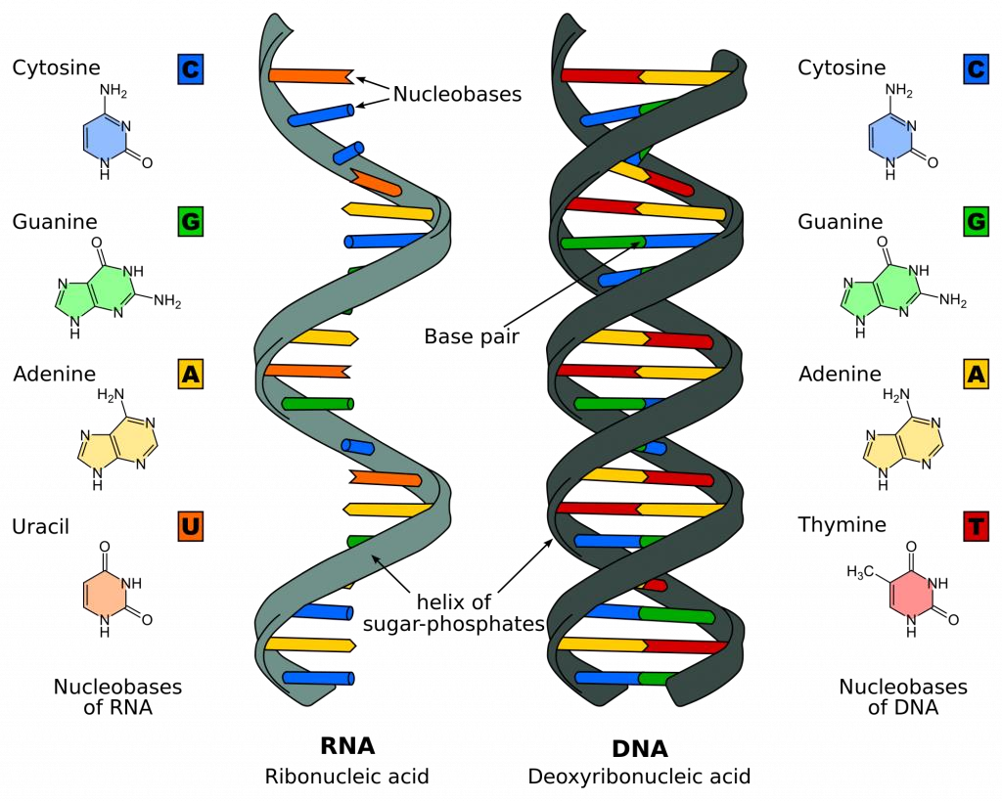

Figure (3) DNA Structure

Types of Chromosomes

Human has 46 chromosome which means (23) pairs and they are two types:
      - Somatic chromosomes: they are (22) pairs found in each cell except the sex cells (Diploid).

      - Sex chromosomes: they are only one pair found in sex cells (Haploid).
Sex cells (Gametes) are two types:
1- Sperms they are produced by a process called Spermatogenesis. 2- Eggs they are produced by a process called Oogenesis.
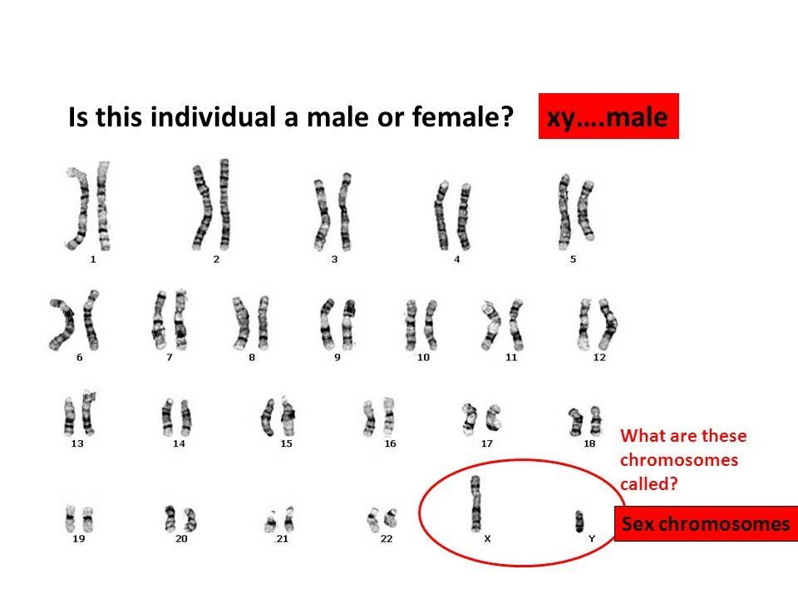

Figure (4) Human chromosomes

