
Lab6 Cytology 2021-2020

Cell Division & Cell Cycle
Cell cycle: means a series of events that lead to replication and division of cells.

During the cell cycle all the components of the cell (Organelles, Cytoplasm and DNA) are duplicated and the DNA is packed into coiled shape in Prokaryotes and Liner shape in Eukaryotes.

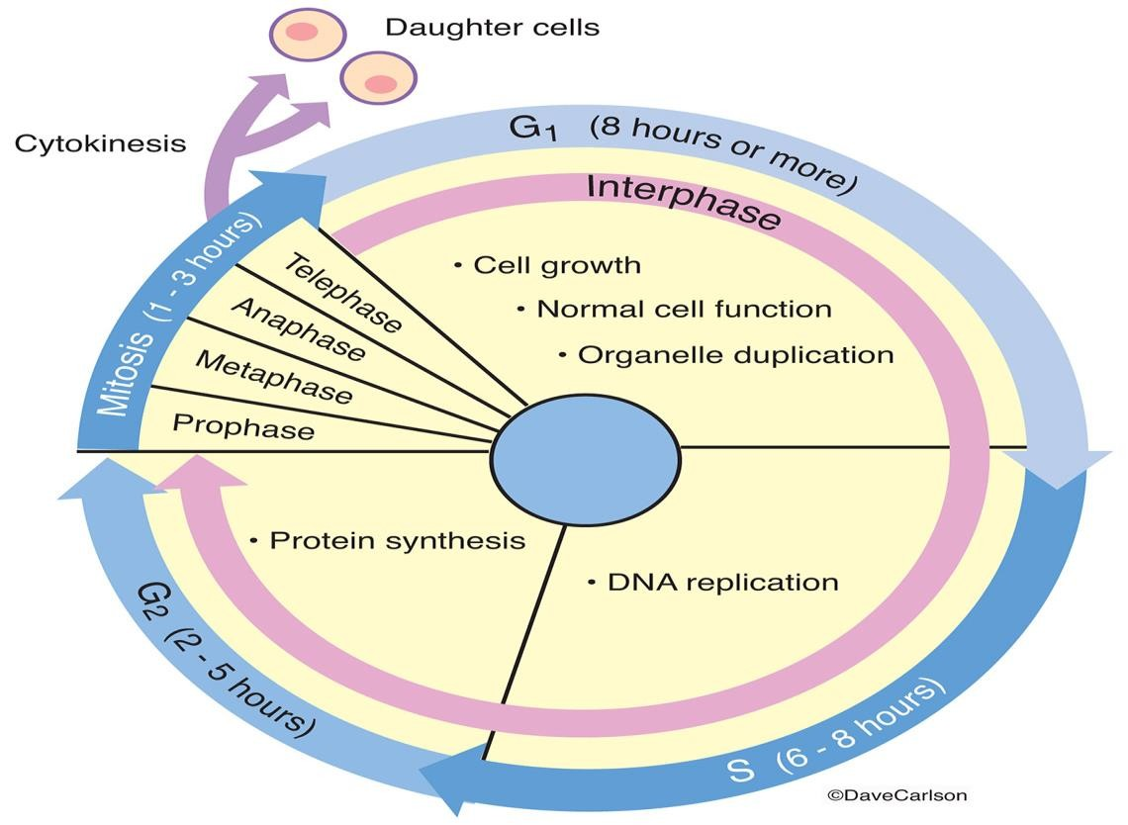

Figure (1) cell cycle

Lab6 Cytology 2021-2020

Phases of cell cycle

- Inter phase: this phase is divided to:

  - G1(gap) phase: cells grown in size and the organelles and cytoplasm are duplicated.
  - S (synthesis) phase: DNA (chromosomes) is replicated.
  - G2 phase: the growth of cells reach its maximum size and the cells are prepared to Mitosis (M phase)
- M (Mitosis) phase : this phase is divided to:

A- Prophase (preparation): the DNA recoils and the chromosomes condense, the nuclear membrane disappears, and the mitotic spindles begin to form.
- Metaphase (organization phase) : the chromosomes are line up in the middle of the cell with the help of spindle fibers attached to the centromere of each replicated chromosome.
- Anaphase (separation phase ) : the chromosomes split in the middle and the sister chromatids are pulled by the spindle fibers to opposite poles of the cell.
- Telophase : the chromosomes , along with the cytoplasm and its organelles and membranes are divided into 2 portions.

Lab6 Cytology 2021-2020

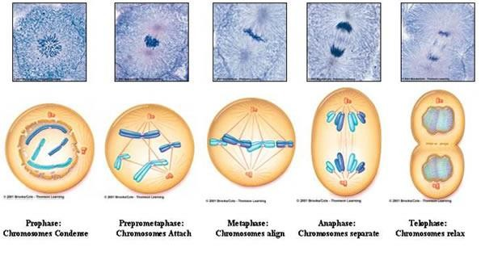
Figure (6) Phases of Mitosis
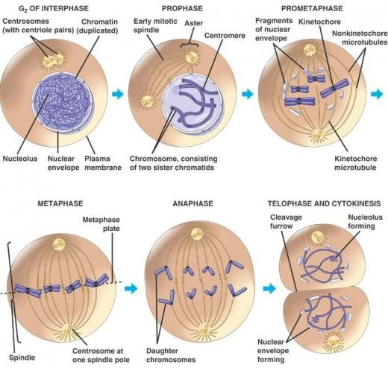

Lab6 Cytology 2021-2020

Cytokinesis

Cytokinesis means the splitting of the cells into two separate daughter cells and its occurs in both plant and animal cells.
Cytokinesis in plant cell is by forming cell plate. Cytokinesis in animal cell is by forming a cleavage furrow.
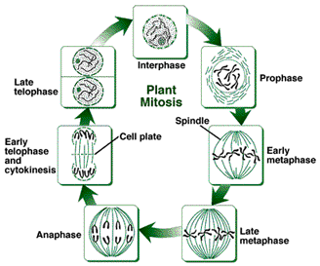

Figure (2) Mitosis in plant cell

Lab6 Cytology 2021-2020

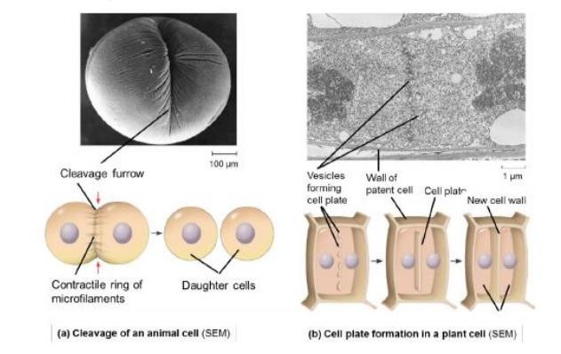

Figure (3) Difference between cytokinesis in plant and animal cell

The plant cell don’t have Asters and centrioles.

The Cell Cycle Control System
  - The sequential events of the cell cycle are directed by a distinctcell cycle control system, which is similar to a clock.
  - The clock has specific checkpoints where the cell cycle stops untila go- ahead signal is received
  - For many cells, the G1 checkpoint seems to be the most importantone.

Lab5 General Biology 2019-2020

  - If cells receives a go-ahead signal at the G1 checkpoint, the cell continues in the cell cycle.
  - If a cell does not receive a go-ahead signal at the G1checkpoint, the cell exits the cell cycle and goes into G0, a no dividing state.
  - The chemicals that regulate the cell cycle called cyclins. Cyclins a group of protein-regulate the timing of the cell cycle in eukaryotic cells.

