Mutation means a change in the gene, nucleotide, and sequence. It may occur at DNA base by adding or deletion or it may be at chromosomal level. Chromosome can exchange parts and genetic material can jump from one chromosome to another and these events caused mutations.
Types of mutations
1- Spontaneous mutations: or what is called germ line mutations occurred or pass to the offspring as a result from mutated alleles from parents.
- Achondroplasia means bone growth disorder that causes dwarfism. People with achondroplasia has normal torso but short limbs as a result from mutation in the 4th chromosome.

2- Induced mutations: these mutations may be occurs by influence factor from environment like (X-Ray, Gama Ray or UV-radiation).

3- Conditional mutation: affect the phenotype under certain conditions for example Hemolytic Anemia glucose 6 phosphate dehydrogenase deficiency , in this situation RBC are broken down, this deficiency is triggered by :
1- bacteria 2- viral infection 3- drugs (Antibiotics or drugs for malaria) 4- eating fava beans 5- inhaling pollen from fava beans.
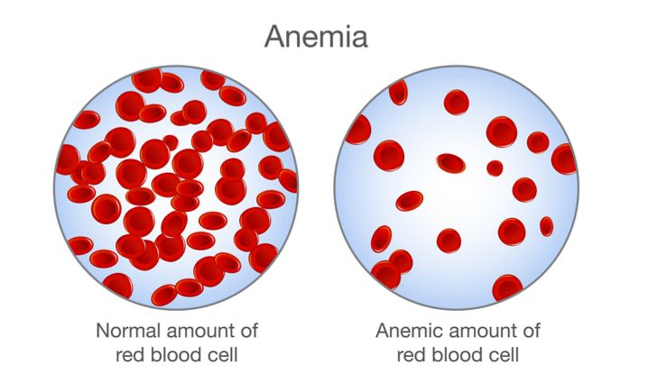
4- Drosophila mutations
Drosophila was a perfect organism in mutations studies because this organism has very low number of chromosomes and they were four pairs of chromosomes, three of them were somatic called Autosomes while the sex chromosome was one pair and they are called Allosomes.

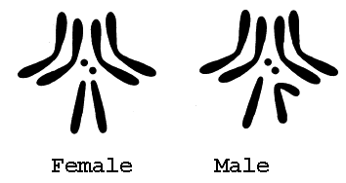
Drosophila chromosomes
Characteristics | Kind | Chromosome number | Number of mutations
Vestigial wing | Recessive | II | Single mutation
Dumpy wing | Recessive | II | Single mutation
Ebony body | Recessive | III | Single mutation
White eye | Recessive | I | Single mutation
Ebony-vestigial | Recessive | II , III | Double mutation
Ebony-dumpy | Recessive | II , III | Double mutation
Phenocopy
- Is a variation in phenotype (referring to single trait) which is caused by environmental conditions (often, but necessary, during organisms development), it’s not a mutation and it’s not hereditary.
- An clear example for phenocopies is the effect of AgNo₃ on the color of Drosophila body for, its effect on the mechanism of Tyrosinase enzyme.
- If the larvae of flies fed on the silver nitrate they develop into yellow bodies which it was in the first way brown.
- Another chemical factor is sodium metaborate that effects on the color of eyes of Drosophila.

