- DNA stands for deoxyribonucleic acid, while RNA is ribonucleic acid. Although DNA and RNA both carry genetic information, there are quite a few differences between them. This is a comparison of the differences between DNA versus RNA, including a quick summary and a detailed table of the differences.

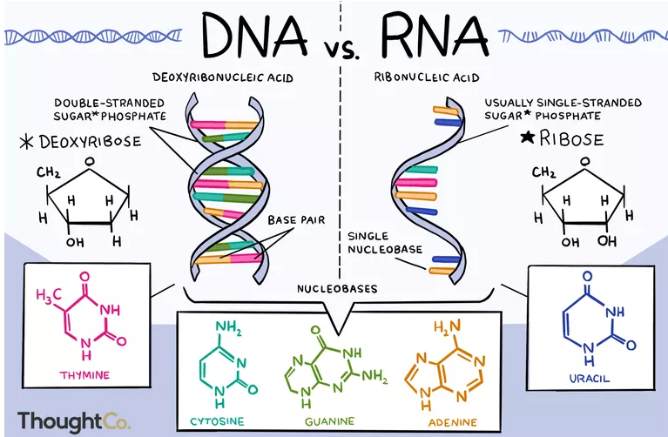

Differences between DNA and RNA
- DNA contains the sugar deoxyribose, while RNA contains the sugar ribose. The only difference between ribose and deoxyribose is that ribose has one more -OH group than deoxyribose, which has -H attached to the second (2') carbon in the ring.
- DNA is a double-stranded molecule while RNA is a single-stranded molecule.
- DNA is stable under alkaline conditions while RNA is not stable.
- DNA and RNA perform different functions in humans. DNA is responsible for storing and transferring genetic information while RNA directly codes for amino acids and as acts as a messenger between DNA and ribosomes to make proteins.
- DNA and RNA base pairing is slightly different since DNA uses the bases adenine, thymine, cytosine, and guanine; RNA uses adenine, uracil, cytosine, and guanine. Uracil differs from thymine in that it lacks a methyl group on its ring.

