Renal and Urinary Tract Diseases

Renal diseases are relatively common and have many different clinical presentations ranging from mild lower urinary tract infection to the disastrous renal failure. Many diseases of the kidney and urinary tract are clinically silent, at least in the early stages. Accordingly, it is common for these conditions to first be detected by routine blood tests or on dipstick testing of the urine.
Kidney function
The kidneys regulate and maintain the constant optimal chemical composition of the blood and interstitial and intracellular fluids throughout the body through integration of the major renal functions. The glomeruli have their distinct function that differ from tubular function, collectively known as renal function.
The main renal functions are classified into:
1- Excretory Functions
The excretory function of the kidneys serves to rid the body of many end products of metabolism and of excessive inorganic substances ingested in the diet. Waste products include the nonprotein nitrogenous compounds urea, creatinine, and uric acid; a number of other organic acids, including amino acids, are excreted in small quantities.
2- Reabsorptive Functions
Reabsorption at the renal tubules is mandatory to preserve essential molecules. Both excretory and absorptive functions work together for homeostasis of most plasma compounds.
The end result of the excretory and the reabsorptive functions of the kidneys is the formation of urine which has a highly variable concentration of its contents.
So, urine formation depends on three renal process:
1- glomerular filtration.
2- tubular excretion
3- tubular reabsorption
According to the previous facts, it becomes logical to say that the formation of urine depends on the following renal functions:
1- filtration
2- secretion
3- reabsorption

So: volume of urine = filtrate + secretion - reabsorption

3- Regulatory Functions
The main regulatory functions of kidneys include:
A- electrolyte homeostasis:
Electrolytes are: Na, K, Cl, Ca, HCO3, PO4, Mg.
Kidneys play a crucial role in the homeostasis of these electrolytes via various mechanisms in accordance with hormonal regulation or other mechanisms.
For example, calcium homeostasis depends on renal function as well as the action of vitamin D and parathyroid hormone.
B- water homeostasis:
Approximately 180 L glomerular filtrate is formed each day, approximately 99% of this to be reabsorbed in the production of urine.
In the kidney, different segments of the nephron show differing permeability to water, enabling the body to both retain water and produce urine of variable concentration.
4- Endocrine Function
The endocrine functions of the kidneys may be regarded as primary, because the kidneys are endocrine organs producing hormones, or as secondary, because the kidneys are a site of
action for hormones produced or activated elsewhere. In addition, the kidneys are a site of degradation for hormones such as insulin and aldosterone.
In their primary endocrine function, the kidneys produce erythropoietin (EPO), prostaglandins and thromboxanes, 1,25(OH2)D3, and renin.
A - The importance of renin in the maintenance of systemic blood pressure.
B - Erythropoietin : is responsible for stimulating erythroid progenitor cells within the bone marrow to produce red blood cells, this why a patient with chronic renal failure usually develops anemia.
C - Prostaglandins and Thromboxanes: has an important role in regulating the physiologic action of other hormones on renal vascular tone, mesangial contractility, and tubular processing of salt and water.
D- 1,25(OH2)D3: The kidneys are primarily responsible for producing 1,25(OH2)D3 from 25-hydroxycholecalciferol as a result of the action of the enzyme 25-hydroxycholecalciferol 1α-hydroxylase found in proximal tubular epithelial cells. Vitamin D is responsible for calcium homeostasis.

Presenting problems in renal and urinary tract disease
- Dysuria:
Dysuria refers to painful urination, often described as burning, and commonly accompanied by suprapubic pain. The most common cause of dysuria is urinary tract infection.
- Loin pain
This is usually caused by renal stones, ureteric stones, renal tumors, acute pyelonephritis and urinary tract obstruction.
Acute loin pain radiating anteriorly and often to the groin is termed renal colic. When combined with hematuria, this is typical of ureteric obstruction due to calculi.
- Oliguria/anuria
Oliguria is defined as being present when less than 300 mL urine is passed per day, whereas anuria is deemed to exist when less than 50 mL urine is passed per day. It can result from decreased renal perfusion, severe impairment of renal function, or obstruction of urinary tract.
- Polyuria
Polyuria is defined as a urine volume in excess of 3 L/day. Causes of polyuria include:
- Excess fluid intake
- Hyperglycemia
- Cranial diabetes insipidus
- Diuretics
- Interstitial nephritis
- Hypokalemia
- Hypercalcemia
- Nocturia
Nocturia is defined as waking up at night to void urine. It may be a consequence of polyuria but may also result from increased fluid intake or diuretic use in the late evening. Nocturia also occurs in chronic kidney disease, and in prostatic enlargement.
- Hematuria
Healthy individuals may have occasional red blood cells in the urine, but the presence of macroscopic hematuria (visible to the naked eye) or non-visible hematuria on dipstick testing is indicative of significant bleeding from somewhere in the urinary tract.
So many causes of hematuria are present which could not be related to renal system such as coagulopathy. Other causes include malignant tumors along the urinary tract, benign prostatic hyperplasia, cystitis, nephritis, renal stone, and many other causes.

- Edema
Edema is caused by an excessive accumulation of fluid within the interstitial space. Clinically, this can be detected by persistence of an indentation in tissue following pressure on the affected area (pitting edema).
Non-pitting edema is typical of lymphatic obstruction and may also occur as the result of excessive matrix deposition in tissues – for example, in hypothyroidism. Pitting edema tends to accumulate
in the ankles during the day and improves overnight as the interstitial fluid is reabsorbed.
- Hypertension
Hypertension is a very common feature of renal disease. Additionally, the presence of hypertension identifies a population at risk of developing chronic kidney disease.
Control of hypertension is very important in patients with renal impairment because of its close relationship with further decline of renal function and because of the exaggerated cardiovascular risk associated with chronic kidney disease .

Investigation of renal and urinary tract disease
- Urinanalysis
- Estimation of blood urea and serum creatinine.
- Estimation of glomerular filtration rate.
- Ultrasound
- CT scan, and MRI
- Renal arteriography, and intravenous urography
- Renal biopsy

Renal disorders are usually classified into:
- Acute and chronic.
- Glomerular and tubular.

ACUTE KIDNEY INJURY
Acute kidney injury (AKI), also referred to as acute renal failure, describes the situation where there is a sudden and often reversible loss of renal function, which develops over days or weeks and is usually accompanied by a reduction in urine volume.
There are many causes of AKI and it is frequently multifactorial.
It is often classified into three subtypes:
- Prerenal
when perfusion to the kidney is reduced, leading to acute tubular necrosis.
- Renal
when the primary insult affects the kidney itself; as in glomerulonephritis and drug toxicity.
- Post-renal
when there is obstruction to urine flow at any point from the tubule to the urethra, as seen in prostatic tumors and renal calculi.
Clinical features
Clinical features differ according to the cause:
Prerenal AKI
Patients with pre-renal AKI are typically hypotensive and tachycardic with signs of poor peripheral perfusion, such as delayed capillary return. In most cases the history is very suggestive and the cause is usually apparent. Oliguria and sometimes anuria is a classical symptom.
Renal AKI
Significant hematuria and proteinuria and may have clinical manifestations of an underlying disease, such as SLE or systemic vasculitis. Although blood tests, including an immunological screen, should be performed to clarify the diagnosis in glomerulonephritis, a renal biopsy is usually required.
Postrenal AKI
In most cases the patient has bilateral hydronephrosis suggesting the presence of distal obstruction.

Management of acute kidney injury
Correct hypovolemia and optimize systemic hemodynamic status with inotropic drugs if necessary.
• Administer glucose and insulin to correct hyperkalemia if K⁺ > 6.5 mmol/L.
• Consider administering sodium bicarbonate (100 mmol) to correct acidosis if pH < 7.0.
• Discontinue potentially nephrotoxic drugs and reduce doses of therapeutic drugs according to level of renal function.
• Match fluid intake to urine output plus an additional 500 mL to cover insensible losses once patient is euvolaemic.
• Measure body weight on a regular basis as a guide to fluid requirements.
• Ensure adequate nutritional support
• Administer proton pump antagonists to reduce the risk of upper gastrointestinal bleeding.
• Screen for intercurrent infections and treat promptly if present.

CHRONIC KIDNEY DISEASE
Chronic kidney disease (CKD), previously termed chronic renal failure, refers to an irreversible deterioration in renal function which usually develops over a period of years. Usually, biochemical abnormalities precede the development of clinical features.
Causes
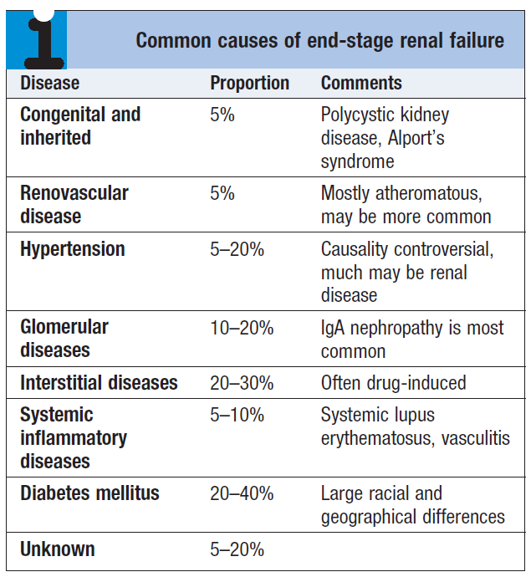

Clinical features
- Nocturia
- Shortness of breath
- Anorexia
- Pruritus
- Weight loss
- Nausea and vomiting
- Anemia
- Hiccups
- Fits
- Coma

Investigation
- High blood urea and serum creatinine.
- Anemia
- Hyperkalemia
- Hypocalcemia
- Albuminuria
- Ultrasound (small sized kidneys)

Management
The aims of management in CKD are
- to prevent or slow further renal damage.
- to limit the adverse physiological effects of renal impairment on the skeleton and on hematopoiesis.
- to treat risk factors for cardiovascular disease.
- to prepare for RRT, if appropriate.

- Antihypertensive therapy
Lowering of blood pressure slows the rate at which renal function declines in CKD, independently of the agent used, and has additional benefits in lowering the risk of hypertensive heart failure, stroke and peripheral vascular disease, as well as reducing proteinuria.

- Maintaining fluid and electrolyte balance
Patients with evidence of fluid retention should have sodium intake limited to about 100 mmol/day, but often loop diuretics may also be required to treat fluid overload.
- Dietary and lifestyle interventions
- Renal bone disease
Using active vitamin D supplement.
- Dialysis
Hemodialysis is better than peritoneal dialysis and is always preferred when feasible.

**********************************************************************************************************************************************************************************************************************************

