vitamins (I)

Vitamins are organic compounds required in trace amounts (microgram to milligram quantities per day) in the diet for health, growth, and reproduction.
Only small amounts of vitamins are required for the functional roles they serve, in contrast to the relatively large amounts of macronutrients as protein, lipid, and carbohydrate. Discovery of vitamins started from observation of deficiency manifestations, e.g. scurvy, rickets, beriberi, etc. The vitamin theory was suggested by Hopkins in 1912 (Nobel Prize, 1929). The term “vitamine” was coined from the words vital + amine, since the earlier identified ones had amino groups. Later work showed that most of them did not contain amino groups, so the last letter ‘e' was dropped in the modern term of vitamin.

Classification of vitamins
Vitamins have traditionally been grouped based on their solubility in water or fat;
1- water soluble vitamins:
These include vitamin B and C.
2- fat soluble vitamins :
These include vitamin A, D, E, and K.
Fat soluble vitamins are absorbed, transported, and stored for longer periods of time and in a manner generally similar to that used for fats, in other words fat soluble vitamins are absorbed as a component of micelle. Most water-soluble vitamins are retained less and excreted more in the urine.
In general, water-soluble vitamins function as coenzymes for several important enzymatic reactions; by contrast, the fat-soluble vitamins generally do not function as coenzymes.

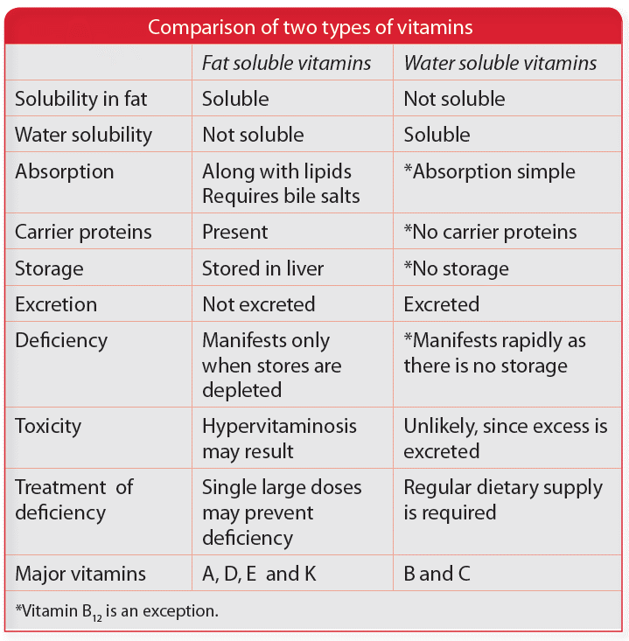

In general, causes of vitamins deficiency include:
1. Reduced intake
2. Impaired absorption
3. Impaired metabolism
4. Additional requirements
5. Increased losses.

Vitamin A
Vitamin A serves many important functions in the body, with its role in vision being of particular significance. Wald was awarded Nobel Prize in 1967, for identifying the role of vitamin A in vision.
It exists in 3 main forms:
1- Retinol, the principal form of vitamin A.
2- Retinal: the active form in retina.
3- Retinyl esters: it is the storage form.
The term retinoids refer to retinol, its metabolites, and synthetic analogs with similar structure.
As vitamin A is a fat soluble vitamin, it is integrated into micelle in order to be absorbed in the small intestine, this is why its absorption is impaired in case of obstructive jaundice.
The liver has enormous capacity to store vitamin A, the reserves are sufficient for 6-9 months.

Functions of vitamin A
1-Vision (night, day, colour)
2- Epithelial cell integrity against infections
3- Immune response
4-Haematopoiesis
5-Skeletal growth
6-Fertility (male and female)
7-Embryogenesis

Role of vitamin A in vision
The role of vitamin A in the visual cycle is specifically related to the retinal form. Wald was awarded Nobel Prize in 1967, for identifying the role of vitamin A in vision. Rhodopsin plays the pivotal role in vision. It is a membrane protein found in the photoreceptor cells of
the retina. Rhodopsin is made up of the protein opsin and 11-cis-retinal.
As light enters the eye, the 11-cis-retinal is isomerized to the all-"trans" form. The all-"trans" retinal dissociates from the opsin in a series of steps called photo-bleaching. Opsin induces a nervous signal along the optic nerve to the visual center of the brain.
After separating from opsin, the all-"trans"-retinal is recycled and converted back to the 11-"cis"-retinal form by a series of enzymatic reactions. In addition, some of the all-"trans" retinal may be converted to all-"trans" retinol form and then transported with an interphotoreceptor retinol-binding protein (IRBP) to the pigment epithelial cells. Further esterification into all-"trans" retinyl esters allow for storage of all-trans-retinol within the pigment epithelial cells to be reused when needed. The final stage is reforming rhodopsin by binding of 11-cis-retinal to opsin in the retina. Rhodopsin is needed to see in low light as well as for night vision. It is for this reason that a deficiency in vitamin A will inhibit the reformation of rhodopsin and lead to one of the first symptoms, night blindness.

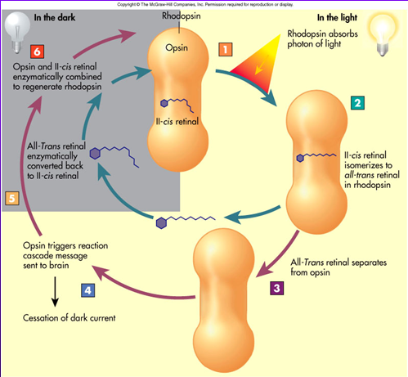
In the retina, there are two types of photosensitive cells, the rods and the cones. Rods are responsible for perception in dim light. Cones are responsible for vision in bright light as well as color vision.
One eye contains about 120 million rods, each of which carries 120 million molecules of rhodopsin, while it contains 6 million cones. Reduction in number of cones or the cone proteins, will lead to color blindness.
Deficiency of vitamin A leads to:
1- Xerophthalmia: dry eyes, and is the leading preventable cause of blindness in children throughout the world.
2- Night blindness
3- Anemia
High doses of vitamin A can lead to intoxication which may be acute or chronic and lead to wide range of signs and symptoms.
Daily requirement of vitamin A is 700- 900 µg.

Vitamin D
Vitamin D is a fat soluble vitamin, it has a vital role in the metabolism of calcium, both its deficiency and toxicity have a major effects on health.
Vitamin D is produced endogenously through exposure of skin to sunlight, and is absorbed from foods containing vitamin D.
It is present in two main forms:
1- Vitamin D2 (Ergocalciferol): of plants source.
2- Vitamin D3 (Cholecalciferol): of animal source.
Both D2 and D3 are considered as provitamins as they need to be converted into the active form of vitamin D [1,25(OH)2D].

Absorption
As previously mentioned, diet from animal sources contains vitamin D3 and diet from plant sources contains vitamin D2, both are absorbed from upper small intestine integrated in the micelle. This is why any defect in micelle formation will lead to vitamin D deficiency.

Apart from dietary source, on exposure to sunlight, 7-dehydrocholesterol is converted to cholecalciferol ( D3) in the skin (dermis and epidermis). The production of vitamin D in the skin is directly proportional to the exposure to sunlight and inversely proportional to the pigmentation of skin, although excessive exposure to sunlight does not result in vitamin D toxicity since excess provitamin D3 are destroyed by sunlight itself.

Metabolism
Both vitamin D2 and D3 need further steps in order to be active, they are transported to the liver by binding to vitamin D binding globulin.
Vitamin D2 and vitamin D3 are metabolized to 25-hydroxyvitamin D [25(OH)D] in the liver by vitamin D 25-hydroxylase. This is considered as the first step of activation of vitamin D.
At physiologic concentrations, 25(OH)D is biologically inactive in affecting dietary calcium absorption and it is the major storage and circulatory form of vitamin D.
25(OH)D is metabolized to 1,25- dihydroxyvitamin D [1,25(OH)2D], the biologically active hormone, by 25(OH)D 1α-hydroxylase in the kidney. 1,25(OH)2D is also known as calcitriol.
This step is the main regulatory step in the formation of the active form of vitamin D and depends mainly on 25(OH)D 1α-hydroxylase activity.
In case of hypocalcemia, secretion of parathyroid hormone (PTH) will increase which in turn stimulates 25(OH)D 1α-hydroxylase activity. This enzyme will increase the formation of calcitriol which will increase the absorption of calcium in the gastrointestinal tract.
In contrast, in case of hypercalcemia, secretion of parathyroid hormone will be inhibited which in turn inhibits 25 (OH)D 1α-hydroxylase activity leading to decrease formation of calcitriol , so calcium absorption will be decreased.

Biochemical functions of calcitriol
1- Action on intestine: calcitriol increases the intestinal absorption of calcium and phosphate.
2- Action on bone: calcitriol stimulates calcium uptake for deposition as calcium phosphate.
Surprisingly, calcitriol at physiological level is essential in the process of bone formation but at high levels it will induce bone resorption.
3- Action on kidneys: calcitriol is also involved in minimizing the excretion of calcium and phosphate through the kidney by decreasing their excretion and enhancing reabsorption.
4- Action on parathyroid gland: calcitriol inhibit the synthesis and secretion of PTH.

Deficiency of vitamin A leads to:
1- Rickets in children
2- Osteomalacia in adults

Intoxication with vitamin D will lead to:
1- hypercalcemia
2- constipation
3- renal stone
4- bone resorption
Daily requirement of vitamin D is 400 IU.

Vitamin K
It is a fat soluble vitamin that promotes clotting of blood as it is required for the conversion of several clotting factors and prothrombin. Recently there is growing interest about the effect of vitamin K in bone metabolism.
Three compounds have the biological activity of vitamin K, these are:
1- Phylloquinone (Vitamin K1), the normal dietary source, found in green vegetables
2- Menaquinones (vitamin K2), synthesized by intestinal bacteria.
3- Menadione and menadiol diacetate, synthetic compounds that can be metabolized to phylloquinone.

As with other fat soluble vitamins, vitamin K is absorbed in the small intestine after being integrated in micelle, transported to the liver through chylomicron where it is storage.

Functions
The essential and most thoroughly defined role of vitamin K is as a cofactor to vitamin K dependent carboxylase, this enzyme is necessary for the conversion of specific glutamyl residues in target proteins to γ-carboxyglutamyl (Gla) residues. This γ-carboxylation increases the affinity of these proteins for calcium.

The antihemorrhagic function of vitamin K depends on the formation of the Gla proteins:
prothrombin (factor II), proconvertin (factor VII), plasma thromboplastin component (factor IX), and Stuart factor (factor X), which, together with two other hemostatic vitamin K–dependent proteins, proteins C and S, and Ca²⁺, initiate a process to form thrombin that then catalyzes the conversion of fibrinogen to a fibrin clot.
Vitamin K deficiency leads to bleeding tendency. At the same time no toxicity has been observed with the use of high of naturally occurring vitamin K ( K1 & K2 ).
Daily requirement of vitamin K is 90-120 µg/d
The assessment of vitamin K status is performed indirectly by measuring prothrombin time (PT).

Vitamin E
Vitamin E is a fat soluble vitamin that acts as an antioxidant through functioning as a scavenger for molecular oxygen and free radicals. It also has a role in cellular respiration.
Vitamin E is the nutritional term for the group of naturally occurring tocopherols and tocotrienols, that resent in oils and fats, particularly sunflower oil. Meats, fruits, and vegetables contribute little vitamin E.
Vitamin E is absorbed in same manner as other fat soluble vitamins integrated in the micelle, then transported through chylomicron to the liver and peripheral tissues.

Functions
1- Necessary for neurologic function.
2- Necessary for reproductive functions.
3- Protection of the red cell from hemolysis.
4- Prevention of retinopathy in premature infants.
5- Inhibition of free radical chain reactions of lipid peroxidation by synergistic action with vitamin C.

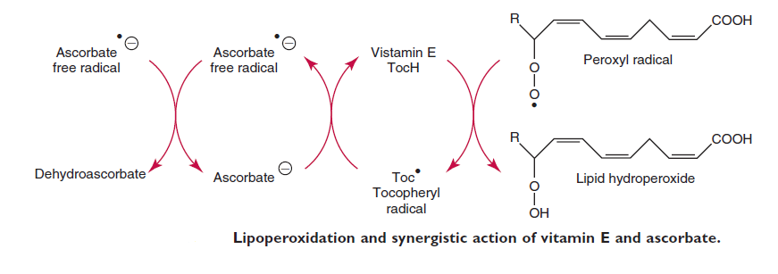

Deficiency of vitamin E leads to :
1- Hemolytic anemia
2- Neuropathy

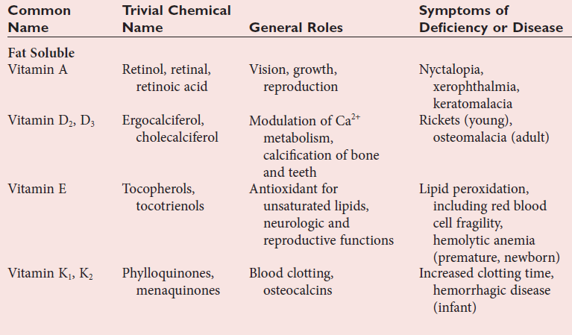
(Fat soluble vitamins)
^^^^^^^^^^^^^^^^^^^^^^^^^^^^^^^^^^^^^^^^^^^^^^^^^^^^^^^^^^^^^^^^^^^^^^^^^^^^^^^^^^^^

