Minerals & trace elements

Our diet contains four essential nutrients, these are: vitamins, essential fatty acids, essential amino acids, and minerals.
Minerals are inorganic chemical elements essential for human survival, of no caloric value, and do not degraded by digestion or cooking; deficiency in any of them may lead to serious consequences.
The major six minerals present in human body in order of abundance are:
calcium, phosphorus, potassium, sodium, chloride, and magnesium.
These six minerals together with non-mineral elements carbon, hydrogen, oxygen, and nitrogen comprise around 99.9% of human body.
Trace elements are minerals that present in very minimal concentration in human body, they include: iron, cobalt, copper, zinc, manganese, molybdenum, iodine, and selenium, but the total number of chemical elements that are absolutely needed is not known for any organism.
Minerals will be discussed briefly in this lecture according to their clinical importance.

I- Calcium metabolism
Calcium is the most abundant mineral in the body, there being about 25 mol (1 kg) in a 70 kg man.
Approximately 99% of the body’s calcium is present in the bone combined with phosphate, in turn about 85% of the body’s phosphate content is in the bone.
Calcium is present in 3 forms:
1- Ionized (free) calcium
2- Protein bound calcium
3- Calcium complex
Disorders of calcium homeostasis are relatively common biochemical abnormalities that might be the cause or the result of serious medical conditions.

Calcium homeostasis
In adults, calcium intake and output are normally in balance. Balance is largely achieved through matching net absorption over 24 h closely with the corresponding 24-h urinary excretion; this varies with the diet.
In infancy and childhood, there is normally a positive balance, especially at times of active skeletal growth.
In older age, calcium output may exceed input, and a state of negative balance then exists; this negative external balance is particularly marked in women after menopause, and is important in the development of post-menopausal osteoporosis. In women, the mother loses calcium to the fetus during pregnancy, and by lactation.

Function of calcium
1- Calcium is a major mechanical constituent of the bone. Calcium salts in bone have a mechanical role, but are not metabolically inert. There is a constant state of turnover in the skeleton associated with deposition of calcium in sites of bone formation and release at sites of bone resorption (∼5% per year of the adult skeleton is remodeled). Calcium in the bone also acts as a reservoir that helps to stabilize plasma calcium.

2- Maintenance of extracellular ionized calcium within narrow limits is necessary for normal excitability of nerve and muscle. An increase in ionized calcium raises the threshold for the nerve action potential, and vice versa.
3- The ion is also required in the activation of the clotting and complement cascades.
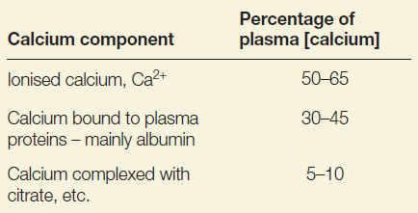
The components of calcium in plasma

Control of calcium metabolism
Calcium is present in plasma in three forms, in equilibrium with one another. Plasma [Ca2+] is the
physiologically important component, and is closely regulated in humans by PTH and 1:25-dihydroxycholecalciferol: both act to increase plasma [Ca2+] .
Growth hormone (GH), glucocorticoids (e.g. cortisol), oestrogens, testosterone and thyroid hormones (thyroxine (T4) and tri-iodothyronine (T3)) also influence calcium metabolism.
The body’s responses to a fall in plasma [Ca2+] are shown in the following figure.
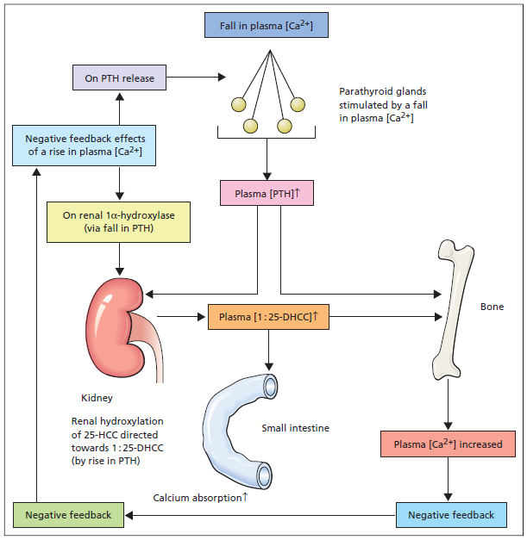

In case of hypocalcemia, the following response occurs:
1- hypocalcemia stimulate secretion of PTH
2- PTH has two main functions:
A- on the kidneys: stimulates one alpha hydroxylase, which in turn leads to more hydroxylation of 25(OH)D3 into the active form 1,25 (OH)2D3.
B- on bones: stimulates the release of calcium from bone to blood ( bone resorption).
3- the active form of vitamin D will increase calcium absorption at the small intestine, and increase bone resroption as well.
4- hypocalcemia will be corrected by increasing calcium absorption by the action of vitamin D, and by release of calcium form bones by the action of both vitamin D and PTH. Correction of plasma calcium has a negative feedback effect on the parathyroid gland leading to inhibition of PTH .

Effects of plasma H+
In acidosis, the protonation of albumin reduces its ability to bind calcium, leading to an increase in unbound [Ca2+], and vice versa, without any change in total [calcium]. Thus, hyperventilation with respiratory alkalosis can reduce plasma [Ca2+], with the development of tetany. In chronic states of acidosis or alkalosis, PTH acts to readjust the plasma [Ca2+] back to normal.

Effects of serum [albumin]
Because albumin is the principal binding protein for calcium, a fall in serum [albumin] will lead to a fall in bound calcium and a decrease in total [calcium] (and vice versa). Under these circumstances, the unbound plasma [Ca2+], the physiologically important fraction, will be maintained at normal levels by PTH. Modest but potentially misleading increases in serum [calcium] may also result from abnormal calcium binding, due to raised serum [albumin].

II- Phosphate metabolism
Eighty-five per cent of body phosphorus is located in the mineral phase of bone. The remainder is present outside bone, largely in an intracellular location as phosphate compounds. In the extracellular fluid, phosphate is mostly inorganic.
Intracellular phosphate has vital functions in:
1- macromolecular structure (e.g. in DNA)
2- energy metabolism (e.g. energy-rich phosphates such as ATP)
3- cell signaling
4- enzyme activation by phosphorylation.
Intracellular phosphate is largely organic as a component of phospholipids, phosphoproteins, nucleic acids and nucleotides (e.g. ATP).

Phosphate Homeostasis
Body phosphate homeostasis is determined by modulation of intestinal uptake of dietary phosphate, renal phosphate reabsorption and excretion, and the exchange of phosphate between extracellular and bone storage pools.

PTH reduces the reabsorption of phosphate from the proximal tubule of the kidney, which means more phosphate is excreted through the urine.
However, PTH enhances the uptake of phosphate from the intestine and bones into the blood. In the bone, slightly more calcium than phosphate is released from the breakdown of bone.
In the intestines, absorption of both calcium and phosphate is mediated by an increase in activated vitamin D. The absorption of phosphate is not as dependent on vitamin D as is that of calcium.
The end result of PTH release is a small net drop in the serum concentration of phosphate.

III- Magnesium metabolism
Magnesium is the second most abundant intracellular cation. It is essential for the activity of many enzymes, including the phosphotransferases. Bone contains about 50% of the body’s magnesium; a small proportion of the body’s content is in the ECF.
Plasma [magnesium] is normally kept within narrow limits, which implies close homeostatic control. The serum [magnesium] may be normal although a state of intracellular depletion exists.
Significant amounts are contained in gastric and biliary secretions which may explain the possible toxicity with magnesium in case of obstructive liver disease.
Renal conservation of magnesium is at least partly controlled by PTH and aldosterone.
When the dietary intake is restricted, renal conservation mechanisms are normally so efficient that
depletion, if it develops at all, only comes on very slowly.
Extracellular magnesium is important for normal neuromuscular activity, while intracellular magnesium is an important:
1- as a cofactor for various enzymes and nucleic acids.
2- for normal cellular function
3- for replication
4- production of energy

Normal levels of magnesium are not only necessary for PTH release but may also be required to ensure an adequate end-organ response to PTH.

IV-Iron
Iron is an essential element present mainly in the porphyrin complex, haem, and in iron storage proteins, ferritin and haemosiderin. Haem, which is present in haemoglobin, myoglobin and cytochromes, is formed by the insertion of ferrous iron, Fe2+, into protoporphyrin
The adult human possesses about 70 mmol (4 g) of iron. Iron balance is regulated by alterations in the intestinal absorption of iron. There is only a limited capacity to increase or decrease the rate of loss of iron.
Dietary iron and iron absorption
The normal intake of iron is about 10–20 mg/day. Good sources are liver, fish and meat.
Normally, about 5–10% of dietary iron is absorbed by duodenum, and the rate of absorption is controlled by physiological and dietary factors which are:
1- State of iron stores in the body:
Absorption is increased in iron deficiency and decreased when there is iron overload.
2- Rate of erythropoiesis:
When this rate is increased, absorption may be increased even though the iron stores are adequate or overloaded.
3-Contents of diet:
Substances that form soluble complexes with iron (e.g. ascorbic acid) facilitate absorption. Substances that form insoluble complexes (e.g. phytate) inhibit absorption.
4- The chemical state of the iron:
Iron in the diet does not usually become available for absorption unless released during digestion. This depends, at least partly, on gastric acid production; Fe2+ is more readily absorbed than Fe3+, and the presence of H+ helps to keep iron in the Fe2+ form. Iron in haem (in meat products) can be absorbed while still contained in the haem molecule in the haem molecule.

Iron transport, storage and utilization
After being taken up by the intestinal mucosa, iron is either:
(1) incorporated into ferritin and retained by the mucosal cells which is then lost by sloughing of mucosal cell , or
(2) transported across the mucosal cells directly to the plasma, where it is carried mainly combined with transferrin.
The total iron circulating bound to transferrin is taken up by cells and either incorporated into
haem or stored as ferritin (or haemosiderin, probably formed by the condensation of several molecules of ferritin).
In summary, Iron is stored as ferrous state in ferritin., while transported in plasma bounded to transferrin as ferric state.

Functions of iron
1- It serves as a carrier of oxygen to the tissues from the lungs by red blood cell haemoglobin.
2- A transport medium for electrons within cells
3- An integrated part of important enzyme systems in various tissues.

Iron deficiency
Worldwide, this is the most common single nutrient deficiency which occurs secondary to various medical conditions such as poor iron intake, malabsorption, bleeding, or many other conditions.
In patients who develop iron deficiency,
• serum [ferritin] falls, then
• serum [transferrin] and TIBC increase, after which
• serum [iron] falls, and finally
• anemia becomes evident which is a hypochromic microcytic anemia.

Iron overload
This is much less common than iron deficiency. Diagnosis is not usually difficult once the possibility has been considered. High levels of Iron are toxic, and can lead to many organ damage especially the liver and the heart.
Increased serum [iron] with normal [transferrin] (or TIBC) often lead to 100% saturation of transferrin (or TIBC). Serum [ferritin] is increased, often to more than 1000 μg/L.

This condition is most commonly occurs due to :
1- Parenteral administration of iron, including repeated blood transfusions.
2- Hereditory haemochromatosis, which is characterized by increased absorption of iron.

Other trace elements will be discussed in brief:
Trace element | Functions | Clinical  Consequences of Deficiency
Zinc | Structural/cofactor role for several enzymes (e.g. alkaline phosphatase, carbonic anhydrase, enzymes of nucleic acid synthesis | Dermatitis, immune  deficiency, poor  wound healing
Selenium | Structural component of several enzymes  including anti-oxidant enzymes such | Cardiac and skeletal myopathy. Possible increased risk of atheroma  and some cancers
Copper | Required for the action of several enzymes, Circulates on caeruloplasmin which can increase as part of the acute phase response | Microcytic anaemia,  neutropenia. Osteoporosis

Other trace elements
Chromium may be involved in glucose homeostasis; a chromium complex is able to improve glucose tolerance in some diabetics. Malnourished infants may develop severe glucose intolerance that improves with chromium supplementation.
In adults, a syndrome presenting with weight loss, peripheral neuropathy
and marked insulin-insensitive glucose intolerance has been described that improves with
chromium supplementation.

Molybdenum is a component of xanthine oxidase and some other metallo-enzymes. Its deficiency has been reported to cause xanthinuria, with low serum [urate] and low urinary uric acid output.
Cobalt is necessary for vitamin B12 metabolism.
*****************************************************************************************************

