enzymes (part II)

Specificity of enzymes
One of the properties of enzymes that makes them so important as diagnostic and research tools is the specificity they exhibit relative to the reactions they catalyze. A few enzymes exhibit absolute specificity; that is, they will catalyze only one particular reaction. Other enzymes will be specific for a particular type of chemical bond or functional group.

In general, there are four distinct types of specificity:
1. Absolute specificity
The enzyme will catalyze only one reaction.
2. Group specificity
The enzyme will act only on molecules that have specific functional groups, such as amino, phosphate and methyl groups.
3. Linkage specificity
The enzyme will act on a particular type of chemical bond regardless of the rest of the molecular structure.
4. Stereochemical specificity
The enzyme will act on a particular steric or optical isomer.

Factors Affecting Enzyme Activity
The activity of an Enzyme is affected by its environmental conditions. Changing these conditions alter the rate of reaction catalyzed by the enzyme.
Several factors affect the rate at which enzymatic reactions proceed, these are:
1- Temperature
2- pH
3- Enzyme concentration
4- Substrate concentration
5- The presence of any enzyme activators.
6- The presence of any enzyme inhibitors.

1- Temperature
Increasing temperature increases the energy of substrate molecules, hence increasing temperature increases the rate of reaction, forming more product.
Generally, the rate of reaction of most enzymes will double by a rise in 10°C.
As temperature increases, the shapes of the active sites of enzyme will be less complementary to the shape of their substrate, and more enzymes will be denatured (loss of tertiary structure of protein occurs). This will decrease the rate of reaction.
Most human enzymes have the optimum temperature around 37°C. Certain bacteria living in hot springs will have enzymes with optimum temperature near 100°C.
In summary, as temperature increases, initially the rate of reaction will increase, because of increased Kinetic Energy. However, the rate of reaction will begin to decrease as the temperature continues to increase.

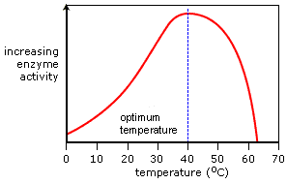

The temperature at which the maximum rate of reaction occurs is called the enzyme's optimum temperature. This is different for different enzymes. Most enzymes in the human body have an optimum temperature of around 37.0 °C.

2- pH
H⁺ and OH⁻ ions are charged and therefore interfere with hydrogen and ionic bonds that hold together an enzyme, since they will be attracted or repelled by the charges created by the bonds. This interference causes a change in shape of the enzyme, and importantly, its active site.
Different enzymes have different optimum pH values. The optimum pH is the pH value at which the shape of enzyme active sites is the most complementary to the shape of their substrate. At the optimum pH, the rate of reaction is at an optimum.
Any change in pH above or below the optimum will quickly cause a decrease in the rate of reaction, since more of the enzyme molecules will have active sites whose shapes are not (or at least are less) complementary to the shape of their substrate.
Optimum pH may vary depending on the temperature, concentration of substrate, presence of ions, etc. Usually enzymes have the optimum pH between 6 and 8. Some important exceptions are pepsin (with optimum pH 1–2); alkaline phosphatase (optimum pH 9–10) and acid phosphatase (4–5).

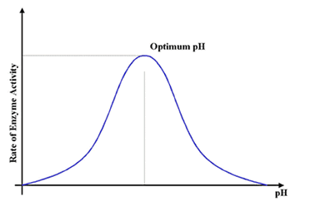

Small changes in pH above or below the optimum do not cause a permanent change to the enzyme, since the bonds can be reformed. However, extreme changes in pH can cause enzymes to denature and permanently lose their function.
Enzymes in different locations have different optimum pH values since their environmental conditions may be different. For example, the enzyme pepsin functions best at around pH 2 and is found in the stomach, which contains hydrochloric acid.

3- Substrate Concentration
Increasing substrate concentration increases the rate of reaction. This is because more substrate molecules will be attached to the active sites of enzyme, so more product will be formed.
However, after a certain concentration, any increase will have no effect on the rate of reaction, since substrate concentration will no longer be the limiting factor.
The enzymes will effectively become saturated, and will be working at their maximum possible rate. This is called zero order reaction.

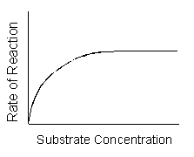
4- Enzyme Concentration
The rate of a reaction or velocity (V) is directly proportional to the enzyme concentration, when sufficient substrate is present. Velocity of reaction is increased proportionately with the concentration of enzyme, provided substrate concentration is unlimited, as more enzymes will be attached with substrate molecules.
However, this will only have an effect up to a certain concentration, where the enzyme concentration is no longer the limiting factor.
This property is used of determining the level of particular enzyme in plasma, serum or tissues. Known volume of serum is incubated with substrate for a fixed time, then reaction is stopped and product is quantitated (end point method). Since the product formed will be proportional to the enzyme concentration, the latter could be assayed.
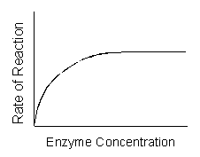

5- Enzyme inhibitors
Enzyme inhibitors reduce the rate of an enzyme catalyzed reaction by interfering with the enzyme in some way. This effect may be permanent or temporary.
Competitive enzyme inhibitors work by preventing the formation of enzyme-substrate complexes because they have a similar shape to the substrate molecule.
This means that they fit into the active site, but remain unreacted since they have a different structure to the substrate. Therefore less substrate molecules can bind to the enzymes so the reaction rate is decreased.
Competitive inhibition is usually temporary, and the inhibitor eventually leaves the enzyme. This means that the level of inhibition depends on the relative concentrations of substrate and inhibitor, since they are competing for places in enzyme active Sites.

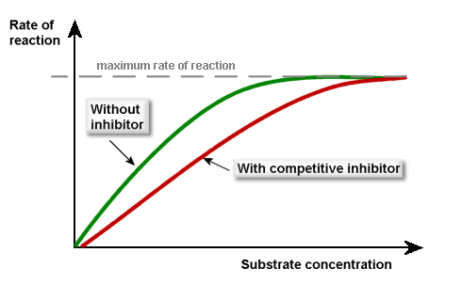

Non-competitive enzyme inhibitors work not by preventing the formation of enzyme-substrate complexes, but by preventing the formation of enzyme-product complexes. So they prevent the substrate from reacting to form product.
Usually, non-competitive inhibitors bind to a site other than the active site, called an allosteric site. Doing so distorts the 3D tertiary structure of the enzyme, such that it can no longer catalyzes a reaction.
Since they do not compete with substrate molecules, non-competitive inhibitors are not affected by substrate concentration.
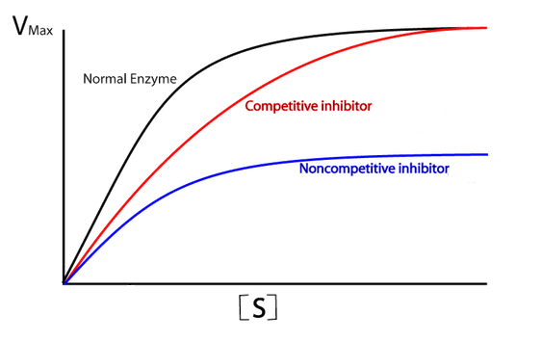

Enzyme inhibitors are used in controlling metabolic reactions. This allows product to be produced in very specific amounts.
Examples of enzyme inhibitors:
1- Regulators
In many cases, the final product of a metabolic pathway acts as a non-competitive inhibitor to one of the enzymes earlier along the chain. This means that the metabolic process controls itself, since the more product gets produced, the more it inhibits the pathway, and so the slower the process proceeds.
2- Metabolic Poisons
Many poisons work by inhibiting the action of enzymes involved in metabolic processes, which disturbs an organism.
For example, potassium cyanide is an irreversible inhibitor of the enzyme cytochrome C oxidase, which takes part in respiratory reactions in cells. If this enzyme is inhibited, ATP cannot be made since oxygen use is decreased. This means that cells can only respire anaerobically, leading to a buildup of lactic acid in the blood. This is potentially fatal.
3- As Medicines
Some enzyme inhibitors can be used as medicines in the treatment of conditions.
For example, infection by viruses can be treated by inhibitors to the viral enzyme protease, often competitive inhibitors. This means that viruses cannot build new protein coats and therefore cannot replicate.
Penicillin works by inhibiting a bacterial enzyme that is responsible for forming cross-links in bacteria cell walls. This therefore halts reproduction.

6- Enzyme activators
Many examples are present for enzyme substances that when present during enzymatic reaction can increase the rate of the reaction by increasing enzyme activity, these include:
- Inorganic ions
Chloride ions activate salivary amylase and calcium ions activate lipase.
- Conversion of proenzyme into enzyme
All the gastrointestinal enzymes are synthesized in the form of pro-enzymes, and only after secretion into the alimentary canal, they are activated. This prevents autolysis of cellular structural proteins.
Isoenzymes
Isoenzymes are enzymes that catalyze identical chemical reactions but they differ in their amino acid sequence. Isozymes are usually the result of gene duplication.
These enzymes usually display different kinetic parameters, or different regulatory properties. The existence of isozymes permits the fine-tuning of metabolism to meet the particular needs of a given tissue or developmental stage.

The enzyme Lactate Dehydrogenase is made of two (H-form and M-Form) different sub units, combines in different sequence depending on the tissue in which it is present as shown in below table:

Type | Composition | Location
LDH₁ | HHHH | Heart and Erythrocyte
LDH₂ | HHHM | Heart and Erythrocyte
LDH₃ | HHMM | Brain and Kidney
LDH₄ | HMMM | Skeletal Muscle and Liver
LDH₅ | MMMM | Skeletal Muscle and Liver

Different forms of isoenzymes have their clinical application in diagnosis of diseases.
Whilst isozymes may be almost identical in function, they may differ in other ways.
In particular, amino acid substitutions that change the electric charge of the enzyme are simple to identify by gel electrophoresis, and this forms the basis for the use of isozymes as molecular markers.

Factors Affecting Enzyme Concentrations in Plasma or Serum
The measured activity of an enzyme in blood is the result of the following factors:
1- Leakage of Enzymes from Cells
Enzymes are retained within their cells of origin by the plasma membrane surrounding the cell. The plasma membrane is a metabolically active part of the cell, and its integrity depends on the cell’s production of ATP. Any process that impairs ATP production by depriving the cell of oxidizable substrates or by reducing the efficiency of energy production by restricting the access of oxygen (ischemia or anoxia) promotes deterioration of the cell membrane.

2- Efflux of Enzymes from Damaged Cells
Cell destruction of any cause will lead to release of intracellular enzymes, so enzymes activity in plasma will increase. The rate of enzyme activity will depend on the rate of cell destruction, although other factors have a role too.

3- Altered Enzyme Production
Small amounts of intracellular enzymes physiologically present in the plasma can be assumed to result from leakage of enzyme from healthy cells.
This contribution of enzymes to the circulating blood may decrease as the result of a genetic deficiency of enzyme production (as is the case for alkaline phosphatase in hypophosphatasia ).
However, cases in which enzyme production is increased are of more general interest in diagnostic enzymology. For example, an increase in the number and activity of alkaline phosphatase producing osteoblasts of bone is responsible for the increased concentration of alkaline phosphatase in the serum of normally growing children.
Increased osteoblastic activity also accounts for increased concentrations of this enzyme in the serum in various types of bone disease.

4- Clearance of Enzymes
Few enzyme molecules are small enough to pass through the glomerulus of the kidney; therefore urinary excretion is not a major route for elimination of enzymes from the circulation.
An exception to this is α-amylase.
Evidence now suggests that many enzymes are not inactivated in the plasma but are rapidly removed, probably by the reticuloendothelial system, such as the bone marrow, spleen, and liver (Kupffer cells), or, to a lesser extent, by nearly all cells in the body.

The following table represents examples of clinically significant enzymes:





