Hormones (part II)

Hormones of Thyroid Gland
Thyroid gland is the largest endocrine gland in humans, weighing about 20 g. It might attain a weight of several hundred grams in certain disease states.
It synthesizes two main hormones, triiodothyronine (T3) and tetraiodothyronine or thyroxine (T4). Calcitonin, a hormone involved in calcium homeostasis, is secreted by special cell types called parafollicular C-cells, or simply C-cells.
T3 and T4 are the only hormones in humans that contain organically bound iodine. They are necessary in the following processes:
- Increase oxygen consumption within tissues via increased membrane transport.
- Enhance mitochondrial metabolism (stimulation of mitochondrial respiration and oxidative phosphorylation).
- Increase sensitivity to catecholamines with increased heart rate and myocardial contractility.
- Stimulate protein synthesis and carbohydrate metabolism,
- Increase synthesis and degradation of cholesterol and triglycerides
- Increase vitamin requirements,
- Regulate calcium and phosphorous metabolism.

Thyroid hormones maintain the basal metabolic rate and thus regulates the metabolism of endogenous and exogenous substances.
Hypothyroidism impairs the excretion of many drugs, while hyperthyroidism accelerating their clearance.
Biosynthesis of Thyroid Hormones
Thyroxine (T4) is produced exclusively by the thyroid gland. T3 is produced by deiodination of thyroxine. This process may occur in the thyroid gland, in target tissues or in other peripheral tissues (e.g. liver and kidneys).
Deiodination of thyroxine may also occur at the inner ring to form biologically inactive reverse T3 (r T3).

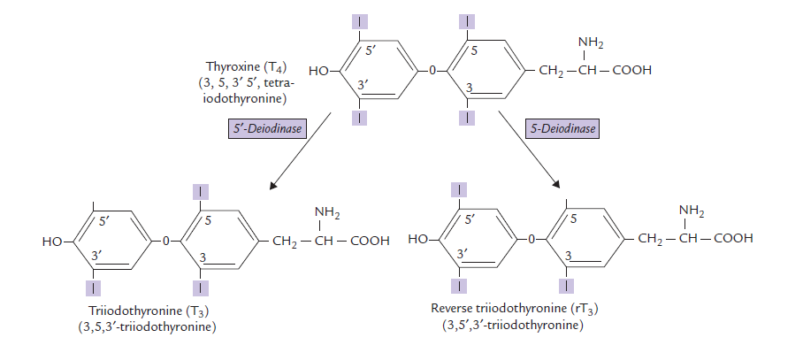

Steps of thyroid hormones synthesis
Step 1: Iodide Uptake
The follicular cells in the thyroid gland take up and concentrate iodide against a concentration gradient (about 20 : 1). It is an energy requiring step and is rate-limiting for the pathway of thyroid hormone synthesis. This step is controlled by TSH.
Step 2: Iodide to Iodine Oxidation
The iodide is oxidized by the enzyme thyroperoxidase (TP) to a more reactive form, iodine.
Step 3: Iodination of Tyrosyl Residues in thyroglobulin (Tgb)
Thyroglobulin acts as a precursor for T3 and T4. It contains several tyrosyl groups to which the reactive iodine attaches; the process is referred to as organification of iodine.
It requires hydrogen peroxide and catalytic action of thyroperoxidase. The tyrosyl residues are iodinated first at position 3 to form mono-iodo-tyrosine (MIT) and then at position 5 to form di-iodotyrosine (DIT).

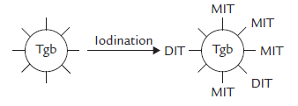

Step 4: Coupling Reactions
Coupling of two iodotyrosyl residues results in the formation of a thyroid hormone (iodothyronine). When two DIT residues are thus coupled, formation of a tetraiodothyronine (thyroxine or T4) residue results.
One MIT residue may be coupled with a DIT to form a tri-iodothyronine (T3) residue.
MIT + DIT = T3 ; DIT + DIT = T4
Normally, about 99% of the hormone produced by the thyroid gland is T4.
Thyroid hormones are derived from protein-bound tyrosine (also require iodine).
T4 is produced exclusively in the thyroid gland and is more abundant than T3, which is the biologically active form.

Step 5: Release of thyroid hormones
Thyroglobulin reenters the thyroid cells again, and by the action of lysosomal enzymes, both T3 and T4 are detached from thyroglobulin and released to the circulation.

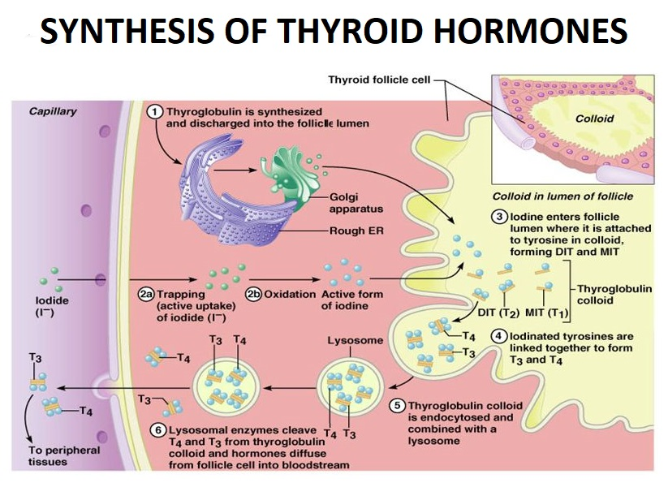

Transportation of T3 and T4
Thyroid hormones are transported bound to two specific binding proteins. More than 99% of T3 and 99.9% of T4 thyroxine-binding globulin (TBG) and transthyretin.
The hormones first bind to TBG, and when it is saturated, to transthyretin. Very small amounts are bound with albumin or remain in free form; the latter accounts for all biological actions of thyroid hormones.
T3 binds with proteins with less avidity than T4. About 99% of T3 and 99.9% of T4 are bound to a protein. The total plasma level of T4 is approximately 50 times higher than that of T3 (80 ng/mL versus 1.5 ng/mL).
The protein binding prevents rapid renal clearance of the hormones and also protects them from enzymatic attack. As a result, their biological half-lives are remarkably long: 6.5 days for T4 and 1.5 days for T3.
Only the free, unbound form of a hormone is biologically active. T3 is more potent than T4 (about 4 times).

Storage and Release of Thyroid Hormones
The thyroid hormones synthesized in the follicular space are still attached to the Tgb molecule. Thus, thyroid follicles store an appreciable amount of thyroid hormones, covalently bound to the amino acid sequence of Tgb.
The thyroglobulin therefore is considered a storage form of T3 and T4 in the colloid, containing several weeks’ supply of these hormones.

Metabolic Fate of T3 and T4
Approximately 90% of the hormone released from the thyroid gland is T4, but part of it is converted to T3 by deiodination in target tissues by 5’-deiodinase.
About two-third of the circulating T3 is derived not directly from the thyroid gland but rather by deiodination of T4 in peripheral tissues, especially the liver and the kidney.
Alternatively, T4 may undergo deiodination in the inner ring to form biologically inactive reverse T3.
Approximately 33% of the thyroxine that is secreted each day produces T3, whereas another 40% produces reverse T3.
The deiodination reactions release iodine that enters plasma and is recycled for new hormone synthesis.
Approximately 75% of T4 is metabolized by deiodination,
producing active T3 and inactive rT3.
The remaining T4 is deactivated by deamidation or decarboxylation and by
conjugation with sulphate or glucuronide.
It is subsequently excreted via bile and, to a lesser extent, in urine.

Regulation of T3 and T4 Synthesis
Synthesis and secretion of thyroid hormones are regulated by hypothalamo-anterior pituitary- endocrine axis. The regulation begins with the hypothalamus.
TRH which promotes exocytosis of TSH.
The secretion of TSH appears to be regulated by an interplay of negative feedback from circulating:
- free T3
- T4
- TRH
and:
- an inhibitory neurotransmitter somatostatin.
The negative feedback by thyroid hormones, in fact, occurs at both hypothalamic and pituitary levels. At the pituitary level, free T4 and T3 inhibit TSH secretion by decreasing both the biosynthesis and release of TSH.

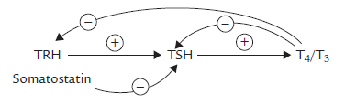

Biochemical Functions of Thyroid Hormones
The thyroid hormones increase the metabolic activities in nearly all cells of the body. They diffuse through the plasma membrane and interact with the nuclear receptors.
The major effects are as below:
- Thermogenesis:
Thyroid hormones cause uncoupling of oxidative phosphorylation, resulting in heat generation (i.e. calorigenic effect). There is swelling of a mitochondria and basal metabolic rate is increased.
- Metabolic effects:
The metabolic effects of thyroid hormones are:
- They stimulate transcription and protein synthesis in various tissues, resulting in positive nitrogen balance.
- They enhance glucose absorption from intestine and its utilization in various tissues.
- They increase gluconeogenesis in liver and kidney.
- They increase lipolysis in adipose tissue.
The net result increased concentration of glucose and free fatty acids in plasma.
- Physiological effects:
Thyroid hormones are required for:
- normal physical growth
- Mental development
Other effects include increase in heart rate and cardiac output, rate and depth of respiration, gastrointestinal motility and secretion of digestive juices.

Clinical Disorders of Thyroid Functions
Insufficient formation of thyroid hormones is known as hypothyroidism and overproduction is known as hyperthyroidism or thyrotoxicosis.
Both are very common in clinical practice affecting almost 3% of the population, and nine times as many women as men are affected.
More than 95% of thyroid diseases originate in the thyroid gland, (mostly due to autoimmunity) and the rest are accounted by hypothalamic or pituitary causes.

Hypothyroidism
The commonest cause is failure of the thyroid gland known as primary hypothyroidism. In adults, the cause of primary hypothyroidism is often spontaneous autoimmune disease (Hashimoto’s thyroiditis).
Clinical features of hypothyroidism in adults include:
- Weight gain
- Cold intolerance
- Constipation
- Hair loss
- Edema
- Anemia (macrocytic)
- Bradycardia
Many other nonspecific features are present that require a high index of suspicion to reach the correct diagnosis.
The biochemical parameters used for specific diagnosis include measurement of serum T3, T4 and TSH.
The expected laboratory findings of primary hypothyroidism are:
- TSH: high
- Free T4: low
- Free T3: low

The expected laboratory findings of secondary hypothyroidism are:
- TSH: low
- Free T4: low
- Free T3: low

In children, hypothyroidism has serious consequences with severe and irreversible mental deficiency, stunted growth and multiple physical deformities. This condition is called cretinism.
Hypothyroidism is treated by oral administration of thyroxine.

Hyperthyroidism
The most common cause of hyperthyroidism is Graves’ disease which is an autoimmune disease predominant in females.
The clinical features of hyperthyroidism are more specific; they include:
- Weight loss
- Nervousness
- Hot intolerance
- Diarrhea
- Palpitation
- Sweating
- Tachycardia
Laboratory diagnosis is made by measuring serum levels of TSH, T3, and T4.
Treatment modalities include medications, surgical removal of the thyroid gland, and use of radioactive iodine.
The expected laboratory findings of primary hyperthyroidism are:
- TSH: low (or even undetected)
- Free T4: high
- Free T3: high
The expected laboratory findings of secondary hyperthyroidism are:
- TSH: high
- Free T4: high
- Free T3: high
Other endocrinal disorders
Pituitary / Hypothalmus
- Hypopituitarism
- Diabetes insipidus
- Syndrome of Inappropriate Antidiuretic Hormone [SlADH}
Adrenal cortex
- Cushing's Syndrome
ACTH Dependent
ACTH Independent
- Adrenocortical Insufficiency
Addison's Disease
Adrenal Medulla
- Pheochromocytoma
Parathyroid
- Primary Hyperparathyroidism
- Secondary Hyperparathyroidism
- Hypoparathyroidism
Pancreas
- Type 1 diabetes mellitus
- Type 2 diabetes mellitus
- Insulinoma

^^^^^^^^^^^^^^^^^^^^^^^^^^^^^^^^^^^^^^^^^^^^^^^^^^^^^^^^^^^^^^^^^^^^^^^^^^^^^^^^^^^^^^^^^^^^^^^^^^^^^^^^^^^^^^^^^^^^^^^^^^^^^^^^^^^^^^^^^^^^^^^^^^^^^^^^^^^^^^^^^^^^^^^^^^^^^^^^^^^^^^^^^^^^^^^^^^^^^^^^^^^^^^^^^^^^^^^^^^^^^^^^^^^^^^^

