digestion & absorption

Digestion is the chemical breakdown of complex biological molecules into their component parts in order to be easily absorbed with filtering of the harmful substances and getting rid of the solid wastes.
Digestion is associated with significant changes in both physical and chemical features of dietary components.
It involves the conversion of:
1- Lipids to fatty acids and monoglycerides.
2- Proteins to individual amino acids.
3- Carbohydrates into simple sugars.

The gastrointestinal tract is a continuous tube that extends from mouth to anus and is formally contiguous with the external environment. A single cell layer of columnar epithelial cells comprises the semipermeable barrier across which controlled uptake of nutrients takes place.

The primary function of the gastrointestinal tract is to serve as a portal whereby nutrients and water can be absorbed into the body, so the meal is mixed with a variety of secretions that arise from both the gastrointestinal tract itself and organs that drain into it, such as the pancreas, gallbladder, and salivary glands. Likewise, the intestine displays a variety of motility patterns that serve to mix the meal with digestive secretions and move it along the length of the gastrointestinal tract.

Ultimately, residues of the meal that cannot be absorbed, along with cellular debris, are expelled from the body.
All of these functions are tightly regulated in concert with the ingestion of meals. Thus, the gastrointestinal system has evolved a large number of regulatory mechanisms that act both locally and over long distances to coordinate the function of the gut and the organs that drain into it.

The liver, while playing important roles in whole body metabolism, is usually considered a part of the gastrointestinal system for two main reasons:
First,
it is essential for excretion of lipid-soluble waste products that cannot enter the urine. These are secreted into the bile and thence into the intestine to be excreted with the feces.
Second,
the blood flow draining the intestine is arranged such that substances that are absorbed pass first through the liver, allowing for the removal and metabolism of any toxins that have inadvertently been taken up, as well as clearance of small numbers of enteric bacteria.

Anatomy
The GI tract is comprised from:
1- Mouth
2- Pharynx
3- Esophagus
4- Stomach
The stomach consists of three major zones: the cardiac zone, the body, and the pyloric zone, each zone has its distinctive function in respect to digestion and absorption; for example, HCl is secreted by the parietal cells that are present only in the body of the stomach.
5- Small intestine
The small intestine consists of three parts: the duodenum, jejunum, and ileum.
In the adult human, the small intestine is approximately 6-meter-long and decreases in cross section as it proceeds distally.
The duodenum is about 25 cm long and is the shortest and widest part of the small intestine. The jejunum and ileum make up the remainder of the small intestine. There is no clear demarcation, but the ileum is the distal 3.5 m.
The entire mucous surface of the small intestine is lined with very small (1 mm) finger-like projections (villi).
The luminal surface (brush border) of each epithelial cell consists of some 1700 microvilli projecting about 1μm from the cell. The folds, villi, and microvilli together present an absorptive surface of 600 times greater than would be inferred from the length and diameter of this portion of the gut. The absorptive surface area of the small intestine is estimated to be about 250 m² .
6- Large intestine
The large intestine is about 1.5 m in length, extending from the ileum to the anus, and includes the cecum, appendix, colon, rectum, and anal canal.
The colon is about 1-meter-long and is divided into the ascending, transverse, descending, and sigmoid sections. The sigmoid colon connects to the rectum, which is approximately 15 cm long. The rectum in turn connects to the anal canal (the terminal end of the large intestine).

Phases of Digestion
The process of digestion can be conveniently subdivided into neurogenic, gastric, and intestinal phases.

I- Neurogenic Phase
The neurogenic or cephalic phase is initiated by the intake of food into the mouth or even before; the sight, smell, and taste of food stimulate the cerebral cortex and subsequently the vagal nuclei.
The process is chemically mediated by acetylcholine which acts on gastric parietal cells. The vagus nerve also stimulates gastric chief and parietal cells to secrete pepsinogen and hydrochloric acid.
Histamine and gastrin are proved to have their own stimulatory effect on parietal cells for HCl secretion.

II- Gastric Phase
When food enters the stomach, the resulting distention initiates the gastric phase of digestion, mediated by local and vagal reflexes.
Hydrochloric acid release is caused by:
(1) direct vagal stimulation of the parietal cells
(2) gastrin secreted by the antral cells due to local distension and vagal stimulation, gastrin in turn will stimulate HCl secretion by parietal cells.
(3) release of gastrin caused by the near neutralization of gastric hydrochloric acid by ingested food entering the pyloric zone.
Food is mixed by contractions of the stomach and is partially degraded into chyme by the chemical secretions of the stomach.

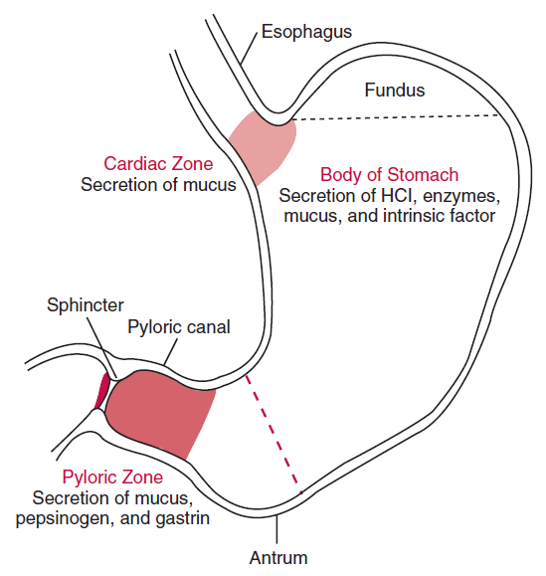
Schematic drawing of the stomach, with major zones

III- Intestinal Phase
The intestinal phase of digestion begins when the weakly acidic digestive products of proteins and lipids enter the duodenum. Many GI hormones and other regulatory peptides are released by both neural and local stimulation and act within the GI tract to regulate digestion and absorption.
During the intestinal phase, carbohydrates, proteins, and fats are broken down and absorbed. Most nutrients, including vitamins and minerals, have been absorbed by the time the food passes from the jejunum and ileum into the large bowel.
In the large intestine, water is actively absorbed, electrolyte balance is regulated, and bacterial actions take place. These processes result in the formation of feces.

Processes of digestion and absorption
The total quantity of fluid absorbed each day by the gut is estimated to be about 9 L, which is composed of 2 L oral intake, 1.5 L saliva, 2.5 L gastric juice, 0.5 L bile, 1.5 L pancreatic juice, and 1 L intestinal secretions. More than 90% of this fluid is absorbed in the small intestine.
The maximal absorptive capacity for fluid is probably at least 20 L.
Several hundred grams of carbohydrates, about 100 g of fat, and 50 to 100 g of amino acids are absorbed daily in the small gut but maximal absorptive capacity is believed to be at least 10 times greater.
For proper understanding of the processes of digestion and absorption we have to study the biochemical components of gastrointestinal secretions because of their essential role in both digestion and absorption.

I- Salivary secretion
The first secretion encountered when food is ingested is saliva, which is produced by three pairs of salivary glands (the parotid, submandibular, and sublingual glands) that drain into the oral cavity.
The function of saliva includes:
1- initiation of digestion of starch (mediated by the action of salivary amylase).
2- protection of the oral cavity from bacteria (by the action of immunoglobulin A and lysozyme).
3- lubrication the food bolus (aided by mucins) for easy swallowing.
4- neutralization of any gastric secretions that reflux into the esophagus (as saliva is an alkaline fluid).
5- aids in speech.
Xerostomia is a subjective felling of dry mouth usually caused by a change in the composition of saliva, or reduced salivary flow.

II- Gastric secretion
Like salivary secretion, the stomach actually readies itself to receive the meal before it is actually taken in, during the so-called cephalic phase. Subsequently, there is a gastric phase of secretion that is quantitatively the most significant, and finally an intestinal phase once the meal has left the stomach. Each phase is closely regulated by both local and distant triggers.

There are four major secretory products presents in gastric secretion, all of which are important either to the digestive process or to control of gastric function, these are:
1- Mucus
Mucous cells, which cover the entire lumen surface secrete a bicarbonate-rich mucus that coats and lubricates the gastric surface, and serves an important role in protecting the epithelium from acid and other chemical insults.
2- Acid
Hydrochloric acid is secreted from parietal cells into the lumen where it establishes an extremely acidic environment. This acid is important for activation of pepsinogen and inactivation of ingested microorganisms such as bacteria. Gastric acidity is vital for protein denaturation.
3- Proteases
Pepsinogen is secreted into gastric juice from both mucous cells and chief cells. Once secreted, pepsinogen is activated by stomach acid into the active protease pepsin, which is largely responsible for the stomach's ability to initiate digestion of proteins.
4- Hormones
The principal hormone secreted from the gastric epithelium is gastrin, a peptide that is important in control of acid secretion and gastric motility.

A number of other enzymes are secreted by gastric epithelial cells, including a lipase and gelatinase. One secretory product of considerable importance is intrinsic factor, a glycoprotein secreted by parietal cells that is necessary for intestinal absorption of vitamin B₁₂.
The stomach provides four basic functions that assist in the early stages of digestion and prepare the ingestion for further processing in the small intestine:
- It serves as a short-term storage reservoir, allowing a rather large meal to be consumed quickly and dealt with over an extended period of time.
- It is in the stomach that substantial enzymatic digestion is initiated, particularly of proteins.

- Vigorous contractions of gastric smooth muscle mix and grind foodstuffs with gastric secretions, resulting in liquefaction of food, a prerequisite for delivery of the ingested food to the small intestine.
- As food is liquefied in the stomach, it is slowly released into the small intestine for further processing.

III- Pancreatic secretion
The pancreatic juice contains enzymes that are of major importance in digestion. Its secretion is controlled in part by a reflex mechanism and in part by the gastrointestinal hormones: secretin and cholecystokinin.
The pancreatic juice is alkaline and has a high HCO^{3–} content. About 1500 mL of pancreatic juice is secreted per day. Bile and intestinal juices are also neutral or alkaline, and these three secretions neutralize the gastric acid.
The pancreatic juice also contains a range of digestive enzymes, but most of these are released in inactive forms and only activated when they reach the intestinal lumen.
The main digestive enzymes present:
1- Trypsin (trypsinogen):
Its function is the digestion of proteins and polypeptides by cleaving peptide bonds.
2- Pancreatic lipase
Its function is the digestion of triglycerides into monoglycerides and fatty acids.
3- Pancreatic α-amylase
Its function is the digestion of starch and glycogen into maltriose and maltose.
4- Phospholipase A2
Its function is the digestion of phospholipids into fatty acids and lysophospholipids.

IV- Biliary secretion
The bile acids are important in the digestion and absorption of fats by the process of emulsification and micelle formation. In addition, bile serves as a critical excretory fluid by which the body disposes of lipid soluble end products of metabolism.

Bile is also the only route by which the body can dispose of cholesterol, either in its native form, or following conversion to bile acids, it is made up of the bile acids, bile pigments, and other substances dissolved in an alkaline electrolyte solution that resembles pancreatic juice. About 500 mL is secreted per day.
Ninety to 95% of bile acids are reabsorbed at the terminal ileum and returned back to liver, the other 5-10% are is lost in stool. The two principal (primary) bile acids formed in the liver are cholic acid and chenodeoxycholic acid. In the colon, bacteria convert primary bile acids into secondary bile acids.

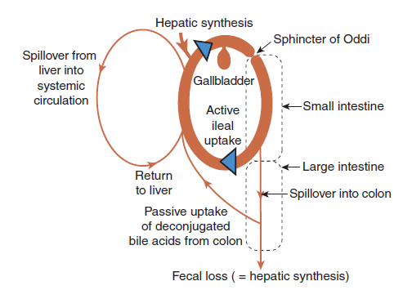
The circulation of bile acids

V- Intestinal secretion
Most of nutrients are absorbed in the small intestine (mainly in jejunum). The first part of the small intestine (duodenum) receives both biliary and pancreatic secretion through the ampulla of Vater, these secretions have the major role in the processes of digestion and absorption.
The intestine itself also supplies a fluid environment in which the processes of digestion and absorption can occur.

Digested material may be transported into blood vessels in the wall of the small intestine by one of the four following processes:
1- Simple (passive) diffusion
Movement of molecules from high concentration to low concentration, requires no energy,
e.g. monoglycerides and fatty acids

2- Facilitated diffusion
Movement of molecules from high concentration to low concentration, requires no energy, but requires carrier proteins, e.g. fructose.

3- Primary active transport
Movement of molecules from low concentration to high concentration, requires ATP, and carrier protein , e.g. amino acids.

4- Secondary active transport
Movement of molecules from low concentration to high concentration, requires energy that comes from the electrochemical gradient created by pumping ions out of the cell, and carrier protein , e.g. glucose.

The large intestine
The Large Intestine is the last part of the digestive system, its function is to absorb water from the remaining indigestible food matter, and then to pass useless waste material from the body.
The large intestine takes 32 hours to finish up the remaining process of the digestive system. Food is not broken down any further in this stage of digestion.
The main functions of the large intestine include:
1- reabsorption of water and mineral ions such as sodium and chloride.
2- absorption of vitamin K synthesized by gut flora.
3- absorption of minimal amount of fatty acids.
4- formation and temporary storage of feces.

In the previous lectures, absorption of carbohydrates and fat was discussed in details, so only protein absorption will be discussed here.

Protein absorption
Protein digestion is initiated in the stomach by the action of pepsin in a highly acid medium. The acidity also denatures the protein, unfolding the polypeptide chains for better access
by the gastric, pancreatic, and intestinal proteolytic enzymes.

The polypeptides and amino acids produced in the stomach will stimulate pancreatic juice secretion which contains the major enzymes (pepsin, trypsin, chymotrypsin) responsible for hydrolysis of polypeptides into amino acids or 2-6 peptides. The amino acids are absorbed by the primary active transport while the peptides will be converted into amino acids by the action of aminopeptidases and dipeptidases of the brush border of the intestine before absorption.

^^^^^^^^^^^^^^^^^^^^^^^^^^^^^^^^^^^^^^^^^^^^^^^^^^^^^^^^^^^^^^^^^^^^^^^^^^^^^^^^^^^^^^^^^^^^^^^^^^^^^^^^^^^^^^^^^^^^^^^^^^^^^^^^^^^^^^^^^^^^^^^^^^^^^^^^^^^^^^^^^^^^^^^^^^^^^^^^^^^^^^^^^^^^^^^^^^^^^^^^^^^^^^^^^^^^^^^^^^^^^^^^^^^^^^^^^^^^^^^^^^^^^^^^^^^^

