NUCLEIC ACIDS

INTRODUCTION
The greatest discovery in 1953 of the double helix, the twisted-ladder structure of deoxyribonucleic acid (DNA), by James Watson and Francis Crick marked a milestone in the history of science and gave rise to modern molecular biology, which is largely concerned with understanding how genes control the chemical processes within cells.
In simple words, their discovery yielded ground-breaking insights into the genetic code and protein synthesis.

Based on their discovery, the concept of central dogma was created which stated that:
(( DNA makes RNA and RNA makes protein ))
ln more detail, the transfer of information from nucleic acid to nucleic acid, or from nucleic acid to protein may be possible, but transfer from protein to protein, or from protein to nucleic acid is impossible.
Information means here the precise determination of sequence, either of bases in the nucleic acid or of amino acid residues in the protein.
Nucleic acids are present in all living cells in combination with proteins to form conjugated protein called nucleoprotein. The proteins present usually are basic and they are protamines and histones.
They transfer genetic information from parents to offspring and provide instructions for how (and when) to synthesize the many proteins needed to build and maintain functioning cells and tissues.

Nucleic acids are polymers of specific nucleotides, and are present in two different types:
1. Deoxyribonucleic acid (DNA)
2. Ribonucleic acid

Nucleotides & Nucleosides
A nucleotide is the basic structural unit and building block for both DNA & RNA. These building blocks are hooked together to form a chain of DNA.
A nucleotide is composed of 3 parts:
1- five-sided sugar (ribose or deoxyribose)
2- phosphate group
3- nitrogenous base (nitrogen containing)
The nitrogenous bases found in nucleic acids belong to one of the heterocyclic groups, either purines or pyrimidines. When the nitrogenous bases are combined with a pentose sugar, they are known as nucleosides.
Phosphate group can be attached either at the 5‘-position or the 3‘-position of the pentose, and the nucleoside-phosphate thus formed is known as nucleotide.
Nucleoside = Base + Sugar
Nucleotide = Base + Sugar + Phosphate(s)
Nucleic acids are polymers of several nucleotide units, hold together by covalent linkages.

1- Nitrogenous Bases
The bases are derivatives of purines or pyrimidines.
The major purines of both DNA and RNA are guanine (G) and adenine (A).
ln DNA, the major pyrimidines are thymine(T) and cytosine (C), while in RNA the major pyrimidines are uracil (U) and cytosine (C).
Presence of T instead of U in DNA is important for preventing mutations.

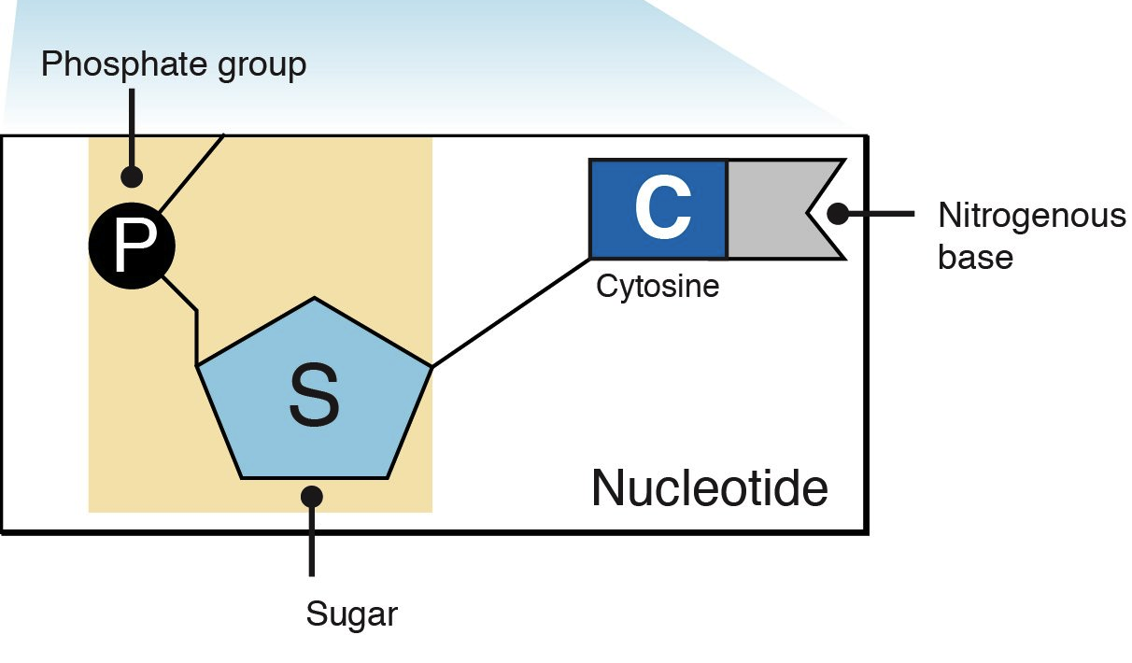
The sugar and phosphate group make up the backbone of the DNA double helix, while
the bases are located in the middle. A chemical bond between the phosphate group of
one nucleotide and the sugar of a neighboring nucleotide holds the backbone together.
Chemical bonds (hydrogen bonds) between the bases that are across from one another
hold the two strands of the double helix together.

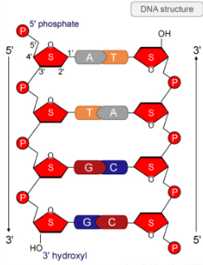

2- Sugars
The 5-carbon sugar found in nucleosides is either D-Ribose is present in RNA, while D-2- deoxyribose. D-Ribose is present in RNA, while D-2’- deoxyribose is present in DNA. Deoxyribose, as the name suggests, differs from ribose in having one less oxygen (at C-2).

As previously mentioned, nucleotides are found primarily as the monomeric units comprising the major nucleic acids of the cell, RNA and DNA.

However, nucleotides are also required for numerous other important functions within the
cell. These functions include:
1- Nucleotides have a variety of roles in cellular metabolism.
2-Nucleotides are the basis of high-energy compounds. The best known example is adenosine triphosphate (ATP), referred to as the currency of free energy in the body, which provides energy for all types of cellular activities. GTP is used as an energy source in protein synthesis.
3- Form a part of several important coenzymes such as NAD+, NADP+, FAD.
4- Regulation of enzyme activity involves certain nucleotides, such as cAMP and cGMP. They are signal conducting molecules, acting as intracellular messengers for certain hormones.
5- Control numerous enzymatic reactions through allosteric effects on enzyme activity.
6- Serve as activated intermediates in numerous biosynthetic reactions.
7- They are the constituents of nucleic acids: deoxyribonucleic acid (DNA) and ribonucleic acid (RNA).

Purine metabolism
A purine is a heterocyclic aromatic organic compound that consists of a pyrimidine ring fused to an imidazole ring. There are many naturally occurring purines. Two of the ﬁve bases in nucleic acids, adenine and guanine are purines.
Other well-known purines include xanthine, hypoxanthine, caffeine, and uric acid.

Metabolism of purines involves two major steps:
A- Synthesis of purines.
B- Catabolism of purines.
Proper understanding of purine metabolism is essential for better understanding of nucleic acids.

A- Synthesis of purines.
The nucleotides arising from endogenous synthesis are sufﬁcient to meet the body's requirements. Therefore, humans are said to be independent upon dietary sources for purines and pyrimidines requirements (Self-sufﬁciency).

Human body can synthesize the purine and the pyrimidine rings by one of the following two pathways:
1- De novo (anew) pathway
2- Salvaging pathway
De novo (anew) pathway
ln de novo synthesis the elements of purine ring system are added step by step, using C-1 of ribose 5-phosphate as a primer. It provides the cell with the capacity to construct the purine ring afresh, with carbon and nitrogen atoms coming from various sources.
The de novo synthesis of is most active in liver, though it may occur in several other tissues. Brain, RBCs and polymorphonuclear leukocytes cannot produce purines by de novo synthesis. This pathway is complex, consisting of 11 steps, and requiring six ATPs.

The Salvage Pathways
Purine bases that are obtained from the normal turnover of cellular nucleic acids can be used to resynthesize the corresponding nucleotides. Pathways of base to nucleotide conversion are referred to as the salvage pathways.
A given base reacts with other molecules to yield the corresponding nucleotide; for example, guanine forms guanosine monophosphate (GMP).

Compared to de novo pathway, salvage pathways account for the production of small fraction of the total purine nucleotides in human body, but they do have certain advantages for being:
- Simpler and more cost-efficient way of producing purine nucleotides.
- Preventing wastage of raw materials.
- Particularly important in brain and other such tissues where de novo pathway is slow or absent.

- Finally, in contrast to the de novo pathway, which is virtually identical in all cells, salvage pathways are diverse in character and distribution.

The tumor cells are known to have an extremely high mitotic rate, and therefore, a higher
requirement for DNA synthesis than normal cells. Therefore, they are more likely to be affected by antagonists of nucleotide synthesis.
With this in mind, several drugs have been developed as antagonists of nucleotide synthesis. Some commonly used antineoplastic drugs and their modes of action are:
1- Glutamine antagonists
They inhibit those steps in purine and pyrimidine metabolism in which glutamine donates a nitrogen.
2- Structural analogues of bases of nucleosides: act by inhibiting individual reactions in nucleotide metabolism or through their incorporation into DNA or RNA. Such DNA or RNA is functionally inactive. This arrests cell division, and hence useful in treatment of cancers.
3- Antifolates

B- Catabolism of Purine Nucleotides
Catabolism of purine nucleotides is a continuous process, balancing the biosynthesis of these compounds. As a result, the nucleotides of every cell are constantly revised.
Both adenine and guanine nucleotides are catabolized in a similar fashion. Hypoxanthine is an intermediate metabolite of purine metabolism which is then converted to xanthine by the enzyme xanthine oxidase.
Further conversion of xanthine to uric acid is catalyzed by the same enzyme. Uric acid in turn will be excreted in urine.
Thus, uric acid is the ﬁnal excretory product of purine catabolism, this is why rapid turnover of nucleic acids will lead to hyperuricemia. This condition is commonly encountered during treatment of malignancies.
Gout is a clinical syndrome, associated with hyperuricemia.

Pyrimidine synthesis differs from purine synthesis in one important aspect. The pyrimidine ring is synthesized before being attached to ribose 5-phosphate; in contrast, the purine ring is constructed on a pre-existing ribose 5-phosphate.
Pyrimidine catabolism has a signiﬁcant difference from purine metabolism.
Pyrimidine rings can be degraded completely to CO2; and NH3 which is then converted into urea by liver and excreted through kidneys, while purine rings are degraded to the metabolically inert uric acid.

^^^^^^^^^^^^^^^^^^^^^^^^^^^^^^^^^^^^^^^^^^^^^^^^^^^^^^^^^^^^^^^^^^^^^^^^^^^^^^^^^^^^^^^^^^^^^^^^^^^^^^^^^^^^^^^^^^^^^^^^^^^^^^^^^^^^^^^^^^^^^^^^^^^^^^^^^^^^^^^^^^^^^^^^^^^^^^^^^^^^^^^^^^^^^^^^^^^^^^^^^^^^^^^^^^^^^^^^^^^^^^^^^^^^^^^^^^^^^^^^^^^^^^^^^^^^^^^^^^^^^^^^

